Digital Trade, Data Protection and the EU Adequacy Club
Martina F. Ferracane (Teesside University and EUI)
Bernard Hoekman (European University Institute and CEPR)
Erik van der Marel (ECIPE and Université libre de Bruxelles)
Filippo Santi (Università di Bologna)

Revised
4 April 2025

Abstract: Between 2000 and 2020, the EU granted 14 so-called adequacy decisions, permitting EU citizens’ personal data to flow freely between the EU and the respective trading partners, including between the countries accorded adequacy. Adequacy decisions are unilateral, complementing more commonly observed and analyzed mutual recognition arrangements for technical regulations. Using structural gravity and synthetic control methods to assess the relationship between EU adequacy decisions and digital trade, using different approaches to define digital trade, we find that adequacy increases bilateral digital trade, driven to an important extent by EU-US agreements. We also show that digital trade between adequacy-receiving countries increases, providing evidence of a ‘club effect’ associated with EU adequacy decisions.
Keywords: digital trade; regulation; trade costs; recognition; clubs
JEL codes: D18; F13; F14: K24; L88; O38

Data statement: The data used in the analysis undertaken in this study are open access.
Conflict of interest statement: The authors declare they have no known competing financial interests or personal relationships that could have appeared to influence the work reported in this paper.

- Introduction
Between 2005 and 2022, exports of digitally delivered services expanded by an average of 8.1 percent annually, the fastest growing category in global trade (WTO, 2023). Such services often utilize personal data at multiple stages of the value chain, including research and development, product design, marketing, and sales. As the extensive use of personal data gives rise to privacy concerns (Zuboff, 2019), many governments regulate how personal data is used and shared, seeking to balance the promotion of digital trade with the protection of individual privacy. Such regulation may facilitate digital trade by fostering trust in the digital economy but may also increase trade costs. Much of the extant literature highlights the trade-offs between the free flow of personal data and privacy protection of citizens in the economy (Acquisti et al. 2016). Empirical studies have found that more restrictive data policies negatively impact trade in information and communication technology (ICT) goods and digitally deliverable services.
The European Union (EU) has been a leader in this area with its General Data Protection Regulation (GDPR). In addition to establishing rights for EU citizens (‘data subjects’) and regulating data processing, the GDPR also sets conditions for firms to transfer personal data outside the EU. These conditions include obtaining consent from the data subject or the use of firm-specific contractual mechanisms to ensure data privacy protection in third countries, measures that are generally associated with additional costs for firms. To facilitate data transfers to non-EU countries deemed to provide a level of personal data protection equivalent to that of the EU, the European Commission may accord a so-called adequacy decision to a foreign country. An adequacy determination allows companies located in the ‘adequate’ country to freely transfer EU citizens’ personal data to and from the EU, dispensing with the need for costly firm-specific contractual obligations to assure compliance with the GDPR.
An adequacy decision functions akin to recognition arrangements that are commonly used by countries to reduce the trade costs associated with national regulatory standards for health and product safety. Such arrangements may involve unilateral determinations that another jurisdiction’s regulatory system is equivalent to the national one, or comprise reciprocal, mutual recognition arrangements. An adequacy decision not only allows companies to freely transfer data between the EU and the country concerned but also establishes the right to transfer personal data of EU citizens among all countries accorded adequacy by the EU. This latter dimension creates a potential additional indirect benefit of adequacy: reducing digital trade costs among the ‘club’ of all jurisdictions granted adequacy.
The adoption of these regulatory mechanisms generally relies on the premise that a technical and institutional determination that regulatory regimes are effectively equivalent will lower trade costs. It is important to note that this does imply adequacy is endogenous in the sense of countries self-selecting into adequacy by deciding to adopt EU-type data protection regimes. Regulatory determinations reflect political as well as legal considerations, e.g., a desire to offer preferential treatment to political allies. Adequacy decisions have been accorded to only a small subset of the many countries that have adopted national personal data protection frameworks modeled on the GDPR, as well as to the US, which does not have GDPR-like legislation.
The fact that adequacy is granted on a selective basis raises the question of the magnitude of the direct trade benefits of the associated preferential access to markets that is implied, as well as the potential indirect benefits that accrue due to membership of the club. In this paper, we use structural gravity modeling and synthetic control methods to assess the relationship between EU adequacy decisions and digital trade, distinguishing between EU-US decisions and all other adequacy decisions.
We extend extant analyses of the trade effects of personal data protection (Spiezia and Tscheke 2020; Wu et al., 2023; Ma et al., 2023) by estimating the impact of unilaterally determined EU adequacy decisions on digital trade, controlling for regulatory data agreements and trade agreements with data privacy provisions that might also influence digital trade outcomes. We identify both a positive bilateral digital trade impact and an adequacy club effect, thereby contributing to the literature assessing the economic effects of discriminatory international cooperation aiming to lower the costs of regulatory heterogeneity. To the best of our knowledge, ours is the first empirical study to examine the digital trade impacts of GDPR adequacy decisions by focusing on both (i) bilateral digital trade between the EU and partner countries and (ii) digital trade between countries accorded an EU adequacy decision, i.e., the potential club effect associated with recognition of national data protection regulations.
We employ different approaches to define digital trade, using both sectoral classifications of digital trade and data intensity measures that capture the dependence of different sectors on data flows. Our baseline methodology builds on a standard structural gravity model to estimate the effect of adequacy decisions on aggregate bilateral digital trade with the EU and on digital trade between jurisdictions accorded adequacy. This is supplemented by a pooled product-level gravity model across all industries and sectors using data intensity measures. However, because the bilateral structural gravity framework and set of fixed effects preclude evaluation of the country-specific impact of adequacy on overall digital trade, we complement the gravity-based analysis with a synthetic control approach to assess the heterogeneity of both the bilateral and club effects of adequacy decisions on digital trade.
We find that countries with adequacy decisions experience an 8-9 percent increase in bilateral digital trade with the EU. Moreover, we find evidence of a positive club effect associated with EU adequacy decisions, reflected in increased digital trade between countries whose personal data protection regimes are deemed equivalent and have received adequacy decisions, notwithstanding the bilateral ‘hub and spoke’ nature of adequacy decisions. This dynamic has not previously been analyzed in the literature. Our findings suggest that digital trade expands within the network of adequacy-granted countries. The synthetic control analysis confirms these results, while highlighting the heterogeneous impact across countries accorded adequacy decisions.
The paper proceeds as follows. Section 2 provides background information on the EU GDPR and the process involved in obtaining an adequacy decision for personal data protection regimes. Section 3 discusses the gravity model framework we use to estimate bilateral adequacy and club effects on digital trade and presents the main results. Section 4 reports the results of applying a more detailed empirical strategy, pooling across all industries and sectors and using different measures of data intensity. Section 5 analyzes specific instances of adequacy decisions using synthetic control methods. Section 6 concludes.
- The GDPR, adequacy decisions and digital trade
In 1998, the EU implemented the Data Protection Directive governing the treatment of personal data of citizens from the European Economic Area. This directive permitted personal data to be freely transferred to third countries if the EU determined that the receiving country provided an adequate level of personal data protection. It was replaced by the GDPR in 2018. The GDPR lays out specific conditions under which personal data can flow to countries in the absence of an adequacy decision. These conditions entail the use of contractual mechanisms, including binding corporate rules and standard contractual clauses. The former provide a legal basis for transferring data within a multinational company and apply only to intra-firm data transfers; the latter are legal templates defined by the European Commission for transferring data to a firm located outside the EU.
These contractual mechanisms enable companies to certify compliance with EU regulations for transferring personal data abroad. They are costly for firms due to the burdensome approval procedures involved (Cory et al., 2020). The associated costs are both fixed and variable: in addition to fulfilling the contractual arrangements required to use these model documents, firms may need to hire data specialists and specialized consultancy firms for data mapping, management, and third-party auditing services. The costs will vary based on the number of countries, the type of data transfer, and the processing activity involved. Thus, standard contractual clauses must be drafted every time personal data processing activities change (Chivot and Cory, 2020). For binding corporate rules, the Data Protection Authority of the EU Member States where the firm or its subsidiary operates must approve the data transfer. The fixed costs of using these legal templates will place a relatively larger burden on small and medium-sized enterprises.
When an adequacy decision is implemented, companies no longer need to rely on prior consent, binding corporate rules and standard contractual clauses because the regulatory regime in the recipient countries is deemed ‘essentially equivalent’ to that of the EU. The equivalence in the level of data protection refers not only to the substance of the data protection rules, but includes multiple other factors, including respect for the rule of law and human rights, access of public authorities to personal data, and existence and effective functioning of independent supervisory authorities. In practice, the process for deciding whether to pursue a dialogue on adequacy with a third country is discretionary. The willingness of the EU to engage in adequacy discussions will reflect political considerations, as noted by the EU, consistent with the theory of discriminatory clubs developed by Davis (2023). That is, adequacy decisions are determined by factors in addition to a nation’s personal data protection regime.
Between 2000 and 2023, the EU granted adequacy 17 times (Appendix Table A1). In our empirical analysis, we focus on 14 adequacy decisions agreed through 2020, the last year for which we have trade as well as input-output data to measure our data intensity measures. Except for the US, all adequacy decisions require countries to have a comprehensive data privacy protection framework. In an adequacy decision, the European Commission certifies that the data protection regime of the trading partner is essentially equivalent in providing the same level of data protection as in the EU. In the case of the US, which does not have a comprehensive national data protection regime, adequacy decisions are based on a specific framework agreement governing data flows. As such, the adequacy decisions for the US certify the equivalence of the specific framework and not of the data protection regime in the US. Therefore, adequacy status is granted only to companies that have self-certified compliance with specific requirements that ensure personal data protection meets EU standards.
The first EU-US framework agreement for personal data flows was the Safe Harbor Privacy Principles, signed in 2000. This permitted US companies to voluntarily comply with seven basic privacy principles and several associated requirements. Any US business or organization subject to regulation by the Federal Trade Commission that self-certified compliance could apply to participate. Over 4,500 US companies relied on this mechanism to transfer EU citizens’ personal data between the EU and the US. In 2015, the Court of Justice of the European Union (CJEU) invalidated the agreement, following a complaint brought by privacy activist Max Schrems against Facebook. The Court ruled that Safe Harbor did not sufficiently limit the potential for US authorities to access EU citizens’ personal data and therefore did not guarantee the protection of the EU’s fundamental right to privacy. Companies utilizing the framework were given a grace period of four months to revert to alternative mechanisms for data transfers whilst the EU and US negotiated a new agreement. In 2016, a substantially more detailed Privacy Shield Framework was agreed. This clarified responsibility for compliance with EU data protection standards and included assurances from the US authorities regarding the treatment of complaints and redress possibilities. Over 5,300 companies signed up to the Privacy Shield framework. In 2020, it was invalidated by a second ruling of the CJEU. To address the ruling, in 2023 the Commission replaced Privacy Shield with the EU-US Data Privacy Framework (European Commission, 2023). To date, 2,675 companies have self-certified compliance under this framework.

2.1. Exploratory analysis
A basic event study estimating the impact of the 14 EU adequacy decisions implemented through 2020 on bilateral digital trade provides the initial motivation for our empirical analysis. Digital trade in this exercise spans digital services (audiovisual, telecommunications and IT services) and associated ICT goods and equipment. Figure 1 plots the five-year period preceding and following an adequacy decision, set at t=0, for digital trade between the EU and adequacy-granted partner countries (left-panel) and between partner countries that have an adequacy decision (right-panel). The latter captures what we call the club effect of EU adequacy decisions.
Figure 1: Event study of bilateral digital trade among countries with adequacy
EU exports to countries with adequacy Exports among countries with adequacy
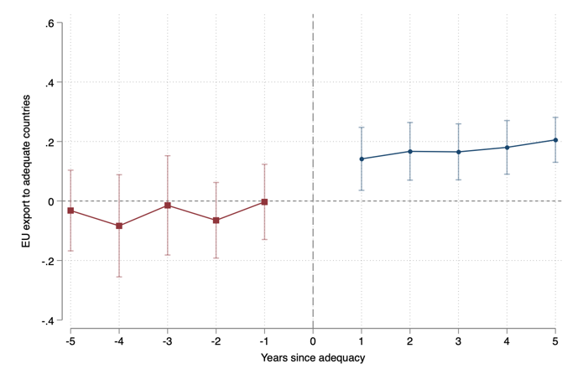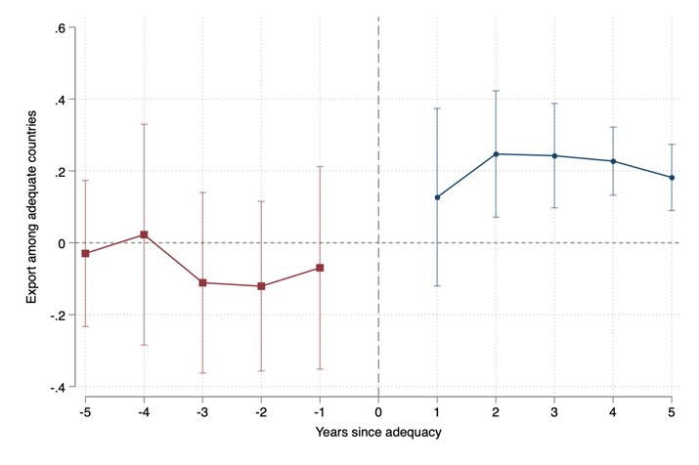
Notes: the plot reports the point estimates of a simple event study regression taking the form: $X_{ijt}=α+\sum_{t=1}^{5}{β_{w}Lag_{w+t}}+\sum_{t=1}^{5}{β_{k}Lead_{k}+{β'GRA}_{ijt}{+ α}_{i}+γ_{j}}+λ_{t}+ϵ_{ijt}$, where $X_{ij,t}$ are digital trade exports, ${GRA}_{ij,t}$ are standard gravity controls, ${ α}_{i}$, $γ_{j}$, and $λ_{t}$ are exporter, importer, and time fixed effects, respectively, and $ϵ_{ij,t}$ is an error term. Definitions of these variables are discussed in Section 3. The left-hand panel plots point estimates for digital trade between EU members and all partner countries with an adequacy decision. The right-hand panel plots estimates for digital trade between countries with EU adequacy. Source: OECD Trade in Value Added database.

Prior to an adequacy decision, both panels show no significant difference in digital trade compared to countries that did not receive adequacy during the sample period. The gap becomes positive following an adequacy decision, with coefficient estimates that are statistically significant at the 1 percent level in the second and subsequent years following the adequacy decision. The event study estimates plotted in the right-hand panel are suggestive of a club effect associated with decisions enabling the onward transfer of EU personal data among the set of countries with an adequacy decision.

- Gravity-based analysis of adequacy
The gravity model is a widely used empirical framework to assess the determinants of bilateral trade flows, including policy variables (Head and Mayer, 2014). In our case, the policy of interest is an EU adequacy decision, which is expected to reduce bilateral trade costs. Trade costs, $τ_{ijk}$, comprise two elements:
$$τ_{ijkt}=T_{ijkt}(1+t_{ijkt}) (1)$$
where $T_{ijk}$ are the (iceberg) transfer costs incurred by firms in origin country $i$ when exporting to destination country $j$, and $t_{ijk}$ denotes the ad valorem tariff on imports of ICT goods applied by destination country $j$ from origin $i$. These may vary over time, reflecting e.g., changes in policies. Since tariffs do not apply to digital services, and most ICT goods covered by our definition of digital trade have zero import duties due to the WTO International Technology Agreement, in our empirical analysis we focus on $T_{ijkt}$, the transaction costs that firms in origin country i incur when exporting to destination country j. These will be determined by standard gravity variables such as bilateral distance, participation in trade agreements or shared language, as well as policy frictions, including differences in regulatory regimes that increase the marginal cost for a firm trading across borders. In our setting such costs include the need for individual contract-specific measures to safeguard data privacy each time a firm engages in cross-border data transfers with the EU. $T_{ijkt}$ will therefore incorporate the effects of cross-border data frameworks that remove the need for firms to incur such costs, attenuating policy frictions between country pairs $i$ and $j$ for trade in digital sectors $k$.
3.1 Empirical specification
Our baseline empirical gravity equation is derived directly from Anderson et al (2018) and takes the form:
$$X_{ijt}^{dig}=exp\left(τ_{ijt}φ+α_{it}+γ_{jt}+δ_{ij}\right)e_{ijt} (2)$$
where $X_{ijt}^{dig}=\sum_{k=1}^{d}{X_{ijk}}$, the aggregate digital trade between country $i$ and country $j$, with the superscript $dig$ denoting one of the two definitions of digital trade described in Section 3.2, summing over sectors $k$ for year $t.$ The term $τ_{ijt}$ is a vector that captures all observable trade costs relevant for digital trade as described above, with $φ$ being the associated vector of coefficients. The terms $α_{it}, γ_{jt}$ and $δ_{ij}$ correspond to exporter, importer and bilateral fixed effects; $e_{ijt}$ is the error term.
As is standard in the gravity literature (i.e. Santos Silva and Tenreyro 2006; Woolridge, 2023), we use PPML to estimate equation (2) as follows:
$$X_{ijt}^{dig}=exp\left\{{βADQ}_{ijt}+{ϕGRA}_{ijt}+α_{it}+γ_{jt}+δ_{ij}\right\}+ε_{ijt} (3)$$
where ${ADQ}_{ijt}$ captures the existence of bilateral adequacy decisions between EU members and partner countries, whereas the other elements of $τ_{ij,k}$ reflecting all standard dyadic time-varying covariates typically used in gravity models are captured by ${GRA}_{ijt}$ (discussed further in Section 3.2). Equation (3) includes the three sets of fixed effects. Given the difference between the Safe Habor and Privacy Shield frameworks for the US and other adequacy decisions, in most of the analysis we split the term ${ADQ}_{ijt}$ into two components. One captures whether the EU has granted adequacy to any country other than the US. We label this as ‘regular’ adequacy decisions (${RADQ}_{ijt}$). The second component captures whether the Safe Harbor/ Privacy Shield frameworks between the EU and the US were in place ($SH/PS_{ijt}$). Both terms are represented as a dummy variable assuming value 1 in every period following the determination of adequacy for the partner country.
Club effect
The potential effects of adequacy decisions are not limited to digital trade between the EU and partner countries granted adequacy. The fact that the European Commission permits onward transfers of EU citizens' personal data to any country accorded adequacy potentially reduces bilateral trade costs among members of the “adequacy club”. For this reason, we distinguish between the "direct effect" of an adequacy decision on trade between the EU and an adequacy recipient country (${ADQ}_{ijt}$) and the potential indirect "club effect" of adequacy (${CLB}_{ijt}$) that may enhance bilateral digital trade between country pairs that have been accorded adequacy decisions. The ${CLB}_{ijt}$ parameter therefore captures whether and to what extent adequacy induces an additional bilateral trade cost reduction within the club of adequacy countries.
To explore the potential club effect, we modify equation 3 as follows:
$$X_{ijt}^{dig}=exp\left\{{βADQ}_{ijt}+λ{CLB}_{ijt}+{ϕGRA}_{ijt}+α_{it}+γ_{jt}+δ_{ij}\right\}+ε_{ijt} (4)$$
where $ADQ_{ijt}$ is a dummy variable equal to one starting in the year the EU accords adequacy to a partner country and${CLB}_{ijt}$ is a dummy variable equal to 1 in year $t$ when countries i and j both have adequacy status. In doing so we again distinguish between regular adequacy decisions (${RADQ}_{ijt}^{Club}$) and adequacy frameworks with the U.S. ($SH/PS_{ijt}^{Club}$). If an adequacy decision sufficiently lowers policy frictions between third countries that have been granted adequacy, reducing trade costs, we expect a positive coefficient estimate for this term. The vector ${GRA}_{ijt}$ and the three sets of fixed effects are the same as in equation (3).
3.2 Dependent and explanatory variables
Defining digital trade
Digital trade is defined to span both ICT goods and digital services. We include ICT goods because the activities of firms using EU personal data are often dependent on these goods. The complementarity between trade in digital equipment and digital services trade becomes evident when examining the list of firms that have subscribed to the EU-US data transfer frameworks. The US Department of Commerce requires participating firms in these frameworks to report on their sector activity and to provide a description of why they want to use the data agreement. A text analysis algorithm applied to these purpose descriptions reveals that words such as ‘goods’, ‘devices’, ‘electronics’ and ‘equipment’ are mentioned by almost half of the companies that have self-certified compliance with the 2023 EU-US Data Privacy Framework. Appendix Table A2 lists the top 10 sectors represented by firms participating in this arrangement. These sectors account for about 95 percent of all listed firms. Companies active in ICT services and business and professional services most frequently mention ICT goods in their purpose descriptions. Firms in industries such as education technology, biopharmaceuticals, and computer-aided activities have also subscribed extensively to the framework and therefore presumably directly benefit from an adequacy agreement. This mix of sectors is consistent with research highlighting the importance of complementarity between goods and services trade and how they are simultaneously affected by trade policy (e.g., Ariu et al., 2019).
The dependent variable $X_{ijt}^{dig}$ measures digital trade. Given there is no commonly accepted definition of digital trade, we need to select sectors that qualify as digital and that rely on cross-border data transfers. We develop two definitions of digital trade. The first is limited to core digital sectors, as defined by OECD (2023), and includes ICT goods, which complement digital services, as explained earlier. This narrow definition spans publishing, audiovisual and broadcasting, telecommunications, information technology services, and computer, electronic and optical equipment. A second broader definition adds other digitally deliverable services, such as business, financial, health, and education services, following the Handbook on Measuring Digital Trade (IMF-OECD-UNCTAD-WTO, 2023).
These sectoral definitions do not consider the extent to which other sectors may be affected by cost frictions related to data protection because of their reliance on personal data transfers. For example, the pharmaceutical sector, while not digital, relies on data transfers for medical research and clinical trials and as such is affected by the GDPR (Bentzen et al., 2023). Appendix Table A2 shows that the biopharmaceutical sector is one of the top sectors participating in the 2023 EU-US Data Protection Framework. We therefore include this sector in our broader definition of digital trade. Appendix Table A5 provides a list of 2-digit ISIC sectors that are included in both the narrow and broad definition of digital trade.
In both cases, the associated bilateral gross trade values for the included sectors are sourced from the OECD Trade in Value Added (TiVA) dataset. An advantage of using TiVA is that data for trade in goods and services are reported in a consistent manner from 1995 to 2020 for the ISIC Rev. 4 sectoral classification, well before the EU started to grant adequacy in 2000. As the database records trade data in squared balanced format across exports and imports, results are similar for both types of flows. We choose to use exports.
Explanatory variables
Given the stringent set of fixed effects, we only need to control for dyadic covariates which vary by country pairs over time. We incorporate a dummy variable capturing whether countries in a dyad are members of a preferential trade agreement (PTA) during our sample period, and another dummy variable indicating whether partner countries are World Trade Organization (WTO) members, sourced from Egger and Larch (2008) and Gurevich and Herman (2018), respectively. We refine the PTA variable to include only agreements with binding provisions on data protection contained in an e-commerce chapter (PTA-DP). Not controlling for PTAs with such provisions could bias our adequacy estimates upwards given potential overlap of partner countries that have a PTA with data protection provisions as well as adequacy. Moreover, our adjusted PTA variable is likely capturing the effect of digital trade better as it narrows down to affect those sectors which are reliant on data protection, which are digital trade sectors. We use data from the Burri and Polanco (2020) Trade Agreements Provisions on Electronic-commerce and Data database, which records all types of binding and non-binding digital provisions in PTAs. We check all PTAs in this dataset and cross-reference them with the Egger and Larch (2008) database. If they match, we create a PTA variable indicating whether it contains legally binding data protection provisions in a specific e-commerce chapter.
Additionally, we include several data-related dyadic controls. First, a variable capturing whether a country is subject to the 1995 EU Data Protection Directive 95/46/EC. As discussed above, this precursor to the GDPR mandates the protection of citizens when transferring and processing personal data. Second, we consider membership in the 1981 Council of Europe Convention for the Protection of Individuals with regard to Automatic Processing of Personal Data. This agreement safeguards individuals' right to privacy and sets certain limits and exceptions for cross-border data flows among signatory countries. A third control is whether a country adheres to the APEC Cross Border Privacy Rules system, an agreement involving Canada, Japan, Mexico, Korea, Singapore, and the US that addresses cross-border data flows. Finally, we control for EU membership given that adequacy decisions are issued by the EU and apply to all EU members.
The three sets of fixed effects, $α_{it}$, $γ_{jt}$ and $δ_{ij}$, control for exporter-year, importer-year and bilateral specific shocks, respectively. Other standard gravity variables, such as distance, are collinear with this set of fixed effects and are, therefore, dropped from our regressions. Appendix Tables A3 and A4 provide details on these variables and their sources. Standard errors are clustered by country-pair and time, following Egger and Tarlea (2015). In addition, to control for the likelihood that adequacy decisions between country-pairs are signed when cross-border data flows are trending upwards, we also add a linear country-pair-specific time trend. This captures any common linear trend specific to a given country pair due to other digital integration factors, such as cross-border data flows in our case. By controlling for this trend, the identification comes solely from above average changes in bilateral digital trade during the sample period relative to countries without adequacy. The inclusion of these time trends further mitigates the potential endogeneity of adequacy decisions.
The inclusion of country-time and pair-fixed effects, along with the pair-trend effects, removes much of the variation in the data, raising the threshold for finding statistically significant relationships between digital trade and adequacy decisions. In principle, assuming that ${GRA}_{ijt}$, together with the set of fixed effects, accounts for all data regulation-related time varying trade frictions, the estimated coefficients can be recovered without bias.
3.3 Baseline results
Table 1 presents the results of PPML estimation of equations (3) and (4) for both the narrow (columns 1-6) and broader definition of digital trade (column 7). Only the results for the adequacy variables are presented. The control variables are reported in Appendix B. The results in Table 1 distinguish between regular adequacy decisions granted to non-US partner countries ($RADQ_{ijt}$), and those pertaining to the U.S. (${SH/PS}_{ijt}$). Columns (1) and (2) first report results for the narrow definition of digital trade for all adequacy decisions taken together, i.e., without distinguishing between regular decisions and those for the US. Results indicate a statistically significant relationship between adequacy and bilateral digital trade between the EU and countries with adequacy, and between countries with adequacy, i.e., a positive club effect. Given the differences between regular adequacy decisions and the frameworks put in place for personal data flows between the EU and the US, in the remainder of this paper we focus on results that differentiate between the two types of frameworks.
Using the narrow definition of digital trade, we find a significant effect for the transatlantic data agreements, but not for regular adequacy decisions (column 3). Columns (4) and (5) consider the potential club effect of adequacy decisions, again distinguishing between the Safe Habor/Privacy Shield frameworks for the US and regular adequacy agreements. Column (4) captures the club effect among adequate countries excluding the US, while column (5) considers the potential club effect among all countries with adequacy. There is no relationship between regular adequacy decisions and digital trade among adequate countries. Conversely, there is a positive association between EU-US adequacy arrangements and digital trade among the club of adequate countries, with coefficient estimates that are significant at the 1 percent level. Column (6) includes all variables. The EU-US framework agreements remain positive and significant for both the direct and club effect, whereas coefficient estimates for the other adequacy decisions remain insignificant. Column (7) replicates the analysis using the broader definition of digital trade. Results remain similar.
Arguably, the adequacy variables may correlate with our PTA variable. Although adequacy decisions are developed independently from trade agreements, in practice, the benefits of a PTA might partly depend on whether adequacy has been granted or on political economy considerations. This is particularly relevant because our regressions include PTAs with data-protection provisions. As reported in Appendix B, the PTA control variable is not significant. Applying a lead of 2 years and lags of 2 as well as 1 and 3 years for the PTA variable does not affect the significance of the coefficient estimates for the adequacy variables.
Table 1: Baseline results, exports
 | (1) | (2) | (3) | (4) | (5) | (6) | (7)
$$ADQ_{ijt}$$ | 0.048* | 0.054**
 | (0.055) | (0.043)
$$ADQ_{ijt}^{Club}$$ |  | 0.062**
 |  | (0.018)
$$RADQ_{ijt}$$ |  |  | 0.002 | 0.001 | 0.024 | 0.023 | 0.002
 |  |  | (0.959) | (0.985) | (0.471) | (0.501) | (0.973)
$SH/PS_{ijt}$ |  |  | 0.070** | 0.070** | 0.078** | 0.078** | 0.096**
 |  |  | (0.036) | (0.037) | (0.023) | (0.024) | (0.010)
$$RADQ_{ijt}^{Club}$$ |  |  |  | -0.044 |  | -0.039 | 0.026
 |  |  |  | (0.473) |  | (0.546) | (0.605)
$$SH/PS_{ijt}^{Club}$$ |  |  |  |  | 0.081*** | 0.080*** | 0.071**
 |  |  |  |  | (0.001) | (0.001) | (0.014)
Digital trade definition | Narrow | Narrow | Narrow | Narrow | Narrow | Narrow | Broad
All controls | Yes | Yes | Yes | Yes | Yes | Yes | Yes
Obs. | 143901 | 143901 | 143901 | 143901 | 143901 | 143901 | 146751
R2 | 0.80 | 0.80 | 0.80 | 0.80 | 0.80 | 0.80 | 0.82
FE Pair | Yes | Yes | Yes | Yes | Yes | Yes | Yes
FE Exp-Year | Yes | Yes | Yes | Yes | Yes | Yes | Yes
FE Imp-Year | Yes | Yes | Yes | Yes | Yes | Yes | Yes
Trend effects | Yes | Yes | Yes | Yes | Yes | Yes | Yes
Two-way cluster | Pair & Year | Pair & Year | Pair & Year | Pair & Year | Pair & Year | Pair & Year | Pair & Year
Notes: Dependent variable: digital exports (EXP). *, **, and *** denote 10%, 5% and 1% significance levels with p-values in parenthesis. FE: fixed effects. SH: Safe Harbor; PS: Privacy Shield; RADQ: regular adequacy agreement; RADQ^{Club}: club effect between regular adequate countries; SH/PS^{Club}: club effect including the US.
4 Pooling across all industries
The results in Table 1 suggest that digital trade is positively associated with adequacy decisions that involve the US. These findings are premised on identifying the effect of adequacy on aggregate digital trade using the time variation in adequacy status across countries. However, insofar as changes in trade costs, prices, and demand are product or sector specific, our estimates could hide substantial heterogeneity. Moreover, as already mentioned, a range of industries and sectors beyond those we characterize as digital may rely on cross-border data transfers.
To address this possibility, we extend the gravity framework by pooling across all industries, following French and Zylkin (2024). In doing so, we correct for potential aggregation bias among the treated sectors and control for any bilateral time-variant unobserved factors that influence bilateral digital trade using fixed effects. At the same time, pooling across sectors enables us to exploit not only the variation over time in adequacy status, but also the variation in digital trade induced by adequacy decisions across all sectors and industries. The approach is akin to estimating an Average Treatment Effect (ATE) on a sector-by-sector basis as opposed to estimating an Average Treatment Effect on the Treated sectors (ATT), as we did before.
We can estimate the effects of adequacy and associated potential club effects by modifying equation (4) to interact the ${ADQ}_{ijt}$ and ${CLB}_{ijt}$ dummy variables with sector-weighted proxies of data-intensity, $I_{k}$:
$$X_{ijkt}=exp\left\{{βADQ}_{ijt}*I_{k}+λ{CLB}_{ijt}*I_{k}+α_{ikt}+γ_{jkt}+δ_{ijt}+ψ_{ijk}\right\}+ε_{ijkt} (5)$$
where $X_{ijkt}$ represents exports of goods and services belonging to sector $k$ between origin country $i$ and destination country $j$ in year $t$, where $k=1,…,d,…,K$ spans all industries, i.e. both digital and non-digital. The terms $α_{ikt}$ and $γ_{jkt}$ correspond to exporter-sector-time and importer-sector-time fixed effects, respectively, each incorporating the sector-level dimension, while $δ_{ijt}$ and $ψ_{ijk}$ correspond to exporter-importer-time and exporter-importer-sector fixed effects. The term $δ_{ijt}$controls for all standard gravity controls and therefore replaces the vector ${GRA}_{ijt}$ used in the aggregate gravity regressions. It also captures the linear country-pair-specific time trends. All regressions again apply two-way clustering by country-pair and year.
The rationale behind interacting the adequacy and club variables with a measure of data intensity is to capture how sectors respond to adequacy based on how much they are affected by data-related cost frictions, something our baseline gravity estimates cannot capture. To define the term $I_{k},$ we first develop two dummy variables following the narrow and broad definitions of digital trade as reported in Appendix Table A5. This is equivalent to attaching a weight equal to one to digital sectors only, as they are the ones that should benefit most from adequacy. In Section 4.2 we augment this strategy with several continuous measures reflecting the level of data dependence across all sectors, i.e., both digital and non-digital.
4.1 Pooled gravity estimates
We first estimate equation (5) using dummy variables for the narrow and broad definitions of digital trade as interaction terms. These estimates differ from our baseline aggregate gravity results because we now include the full set of industries while controlling for all time-varying pair-specific factors at the sector level by including the appropriate set of fixed effects. The inclusion of all sectors implies that identification comes from within pair-time-product variation in trade flows, rather than pair-time variation only. Thus, the estimation assesses how exports in digital sectors are affected as a result of adequacy relative to non-digital sectors.
Table 2 reports the results. When using the narrow definition of digital trade, regular adequacy decisions are statistically significant in all specifications (columns 1-4). The EU-US framework agreements are only significant at the 10 percent level. The significance of the regular adequacy decisions becomes stronger, however, when including the club variables (columns 3-4). Estimates for the SH/PS club effect are positive and statistically significant at the 5 percent level. As in the aggregate analysis, estimates of the club effect for regular adequacy decisions remain insignificant. Moreover, we no longer find any significant relationship between adequacy and our broad definition of digital trade (column 5), supporting the presumption that adequacy should matter more for digital intensive activities. Table 2 also reports estimates of the effects of one of the control variables, the existence of trade agreements that embody digital trade provisions. Such agreements are found to be strongly associated with digital trade flows.
Table 2: Pooled gravity estimates
 | (1) | (2) | (3) | (4) | (5)
 | EXP | EXP | EXP | EXP | EXP
$$RADQ_{ijt}*I_{k}$$ | 0.059* | 0.059* | 0.081** | 0.083** | 0.030
 | (0.096) | (0.078) | (0.034) | (0.025) | (0.317)
$SH/PS_{ijt}*I_{k}$ | 0.069* | 0.069* | 0.080* | 0.081* | -0.010
 | (0.095) | (0.094) | (0.066) | (0.066) | (0.657)
$$RADQ_{ijt}^{Club}*I_{k}$$ |  | 0.009 |  | 0.031 | -0.022
 |  | (0.909) |  | (0.700) | (0.684)
$$SH/PS_{ijt}^{Club}*I_{k}$$ |  |  | 0.084** | 0.085** | 0.069*
 |  |  | (0.020) | (0.019) | (0.090)
PTA DP * I_{k} | 0.329*** | 0.329*** | 0.328*** | 0.328*** | 0.285***
 | (0.000) | (0.000) | (0.000) | (0.000) | (0.000)
Digital trade dummy | Narrow | Narrow | Narrow | Narrow | Broad
Controls | Subsumed | Subsumed | Subsumed | Subsumed | Subsumed
Obs. | 4911529 | 4911529 | 4911529 | 4911529 | 4911529
R2 | 0.71 | 0.71 | 0.71 | 0.71 | 0.71
FE Pair-Year | Yes | Yes | Yes | Yes | Yes
FE Pair-Ind | Yes | Yes | Yes | Yes | Yes
FE Exp-Ind-Year | Yes | Yes | Yes | Yes | Yes
FE Imp-Ind-Year | Yes | Yes | Yes | Yes | Yes
Two-way cluster | Pair & Year | Pair & Year | Pair & Year | Pair & Year | Pair & Year
Notes: *, **, and *** denote 10%, 5% and 1% significance levels. P-values in parenthesis. FE: fixed effects; SH: Safe Harbor; PS: Privacy Shield; RADQ: regular adequacy decision; RADQ^{Club}: club effect between regular adequacy countries; SH/PS^{Club}: club effect including the US. The dummy I_{k} is an indicator that takes value 1 if industry k is included in the definition of digital industries as per Appendix Table A5.
While the aggregate results in Table 1 point to the significance of the EU-U.S. adequacy framework for digital trade, the pooled gravity regression results suggest that this effect is much weaker, although the club effect remains significant. Instead, regular adequacy decisions have a stronger effect. Note that the two results do not necessarily contradict each other, as they are not directly comparable due to differences in their reference units. The aggregate results only measure the increase in the selected digital trade sectors, i.e. the treated units, whilst the pooled gravity results include the entire set of sectors. As such, the latter comprises a different sample, also including non-digital sectors. This also matters for the interpretation of the pooled results. More specifically, the significance of the adequacy variables indicates that, compared to non-digital sectors, trade in sectors assessed as digital expands, on average, faster due to adequacy. In Table 1, no such distinction between the two groups can be made for the outcome variable.
4.2 Robustness: Data intensity-based measures of digital trade
To assess the robustness of our results using sectoral definitions of digital trade, we construct three different continuous data intensity measures. The first measure is based on firm-level information associated with participation in the EU-US Data Protection Framework. As discussed, the US Department of Commerce maintains a list of self-certified companies that includes data on each company's primary sector of activity. Using web scraping, we retrieved data on all 2,675 companies certified under this framework, including their primary and sub-sector activities, as well as the stated purpose for which firms use the adequacy agreement. We use this information to create an indicator of data intensity based on the share of listed firms in each sector.
Two other data intensity measures are derived from national input-output tables provided by the OECD for 1995-2020. These are based on the 2-digit International Standard Industrial Classification (ISIC) (Revision 4) which aligns with our trade data and define data intensity in terms of usage of upstream digital services and goods by firms operating in a given downstream sector. The first measure, domestic input elasticities of digital sectors, refers to the input-output coefficients of digital inputs sourced domestically. The second measure, cross-border input elasticities, refers to the input-output coefficients of imported digital inputs. The rationale for these two measures is that even non-digital downstream sectors might be affected by an adequacy decision due to their digital input usage, which we expect to be a good proxy of data intensity.
To compute these data intensity measures, consistent with our narrow definition of digital trade (Appendix Table A5), we select the digital sectors that sell to other downstream sectors in the economy: Computer, Electronic and Optical Equipment (ISIC D26), Publishing, Audio-Visual and Broadcasting (ISIC D58T60), Telecom (ISIC D61), and Information Technology and Other Information Services (ISIC D62T63). For each downstream sector, we calculate the proportion of inputs from these digital sectors relative to the sector’s total input usage (total intermediate consumption at purchasers’ prices). Since the OECD provides values for inputs sourced from a country’s domestic market as well as imported inputs, we can compute the coefficient for both sets of inputs, which sum to the total value of digital inputs used by each downstream sector.
Our preferred measure is the import input elasticity, which is consistent with the input-output coefficient used in Frey and Presidente (2024). However, as this data intensity measure may suffer from endogeneity because trade is our dependent variable, we also use domestic input elasticities as an additional robustness check. To further reduce endogeneity concerns, we compute the average across all countries covered in the input-output tables for the year 2006, approximately the midpoint of our period. Appendix Table A6 presents the summary statistics for all three digital intensity measures. Appendix Figure A1 shows they are strongly correlated.
Table 3 reports results from estimating equation (5) on bilateral trade for all sectors, where $I_{k}$ is now one of the three continuous digital intensity measures. Results are in line with those reported in Table 2. When using the sectoral share of firms registered under the EU-US data framework to identify data-intensive sectors, we obtain significant results for both regular adequacy decisions and the club effect for the EU-US agreements (column 1). In our preferred specification using cross-border input elasticities (column 2), we obtain similar results. When using domestic input elasticities, the result for regular adequacy decisions is highly significant whereas the results for the SH/PS data frameworks become significant, with its club effect increasing in magnitude as well as significance (column 3). The PTA-DP control variable is again positive, large and statistically significant at the 1% level in all columns.
Table 3: Results of pooled gravity regressions using data intensity measures
 | (1) | (2) | (3) | (4) | (5)
 | EXP | EXP | EXP | EXP | EXP
 |  |  |  | Interval | Placebo
$RADQ_{ijt}*DI_{k}$ | 0.172** | 0.358** | 0.767*** | 0.695*** | 0.797***
 | (0.045) | (0.019) | (0.003) | (0.003) | (0.002)
$SH/PS_{ijt}*DI_{k}$ | 0.137 | 0.263 | 0.922** | 0.366 | 0.973***
 | (0.133) | (0.159) | (0.031) | (0.496) | (0.010)
$RADQ_{ijt}^{Club}*DI_{k}$ | 0.041 | 0.165 | 0.552 | 0.152 | 0.482
 | (0.820) | (0.566) | (0.130) | (0.704) | (0.182)
$$SH/PS_{ijt}^{Club}*DI_{k}$$ | 0.216** | 0.396* | 0.657** | 0.913* | 0.721***
 | (0.022) | (0.057) | (0.024) | (0.050) | (0.007)
PTA DP $*DI_{k}$ | 0.749*** | 1.607*** | 1.972*** | 2.018*** | 1.929***
 | (0.000) | (0.000) | (0.000) | (0.002) | (0.000)
$RADQ_{ijt}*DI_{k}$ (t+4) |  |  |  |  | 0.141
 |  |  |  |  | (0.506)
$SH/PS_{ijt}*DI_{k}$ (t+4) |  |  |  |  | -1.136***
 |  |  |  |  | (0.000)
$RADQ_{ijt}^{Club}*DI_{k}$ (t+4) |  |  |  |  | 0.310
 |  |  |  |  | (0.503)
$SH/PS_{ijt}^{Club}*DI_{k}$ (t+4) |  |  |  |  | 0.105
 |  |  |  |  | (0.654)
Digital variable | DPF | I/O imp | I/O domestic | I/O imports | I/O imp
Controls | Subsumed | Subsumed | Subsumed | Subsumed | Subsumed
Obs. | 4581963 | 4911529 | 4911529 | 1272015 | 4911529
R2 | 0.71 | 0.71 | 0.71 | 0.71 | 0.71
FE Pair-Year | Yes | Yes | Yes | Yes | Yes
FE Pair-Ind | Yes | Yes | Yes | Yes | Yes
FE Exp-Ind-Year | Yes | Yes | Yes | Yes | Yes
FE Imp-Ind-Year | Yes | Yes | Yes | Yes | Yes
Two-way cluster | Pair & Year | Pair & Year | Pair & Year | Pair & Year | Pair & Year
Notes: *, **, and *** denote 10%, 5% and 1% significance levels. P-values in parenthesis. FE: fixed effects; SH: Safe Harbor; PS: Privacy Shield; RADQ: non-US adequacy decision; RADQ^{Club}: club effect between non-US adequate countries; SH/PS^{Club}: club effect including the US. All adequacy variables are interacted with DI_{k} , which refers to the measure of digital intensity used in each interaction term, respectively: (1) DPF: EU-US Data Privacy Framework; (2) I/O imports: IO coefficients of imported digital inputs; (3) I/O domestic: IO coefficients for digital inputs sourced domestically.
We apply two additional robustness checks. First, following Cheng and Wall (2005), Baier and Bergstrand (2007) and Bergstrand et al. (2015), we re-estimate equation (5) using three-year intervals with our preferred cross-border input elasticity measure. The results, reported in column (4), show that the coefficients remain significant for the regular adequacy decisions as well as for the club effect of the two EU-US data frameworks. Second, to address any remaining concerns about identification, we also apply leads of all our independent variables. This serves as a type of placebo test for a potential implicit parallel trend assumption in case of significance and also allows us to examine if there are anticipation effects present in a country being granted adequacy. Consistent with empirical gravity research – e.g., Larch et al. (2019) and Yotov et al. (2016) – we apply a four-year lead using cross-border input elasticities. The results, reported in column (5), show that the main results hold whereas the lead effects remain largely insignificant, except for SH/PS, which is negative and significant.
Overall, using the most conservative estimates from our narrow digital dummy variable in Table 2 (column 4), which arguably offers the strongest empirical approach, the results suggest regular adequacy decisions increase digital trade by some 7-9 percent, whereas the two EU-US framework agreements increase digital trade by around 8 percent, computed as $e^{(β_{1}RADQ | PS/SH)}-1$. Considering the club effect associated with the two Transatlantic data agreements, countries within the adequacy club experience a digital trade impact of around 9 percent. The former estimate pertains to trade between the EU and countries accorded adequacy status, whereas the latter applies to trade between countries that have been granted adequacy. These results apply only to our pooled estimates. In our aggregate estimates, regular adequacy decisions do not have a significant impact, with adequacy only estimated to impact on trade under the two data flow agreements between the EU and the US.
- Synthetic control analysis
The relationship between adequacy decisions and digital trade is likely to be influenced by country characteristics. A gravity model approach is not well suited for identifying idiosyncratic effects of adequacy on a country’s digital trade. To consider the potential role of country-specific factors, we turn to a synthetic control approach. Synthetic control methods involve comparing the performance of a country granted adequacy with that of a synthetically constructed counterfactual unit, which approximates how the country obtaining adequacy would have performed had it never received adequacy status. Pre-adequacy differences between a country receiving adequacy and a constructed counterfactual are minimized by aggregating the pool of potential untreated control units, based on their individual performance with respect to both the outcome of interest (digital trade) and the variables used for matching purposes (Abadie et al., 2015). Provided a set of pseudo-identifying assumptions hold, the difference between the treated and the synthetic control in the post-adequacy period can be attributed to being granted adequacy.
Our objective here is twofold: first, to assess whether the effects of adequacy decisions are homogeneous irrespectively of the country that benefits such decisions; second, if the response is heterogeneous, to understand the pattern of responses. We consider three distinct adequacy decisions: Argentina, Israel and New Zealand. The motivation for focusing on these three countries is that they obtained adequacy at different points in time (2003, 2011, and 2013 respectively) and are located in different parts of the world. Their geographic dispersion may drive idiosyncratic responses to an adequacy decision, associated with a country’s integration into different regional digital markets. Each of the three countries also have distinct features as regards digital trade. Argentina, a middle-income country, saw digital exports expand substantially during the period of analysis. Argentina is also the only Latin American Spanish speaking country with EU adequacy in our sample and is located in the same time-zone as the US. Israel differs from the other countries because of its relatively close geographic proximity to the EU, strong comparative advantage in ICT/high tech industries that rely on cross-border data flows, and deep economic ties with the US. Finally, New Zealand is English-speaking, is among the most geographically remote countries, located in a time zone many hours ahead/behind the EU and US, the two largest digital services traders (WTO, 2023) and has strong historical connections to Europe. New Zealand’s remoteness from the EU and all other countries accorded EU adequacy is salient in evaluating whether adequacy is indeed effective in promoting digital trade and creates a club effect with other adequate partners, notwithstanding its remoteness compared to other adequate countries.
5.1 Methodology
Following Hollingsworth and Wing (2022), we use a matching algorithm that relies on the Least Absolute Shrinkage and Selection Operator (Lasso) for the selection of the optimal mix of matching variables and pre-adequacy lags for the dependent variable. The synthetic control estimator of the Average Treatment Effect on the Treated (ATT) of adequacy, $\hat{β_{st}}$, can be described as follows:
$\hat{β_{st}}=Y_{0t'}-Y_{t}^{*}=Y_{0t^{'}}(1)-\sum_{s=1}^{S}{Y_{st'}π_{s} }$ (6)
where $Y_{t}^{*}=\sum_{s=1}^{S}{Y_{st'}π_{s} }$is a weighted combination of control units and $Y_{0t^{'}}(1)$ is the post-adequacy performance of a “treated” country (Argentina, Israel or New Zealand) with respect to the outcome of interest. The parameter $π_{s}$ is the weight attached to each country in the donor pool, and captures the similarity of a potential control country to the one of interest. This in turn depends on the set of matching variables considered and their trends in the pre-adequacy period. The pool of potential controls (donor pool) for each case study is restricted as follows: for Argentina, we only consider other Spanish speaking countries in Latin America; for New Zealand, we consider all English-speaking countries in the Indo-Pacific found in TiVA, excluding the US and Canada given that both were granted adequacy and are located in a very different time zone; for Israel, we cover all English speaking countries in the dataset, irrespectively of the time-zone and location, excluding the US and Canada.
To illustrate the role of the matching variables, the estimator can be rewritten as:
$\hat{β_{st}}={argmin}_{β}\left\|X_{T}^{pre}-βX_{S}^{pre}\right\|= \sqrt{\sum_{p}{\left(X_{t,p}^{pre}-\sum_{i∈S}{β_{p} X_{S,p}^{pre}}\right)}}$ (7)
i.e. as an optimization problem minimizing the distance between all the observable characteristics of the control units ($X_{S}, S=1, …, S)$and the country obtaining adequacy ($X_{T}$). Consistent with the empirical literature, our matching variables include different lags of our dependent variable (pre-adequacy digital trade in logs), total trade (all three variables in logs), the ratio of digital trade on total trade, per capita GDP (in logs), plus a set of country-specific fixed effects to absorb all country-specific characteristics, such as time zone and geographic location, that do not vary over time.
5.2 Synthetic control estimates
We estimate the effect of adequacy on digital trade using our preferred narrow definition of digital trade. Results for the three countries are reported in Figures 4-6. Each panel compares the performance of the country of interest (the solid line labelled “real”) with that of its synthetic control (the dashed line) with respect to digital trade. The year the adequacy decision was granted by the EU is indicated by the vertical dashed line: 2003 for Argentina, 2013 for New Zealand, and 2011 for Israel. Panel A of each figure reports results for digital trade with all partners irrespective of whether they have been granted adequacy; Panel B restricts the dependent variable to digital trade with other countries granted adequacy by the EU; Panel C reports results for digital trade with the US; and finally Panel D reports results for digital trade with other adequate countries, excluding the US. Panels B-D allow an assessment of heterogeneity of the club effect found in the gravity results.
In addition to the stacked plots for each of the four scenarios defined above, we report the related “spaghetti plots” in Figures C1-C3 in Appendix C. These additional results refer to the in-space placebo tests obtained by randomly assigning adequacy to any of the potential control units in each of the three case studies discussed. The additional plots provide a basic form of robustness and support the conclusion that the effects identified can be attributed to adequacy and not to any country-specific trend. Appendix Table C1 reports all the estimated ATTs and the related root mean square errors, as well as their robustness according to the placebo test.
Figure 4: Synthetic control estimates: Argentina
A: Total digital trade | B: Digital trade with adequate countries
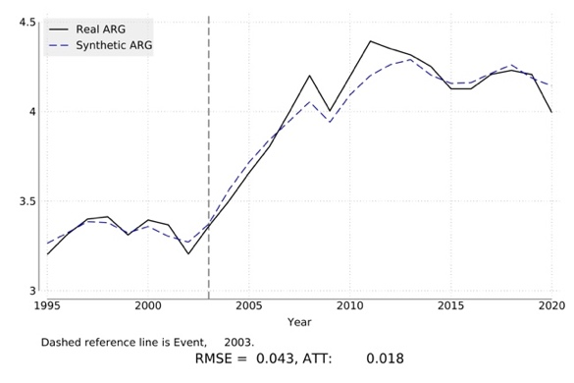 | 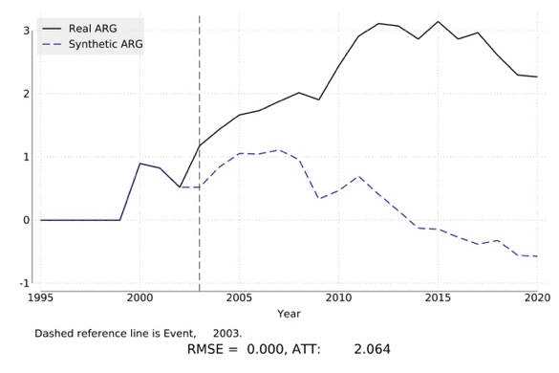
C: Digital trade with the US | D: Digital trade with adequate (excl. the US)
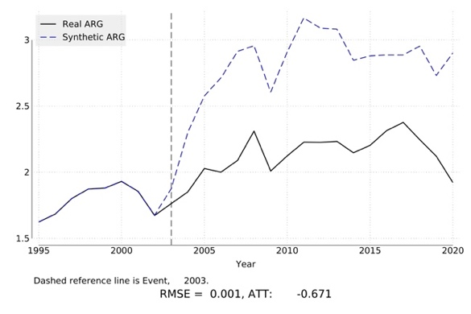 | 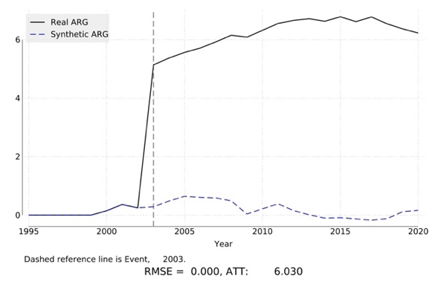
Note: Outcome variable is the narrow definition of digital trade as defined in Appendix Table A5.
Figure 5: Synthetic control estimates: New Zealand
A: Total digital trade | B: Digital trade with adequate countries
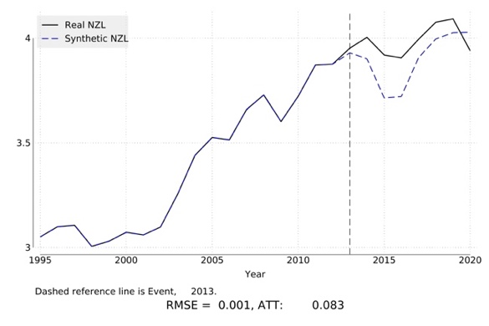 | 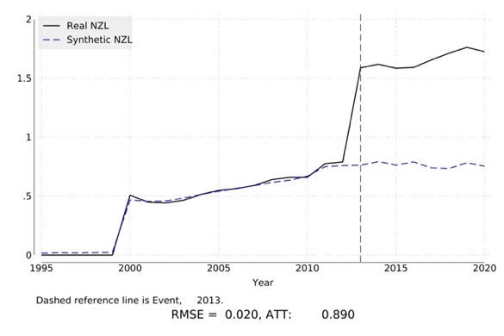
C: Digital trade with the US | D: Digital trade with adequate (excl. the US)
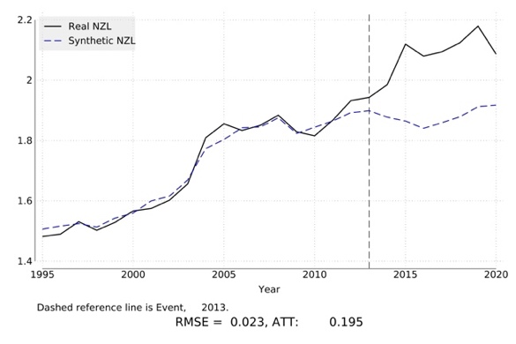 | 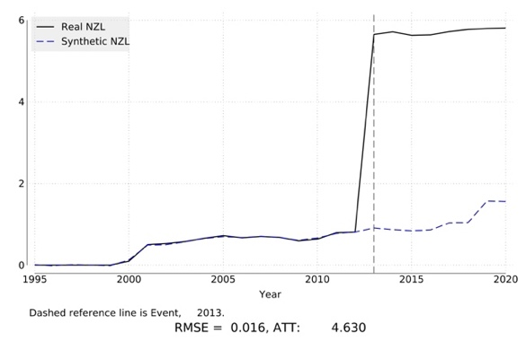
Note: Outcome variable is the narrow definition of digital trade as defined in Appendix Table A5.
Figure 6: Synthetic control estimates: Israel
A: Total digital trade | B: Digital trade with adequate countries
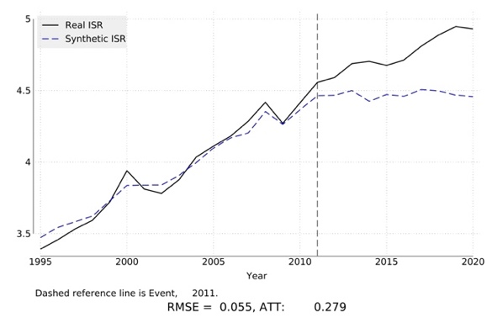 | 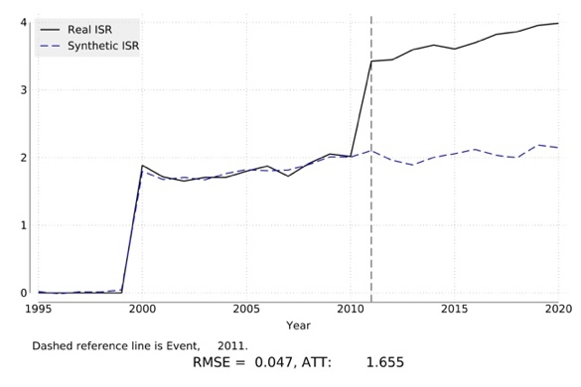
C: Digital trade with the US | D: Digital trade with adequate (excl. the US)
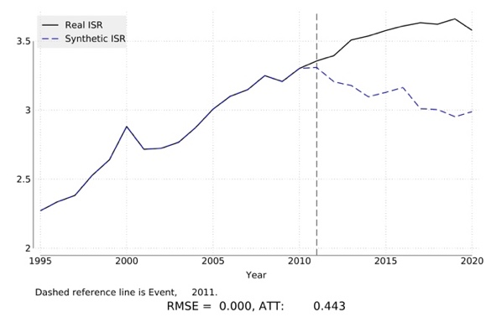 | 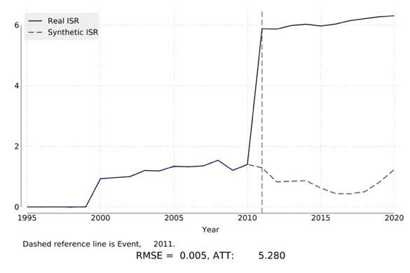
Note: Outcome variable is the narrow definition of digital trade as defined in Appendix Table A5.
The plots in Figures 4-6 are largely consistent with our gravity estimates, revealing that adequacy matters for digital trade. The three cases also highlight the prevalence of heterogeneity, reflected in the large differences in the estimated effects across the four scenarios. The synthetic control exercises for Argentina (Figures 4) and New Zealand (Figure 5) indicate that while adequacy status did not increase their overall digital trade volumes compared to the counterfactual scenario (Panel A), it reshaped their trading patterns.
The estimates for Argentina in Figure 4 suggest that receiving adequacy did not expand total digital trade compared to the counterfactual scenario, i.e. absent the adequacy decision, but Argentina’s digital trade with adequate countries other than the US (Argentina’s main digital trade partner) continuously increased following the adequacy decision, suggesting potential trade diversion from the US to the EU and other adequate countries. This is consistent with the synthetic counterfactual in Panels B and C, which initially increased before respectively declining (Panel B) or stabilizing (Panel C). The estimates for New Zealand in Figure 5 reveal a different pattern. Digital trade only marginally increases relative to the donor pool (Panel A), while we find a larger increase in trade with countries accorded adequacy other than the US and trade with the US. Finally, the case of Israel in Figure 6 is most clearcut, with significant increases in digital trade across all four scenarios following adequacy.
Overall, the case studies for Argentina and New Zealand indicate that adequacy was associated with a reallocation of digital trade flows, with both countries substantially increasing digital trade with the EU and with other adequate countries as compared to the counterfactual. This contrasts with Israel, where the synthetic control exercise indicates that adequacy not only redirected existing trade but generated new digital trade growth overall. Taken together, these findings suggest that adequacy decisions affect digital trade heterogeneously. More broadly, the results align with the gravity-based estimates, indicating a strong positive effect of club membership on digital trade between adequate countries, while the limited but positive impact of adequacy decisions on digital trade overall, suggest that the average effect in our aggregate gravity estimates masks significant differences in how each adequate country responds.
- Conclusion
Regulation of cross-border data flows and differences in national regulatory regimes generates costs for firms that engage in digital trade. Recognition agreements are one potential instrument to reduce such costs. Our baseline model shows that the aggregate volume of digital trade, both narrowly and broadly defined, is positively associated with an adequacy framework being in place for the US. If instead we adopt a pooled gravity regression approach across all sectors, we find that digital exports fared better compared to non-digital exports for non-US, i.e., regular adequacy decisions. When refining our approach to defining digital trade based on the data intensity of sectors, we find that all adequacy decisions are positively associated with trade in data intensive sectors.
Depending on the estimation approach and definition of digital trade, adequacy determinations are associated with increases in bilateral digital trade on the order of 7 to 9 percent, and a similar magnitude for digital trade between countries with adequacy status. Thus, there are nontrivial trade benefits associated with obtaining adequacy, both in terms of direct trade and in terms of accompanying ‘club benefits’. The averages mask significant heterogeneity at the country level, but in all of the estimation approaches adequacy supports growth in digital trade among the club of adequate countries.
The gravity results suggest countries with adequacy decisions exhibit greater digital trade among each other conditional on there being a cross-border data framework for the US, although the synthetic control analysis indicates that the club effect of adequacy extends to other members of the adequacy club. A possible explanation of these findings is that US companies are best equipped to take advantage of adequacy decisions, as they have the capacity to adjust their supply chains and exploit the benefits offered by being part of the club.
Data constraints precluded inclusion of adequacy decisions agreed after 2020. Assessing the impacts of more recent arrangements is presently not possible because insufficient time has passed to generate the required trade and trade in value added data. Future research will be important to deepen understanding of the economic implications of adequacy decisions and their benefits to the countries that are able to join the EU adequacy club.
References
Abadie, A. (2005) Semiparametric difference-in-differences estimators, Review of Economic Studies, 72(1), 1-19.
Abadie, A. (2021) Using Synthetic Controls: Feasibility, Data Requirements, and Methodological Aspects, Journal of Economic Literature, 59(2), 391-425.
Abadie, A., A. Diamond and J. Hainmueller (2015) Comparative Politics and the Synthetic Control Method, American Journal of Political Science, 59(2), 495-510.
Acquisti, A., C. Taylor and L. Wagman (2016) The Economics of Privacy, Journal of Economic Literature, 54(2), 442-92.
Anderson, J. (2011) The gravity model. Annual Review of Economics, 3(1), 133-60.
Anderson, J., I. Borchert, A. Mattoo and Y. Yotov (2018) Dark Costs, Missing Data: Shedding Some Light on Services Trade, European Economic Review, 105(C), 193-214.
Aridor, G., Y. K. Che and T. Salz (2023) The Effect of Privacy Regulation on the Data Industry: Empirical Evidence from GDPR, RAND Journal of Economics, 54(4), 6952-7730.
Ariu, A., H. Breinlich, G. Corcos and G. Mion (2019) The Interconnections Between Services and Goods Trade at the Firm-level, Journal of International Economics, 116, 173-88.
Arkolakis, C., A. Costinot and A. Rodríguez-Clare (2012) New trade models, same old gains?. American Economic Review, 102(1), 94-130.
Baier, S. L. and J. H. Bergstrand (2007) Do Free Trade Agreements Actually Increase Members’ International Trade? Journal of International Economics, 71(1), 72-95.
Bento, P. and D. Restuccia (2021) On Average Establishment Size Across Sectors and Countries, Journal of Monetary Economics, 117(C), 220-242.
Bentzen, H.B., H. Kvammen Olav and G. Ursin (2023) Maximizing the GDPR Potential for Data Transfers: First in Europe, The Lancet Regional Health Europe, 27, 1-4.
Bergstrand, J., M. Larch and Y. Yotov (2015) Economic Integration Agreements, Border Effects, and Distance Elasticities in the Gravity Equation, European Economic Review, 78, 307-27.
Borchert, I., Larch, M., Shikher, S., and Yotov, Y. (2022), The International Trade and Production Database for Estimation - Release 2 (ITPD-E-R02). USITC Working Paper 2022–07–A.
Borusyak, K., P. Hull and X. Jaravel (2024), A Practical Guide to Shift-Share Instruments, NBER Working Paper 33236.
Breinlich, H. and C. Criscuolo (2011) International Trade in Services: A Portrait of Importers and Exporters, Journal of International Economics, 84(2), 188-206.
Burri, M. and R. Polanco (2020) Digital trade provisions in preferential trade agreements: introducing a new dataset. Journal of International Economic Law, 23(1), 187-220.
Business Europe, Digital Europe, ERT and ACEA (2020) Schrems II: Impact Survey Report, Brussels.
Cheng, I. and H. J. Wall (2005) Controlling for Heterogeneity in Gravity Models of Trade and Integration, Federal Reserve Bank of St. Louis Review, 87, 49-64.
Chivot, E. and N. Cory (2020) Response to European Commission Consultation on Transfers of Personal Data to Third Countries and Cooperation Between Data Protection Authorities, Information Technology & Innovation Foundation, Washington DC.
Ciccone, A. and E. Papaioannou (2023) Estimating Cross-industry Cross-country Interaction Models using Benchmark Industry Characteristics, Economic Journal, 133(649), 130-58.
Cory, N., D. Castro and E. Dick (2020) The Role and Value of Standard Contractual Clauses in EU-US digital trade, Information Technology and Innovation Foundation, Washington DC.
Davis, C. 2023. Discriminatory Clubs: The Geopolitics of International Organizations. Princeton University Press.
De Brito, A., C. Kauffmann and J. Pelkmans (2016). The contribution of mutual recognition to international regulatory co-operation. OECD.
European Commission (2017) Communication from the Commission to the European Parliament and the Council - Exchanging and Protecting Personal Data in a Globalised World. COM (2017) 7 final, Brussels.
European Commission (2023) Adequacy decision for the EU-US Data Privacy Framework. Document C(2023)4745 final, Brussels.
Egger, P. and M. Larch (2008) Interdependent preferential trade agreement memberships: An empirical analysis. Journal of international Economics, 76(2), 384-99.
Egger, P. and F. Tarlea (2015) Multi-way Clustering Estimation of Standard Errors in Gravity Models, Economics Letters, 134, 144–47.
Ferracane, M. and E. van der Marel (2021) Do Data Policy Restrictions Inhibit Trade in Services? Review of World Economics, 157(4), 727-76.
French, S. and T. Zylkin (2024) The Effects of Free Trade Agreements on Product-level Trade, European Economic Review, 162, 104673.
Frey, C.B. and G. Presidente (2024) Privacy Regulation and Firm Performance: Estimating the GDPR Effect Globally, Economic Inquiry, 62(3), 1074-89.
Gnutzmann-Mkrtchyan, A. and C. Henn (2018) Peeling Away the Layers: Impacts of Durable Tariff Elimination, Journal of International Economics, 115, 259-76.
Goldberg, S., G. Johnson, and S. Shriver (2023) Regulating Privacy Online: An Economic Evaluation of the GDPR, American Economic Journal: Economic Policy, 16(1), 325-58.
Goldfarb, A. and D. Trefler (2018) AI and International Trade, NBER Working Paper No. 24254.
Gurevich, T. and P. Herman (2018) The dynamic gravity dataset: 1948-2016. USITC Office of Economics Working Paper 2018-02-A.
Head, K. and T. Mayer (2014) Gravity Equations: Workhorse, Toolkit, and Cookbook, Handbook of International Economics, in: G. Gopinath, E. Helpman, K., and K. Rogoff (eds.), Handbook of International Economics, Volume 4, 131-95.
Head, K., T. Mayer and J. Ries (2009) How Remote is the Offshoring Threat? European Economic Review, 53(4), 429-444.
Hollingsworth, A. and C. Wing (2022) Tactics for Design and Inference in Synthetic Control Studies: An Applied Example using High-dimensional Data, At: 10.31235/osf.io/fc9xt.
IMF, OECD, UNCTAD and WTO (2023) Handbook on Measuring Digital Trade. Geneva: WTO.
Larch, M., J. Wanner, Y. Yotov and T. Zylkin (2019) Currency Unions and Trade: A PPML Reassessment with High‐dimensional Fixed Effects, Oxford Bulletin of Economics and Statistics, Vol. 81(3), 487-510.
Ma, S., Y. Shen and C. Fang (2023) Can Data Flow Provisions Facilitate Trade in Goods and Services? Journal of International Trade & Economic Development, 33(3), 343-68.
Rajan, R. and L. Zingales (1998) Financial Dependence and Growth, American Economic Review, 88(3), 559-86.
Reverdy, C. (2023) Estimating the General Equilibrium Effects of Services Trade Liberalization, Review of International Economics, 31(2), 493-521.
Saluste, M. (2021) Adequacy Decisions: An Opportunity for Regulatory Cooperation on Data Protection? RESPECT Working Paper, European University Institute.
Santos Silva, J. and S. Tenreyro (2006) The Log of Gravity, The Review of Economics and Statistics, 88(4), 641-58.
Spiezia, V., and J. Tscheke (2020) International Agreements on Cross-border Data Flows and International Trade: A statistical analysis, OECD STI Working Paper 2020/09.
Sun, R. and D. Trefler (2023) The Impact of AI and Cross-Border Data Regulation on International Trade in Digital Services: A Large Language Model, NBER Working Paper No. 31925.
Wooldridge, J. M. (2023). Simple approaches to nonlinear difference-in-differences with panel data. The Econometrics Journal, 26(3), C31-C66.
WTO (World Trade Organization) (2023), Global Trade Outlook and Statistics, Geneva: WTO.
Wu, J., Z. Luo and J. Wood (2023) How do Digital Trade Rules affect Global Value Chain Trade in Services? The World Economy, 46(10), 3026-47.
Yotov, Y., R. Piermartini, J. Monteiro and M. Larch (2016) An Advanced Guide to Trade Policy Analysis: The Structural Gravity Model, Geneva: WTO.
Yotov, Y. (2024) The Evolution of Structural Gravity: The Workhorse Model of Trade,” Contemporary Economic Policy 42(4), 578-603.
Zuboff, S. (2019) The Age of Surveillance Capitalism: The Fight for a Human Future at the New Frontier of Power, Public Affairs.
Appendix A: Descriptive and additional explanatory tables

Appendix Table A1: Adequacy decisions, 2000 – 2023
Adequacy agreement | Year | European Economic Area relevance | Note
EU - Switzerland | 2000 | Yes
EU - United States (Safe Harbor) | 2000 | Yes | Through 2014 (repealed in 2015)
EU - Canada | 2002 | No | 20 Dec 2001
EU - Argentina | 2003 | Yes
EU - Guernsey | 2003 | Yes
EU - Isle of Man | 2004 | Yes
EU - Jersey | 2008 | Yes
EU - Andorra | 2010 | Yes
EU - Faroe Islands | 2010 | Yes
EU - Israel | 2011 | Yes
EU - Uruguay | 2012 | Yes
EU - New Zealand | 2013 | Yes | 19 Dec 2012
EU - United States (Privacy Shield) | 2016 | Yes | Through 2019 (repealed in 2020)
EU - Japan | 2019 | Yes
EU - UK | 2021 | Yes
EU - South Korea | 2021 | Yes
EU – United States (Data Privacy Framework) | 2023 | Yes

Appendix Table A2: Share firms by sector and number of mentions of ICT goods notified under the EU-US Date Privacy Framework
Sector | Number  Firms | Share | Product | Electronics | Goods | Device | Equipment
ICT | 1245 | 57.19% | 404 | 1 | 32 | 125 | 14
Business and Professional Services | 400 | 18.37% | 86 | 0 | 21 | 28 | 1
Healthcare / Biopharmaceuticals | 123 | 5.65% | 38 | 0 | 10 | 17 | 1
Financial Services | 65 | 2.99% | 12 | 0 | 0 | 2 | 1
Education | 62 | 2.85% | 15 | 0 | 0 | 3 | 0
Media and Entertainment | 57 | 2.62% | 20 | 0 | 1 | 9 | 0
Travel and Tourism | 34 | 1.56% | 10 | 0 | 0 | 3 | 0
Consumer Goods | 32 | 1.47% | 17 | 2 | 3 | 8 | 4
Distribution and Logistics | 25 | 1.15% | 3 | 0 | 8 | 1 | 0
Equipment and Machinery | 18 | 0.83% | 14 | 1 | 1 | 2 | 0
Note: DPF: EU-US Data Privacy Framework.

Appendix Table A3: Description and interpretation of all adequacy variables
Variable | Unit | Interpretation | Sources
$$RADQ_{ijt}$$ | 0-1 | Takes value 1 if there is an adequacy decision between the EU and partner country j (j ≠ U.S.), i.e., for all EU member states i and country j | European Commission
$$SH/PS_{ijt}$$ | 0-1 | Takes value 1 if there is an adequacy framework between the EU and the US | European Commission
$$RADQ_{ijt}^{Club}$$ | 0-1 | Takes value 1 if the i and j have adequacy status (j ≠ U.S.) | European Commission
$$SH/PS_{ijt}^{Club}$$ | 0-1 | Takes value 1 if the pair involves the US and any country which has been granted adequacy | European Commission
$$I_{k}$$ | 0-1 | Takes value one if industry K is included in the definition of digital trade | Own calculations using DPF and OECD (2023)
$$DI_{k}$$ | R > 0 | Data intensity of industry K | OECD ICIO tables.
Notes: Dummies are mutually exclusive. Definitions of dummy variables are provided in Section 3.2 and Appendix Table A5. Digital Intensity measures are discussed in Section 4.2 and summarized in Appendix Table A6. DPF: EU-US Data Privacy Framework.

Appendix Table A4: Gravity controls
Variable | Description | Source
PTA | Preferential trade agreement (includes customs unions, free trade agreements, partial scope agreements, economic integration agreements (services) | Regional Trade Agreements Database, Egger and Larch (2008)
PTA-DP | Preferential Trade Agreement with binding data-related provisions related to data protection | Regional Trade Agreements Database, Egger and Larch (2008); Trade Agreements Provisions on Electronic-commerce and Data database (Burri and Polanco, 2020)
WTO | World Trade Organization | WTO and Dynamic Gravity Database
DPD | Data Protection Directive | EU
CON 118 | Council of Europe Protocol No. 8 to the Convention for the Protection of Human Rights and Fundamental Freedoms (Treaty No. 118) | Spiezia and Tscheke (2020); Council of Europe
CBPR | APEC Cross Border Privacy Rules System | Spiezia and Tscheke (2020); APEC (apec.org)
EU | European Union | Dynamic Gravity Database

Appendix Table A5: Narrow and broad sectoral definition of digital trade
TiVA code | Industry | ISIC Rev.4 | Narrow definition of digital trade | Broad definition of digital trade
C21 | Pharmaceuticals, medicinal chemical and botanical products | 21 |  | ✓
C26 | Computer, electronic and optical equipment | 26 | ✓ | ✓
J58T60 | Publishing, audiovisual and broadcasting activities | 58, 59, 60 | ✓ | ✓
J61 | Telecommunications | 61 | ✓ | ✓
J62_63 | IT and other information services | 62, 63 | ✓ | ✓
K | Financial and insurance activities | 64, 65, 66 |  | ✓
M | Professional, scientific and technical activities | 69 to 75 |  | ✓
N | Administrative and support services | 77 to 82 |  | ✓
P | Education | 85 |  | ✓
Q | Human health and social work activities | 86, 87, 88 |  | ✓

Appendix Table A6: Summary statistics, data intensity measures
 | Obs. | Average | St dev. | Max | Min
Percentage of firms (DPF) | 32 | 0.07681 | 0.15339 | 0.46542 | 0.00075
I/O coefficient IMP (2006) | 35 | 0.01333 | 0.03029 | 0.18053 | 0.00016
I/O coefficient DOM (2006) | 35 | 0.07357 | 0.09711 | 0.49304 | 0.00078
Note: DPF: EU-US Data Privacy Framework.

Appendix Figure A1: Correlations between data intensity measures (log scale)

Note: DPF: EU-US Data Privacy Framework.

Appendix B: Control variables for regressions reported in Table 1
 | (1) | (2) | (3) | (4) | (5)
 | EXP | EXP | EXP | EXP | EXP
PTA-DP | 0.002 | 0.003 | 0.003 | 0.003 | 0.016
 | (0.980) | (0.979) | (0.978) | (0.977) | (0.819)
WTO | -0.394*** | -0.393*** | -0.393*** | -0.393*** | -0.450***
 | (0.000) | (0.000) | (0.000) | (0.000) | (0.001)
DPD | -0.054 | -0.055 | -0.053 | -0.054 | -0.055
 | (0.263) | (0.260) | (0.271) | (0.268) | (0.233)
CON 118 | -0.007 | -0.007 | -0.008 | -0.007 | -0.001
 | (0.764) | (0.770) | (0.756) | (0.761) | (0.948)
CBPR | 0.065 | 0.065 | 0.069 | 0.069 | 0.042
 | (0.159) | (0.159) | (0.136) | (0.136) | (0.400)
EU | 0.038 | 0.038 | 0.039 | 0.039 | 0.107
 | (0.706) | (0.706) | (0.697) | (0.697) | (0.126)
Digital dummy | Narrow | Narrow | Narrow | Narrow | Broad
Notes: Dependent variable: digital exports (EXP). *, **, and *** denote 10%, 5% and 1% significance levels, respectively. P-values in parenthesis. Variable definitions described in Appendix Table A3. Further details on these regressions are provided in Table 1.
Appendix C: Additional synthetic control exhibits and robustness tests
This appendix summarizes the average effect of treatment on the treated (ATT) from the synthetic control methods conducted on different definitions of digital trades and provides the in-space placebo test for the main results reported in Figures 4-6. Appendix Figures C1-C3 report the in-space placebo plots related to our preferred narrow definition of digital trade. The purpose is to provide a test for the main synthetic control results. The test involves reassigning adequacy status iteratively to all countries in the pool of potential controls and then averaging the discrepancy that is recorded post-adequacy between each of these additional “placebo” synthetic controls. Visually, this is reflected in the black dashed line in each panel in Figures C1-C3, with the light-gray lines representing the individual synthetic control analysis run on the countries in the control group. The solid black line in each Figure refers to the effect of adequacy on the country being considered and is the same that is reported in the plots in the main text (Section 5).
Comparing the solid line (our main result) with the dashed line and the red ribbon indicating the 95% confidence interval for the average effect on the control group provides an indication how much of the digital trade performance of a country can be attributed to the effect of adequacy. Visually, this is verified when the solid line extends beyond the 95% confidence interval once adequacy has been obtained.
Appendix Table C1: Summary of all Synthetic Difference-in-Difference estimates
 |  | Argentina |  | New Zealand |  | Israel
 |  | ATT | RMSE | ATT | RMSE | ATT | RMSE
Digital services and goods | Total digital trade | 0.018 | 0.043 | 0.083* | 0.001 | 0.279* | 0.055
Digital services and goods | Digital trade with adequate countries | 2,064 * | 0.000 | 0,890* | 0.020 | 1.655** | 0.047
Digital services and goods | Digital trade with the US | -0.671* | 0.001 | 0,195* | 0.023 | 0.443* | 0.000
Digital services and goods | Digital trade excluding US | 6,030* | 0.000 | 4,630* | 0.016 | 5,280* | 0.005
Notes: ATT = Average effect of treatment on the treated. RMSE: Root Mean Squared Error. * Indicates significance according to the placebo test. See Appendix Table A5 for the definition of digital services and related ICT goods.
Appendix Figure C1: in-space placebo synthetic control estimates for Argentina
A: Total digital trade | B: Digital trade to adequate countries
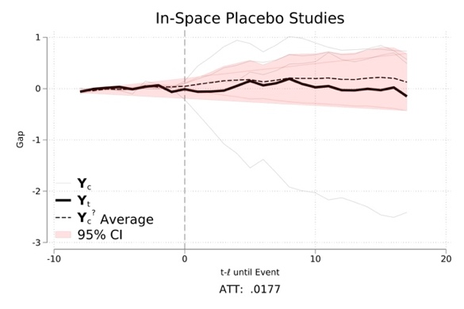 | 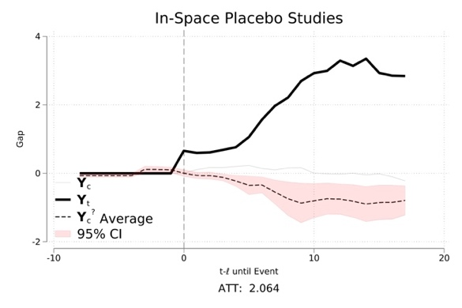
C: Digital trade to the US | D: Digital trade to adequate (excl. the US)
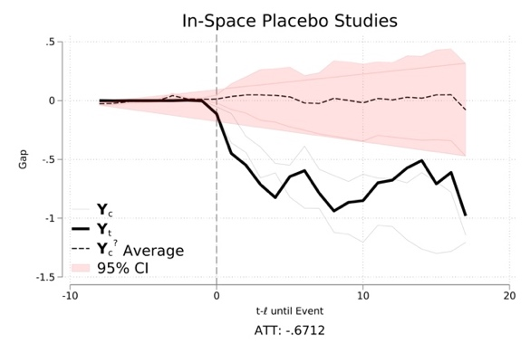 | 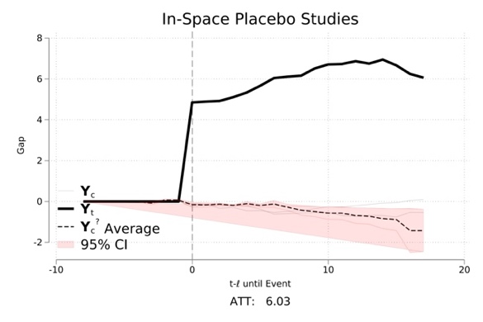
Note: Outcome variable is the narrow definition of digital trade as defined in Appendix Table A5.

Appendix Figure C2: in-space placebo synthetic control estimates for New Zealand
A: Total digital trade | B: Digital trade to adequate countries
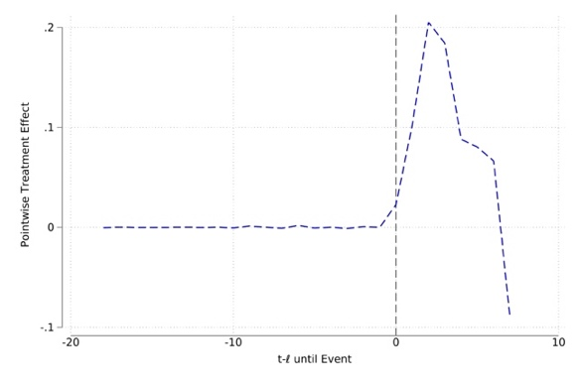 | 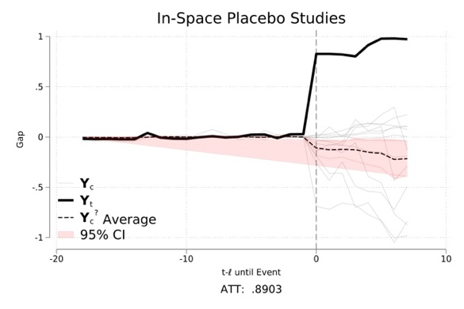
C: Digital trade to the US | D: Digital trade to adequate (excl. the US)
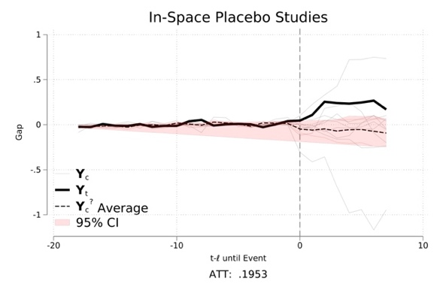 | 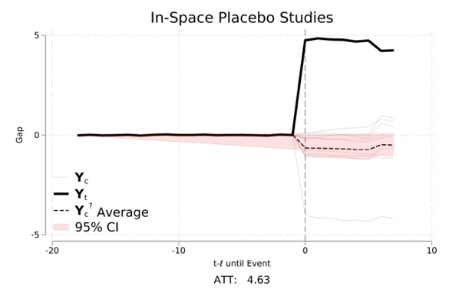
Note: Outcome variable is the narrow definition of digital trade as defined in Appendix Table A5.

Appendix Figure C3: in-space placebo synthetic control estimates for Israel
A: Total digital trade | B: Digital trade to adequate countries
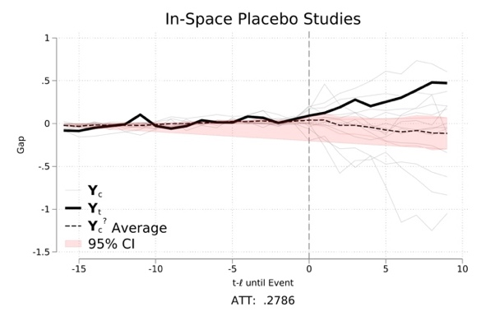 | 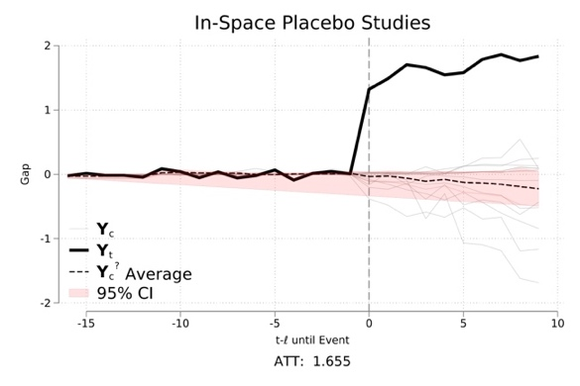
C: Digital trade to the US | D: Digital trade to adequate (excl. the US)
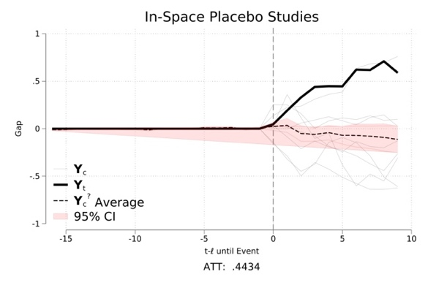 | 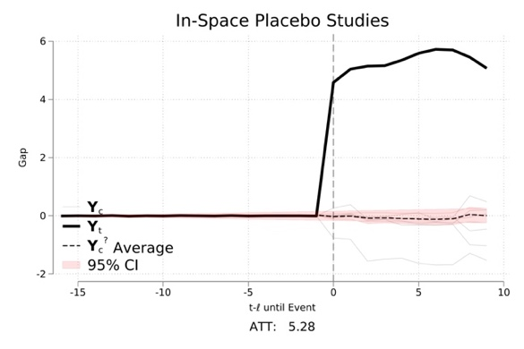
Note: Outcome variable is the narrow definition of digital trade as defined in Appendix Table A5.

Email addresses: Bernard.hoekman@eui.eu; Martina.Ferracane@eui.eu; Filippo.santi6@unibo.it; erik.vandermarel@ecipe.org. We are grateful to two reviewers, Ingo Borchert, Mira Burri, Elisabeth Christen, Paola Conconi, Mattia Di Ubaldo, Javier Lopez-Gonzelez, Peter Herman, Richard Kneller, Douglas Nelson, Hildegunn Nordås, Sarah Oliver, Hein Roelfsema, Maarja Saluste, Rohit Ticku, Jan Tscheke, Alan Winters and participants in workshops and seminars at the EUI, University of Florence, Ӧrebro University, USITC, University of Sussex and the 2024 International Political Economy Society conference for comments and suggestions on earlier drafts. Elena Sisto and Lars Vandelaar provided excellent research assistance. This work was supported by the Centre for Inclusive Trade Policy, Economic and Social Research Council (UK), grant number ES/W002434/1 and draws on a broader research programme supported by the European Research Council, grant no. 101142666-PIANO-ERC-2023-ADG (Hoekman).
Ferracane and van der Marel (2021) and Sun and Trefler (2023). Other studies assessing economic impacts of the GDPR focus on online outcomes or welfare rather than trade. Recent research in this vein includes Goldfarb and Trefler (2018), Goldberg et al. (2023) and Aridor et al. (2023).
EU Regulation on the Protection of Natural Persons with Regard to the Processing of Personal Data and on the Free Movement of Such Data (27 April 2016) Regulation (EU) 2016/679 (GDPR) and Repealing Directive 95/46/EC (repealed 24 May 2018) OJ L 119/1.
Frey and Presidente (2024) find that the GDPR reduces profits by about 8 percent and sales by 2 percent, driven by compliance costs for firms in handling European personal data.
See e.g. De Brito, Kauffmann, and Pelkmans (2016).
The network of EU adequacy decisions is an example of the type of discriminatory club analyzed by Davis (2023).
Adequacy decisions are determined by DG Justice, not DG Trade, which is much more insulated from trade-related business lobbying. The role of DG Justice and political (foreign policy) considerations in the process of according adequacy further reduces any endogeneity concerns.
As discussed below, adequacy decisions granted to the US are sui generis.
The European Economic Area comprises the EU countries plus Norway, Iceland, and Lichtenstein.
The GDPR only marginally changed the framework for personal data transfers compared to the 1995 Data Protection Directive, but it significantly raised the stakes of violating these rules by introducing fines up to 4% of the total worldwide annual turnover of an undertaking for the preceding financial year.
In addition to these contractual mechanisms, firms seeking to transfer EU personal data can also use certain derogations, such as the consent of the data subject for every cross-border transfer of personal data. These derogations are considered restrictive by the European Data Protection Board, especially for large-scale transfers of data (Saluste, 2021). Surveys have shown that both binding corporate rules and standard contractual clauses are widely used by European companies to transfer personal data abroad in the absence of an adequacy decision (Business Europe et al., 2020).
Firms trading services are typically smaller on average as shown by Bento and Restuccia (2021) and Breinlich and Criscuolo (2011).
GDPR, Art. 45.
The criteria for adequacy include “the overall political relationship with the third country in question, in particular with respect to the promotion of common values and shared objectives at international level.” European Commission (2017, p. 6).
CJEU, Case C-362/14, Maximillian Schrems v Data Protection Commissioner, ECLI:EU:C:2015:650 (Schrems I).
CJEU, C-311/18, Data Protection Commissioner v Facebook Ireland Ltd, Maximillian Schrems, ECLI:EU:C:2020:559 (Schrems II).
Our conceptualization of digital trade is discussed in Section 3.2.
A test of the equality of coefficients one year before and one year after adequacy rejects the null hypothesis (no difference between the two) with p-values of 0.0004 or smaller.
Gravity models for services trade have been developed by Anderson et al. (2018) and Reverdy (2023). Yotov (2024) discusses the current standard in gravity estimation.
The ITA eliminated tariffs on most ICT products. See Gnutzmann-Mkrtchyan and Henn (2018).
Since our interest is in examining the effect of adequacy on digital trade between the EU and specific partners granted adequacy, we do not include intra-EU digital trade. Moreover, including EU members as adequacy granted countries could bias our results as they are adequate by definition.
The specification in equation (1) captures the presence of fixed trade costs. Following Anderson (2011, p. 139), “[…] The iceberg metaphor still applies when allowing for a fixed cost, as if a chunk of the iceberg breaks off from the mother glacier. Mathematically, the generalized iceberg trade cost is linear in the volume shipped. […]”. Arkolakis et al. (2012) demonstrate how fixed trade costs can enter the trade cost function multiplicatively in models with monopolistic competition.
The selected set of fixed effects also controls for any changes in domestic data protection regulatory regimes, including possible changes that are implemented by a country to ensure convergence with EU norms.
ADQ and CLB effects will be reflected in $T_{ijkt}$ (Equation 1).
By construction, the four adequacy variables are dummies and are mutually exclusive within any given country dyad. Practically, this means that the four dummies will be assigned a value of one in the following bilateral country cases: (1) EU-ADQ; (2) ADQ-ADQ; (3) EU-US; (4) US-ADQ, where EU are EU members and ADQ are the adequacy-granted countries other than the U.S. In equation (5) case (1) is captured by the term ${RADQ}_{ijt}$; case (2) by ${RADQ Club}_{ijt}$, case (3) by $SH/PS_{ijt}$; and finally case (4) by $SH/P{S Club}_{ijt}$. For all other bilateral combinations in the four dummies will be set to zero.
This number is derived by taking the total number of times such words are mentioned in the purpose description divided by the total number of firms that are listed, i.e. (1,217/2,675) * 100 = 45.5 percent.
In the pooled gravity regressions, we use a measure of sectoral data intensity for all sectors $k= 1…K$, allowing for the possibility that non-digital industries may also be affected by an adequacy agreement.
Given the difficulty of estimating the volume of digitally delivered services, statistics on digital services trade include all services potentially deliverable, providing an upper-bound estimate of digitally delivered trade. Services related to goods trade such as transport, processing of physical inputs owned by others, maintenance and repair, travel, and construction are not included in the OECD-WTO-IMF-UN (2023) definition of digitally deliverable services as they are not provided over digital networks. They are therefore not part of our definition of digital sectors heavily reliant on cross-border data flows.
Other sources that record trade in services such as the International Trade and Production Database for Estimation (Borchert et al., 2022) and the OECD-WTO Balanced Trade in Services dataset do not distinguish between the digital services sectors that are part of our narrow definition.
This period enables us to incorporate most adequacy decisions, with the exception of the most recent decisions for Korea (2021) and the UK (2021). TiVA does not report trade data for Uruguay and the five micro-states of Guernsey, Isle of Man, Jersey, Andorra, and the Faroe Islands.
Since the latter dataset ends in 2019, we fill in missing information for 2020 using data from the WTO.
We only include binding provisions on data protection within a specific e-commerce chapter in a PTA. Even though some PTAs include data-related provisions for specific sectors outside an e-commerce chapter, we do not include them because data protection provisions outside a specific e-commerce chapter are less meaningful. Including them in our assessment may potentially bias our results. We thank Mia Burri for this insight.
The Data Protection Directive entered into force in 1998 for the EU15. For other European countries, it applied in 2004, 2007, or 2013, depending on the date of EU accession. The adoption of the GDPR in 2018 does not affect this control variable as both the Directive and Regulation cover a similar set of countries.
This Convention also includes an addendum called Convention 181 which covers transfers from Party to non-Party countries. Country membership in this Convention varies by year.
These rules have some similarity with the EU-US adequacy agreements in that companies voluntarily subscribe to it, but differs by relying on qualified Accountability Agents, recognized by the participating economies, which certify the policies and practices a company must comply with for data protection.
The controls discussed here are meant to reduce the bias arising from omitting relevant co-determinants of digital trade. Since their magnitude, sign and significance are consistent with the extant literature, we do not report the coefficients in the results tables. These are reported in Appendix B.
Of the control variables, only WTO membership is significant. See Appendix B.
In the baseline analysis, we apply a one-year gap between Safe Harbor and the Privacy Shield frameworks during which there was no data flow agreement between EU members and the US, i.e., the SH/PS dummy is set at zero for 2015. We do the same for the club variables.
The PTA-DP variable is mostly insignificant except when applying the lags of both 1 and 3 years. The lagged PTA-DP comes out significant when applying the lag of 2 and 3 years. Furthermore, regressions using the full PTA dummy do not change the significance of the coefficient results on our adequacy variable but generated a negative and insignificant coefficient sign. Results are available on request.
Baier and Bergstrand (2007) use the three-way fixed effects gravity model to estimate the impact of PTAs on trade.
This approach builds on a long-standing stream of research initiated by Rajan and Zingales (1998). See Ciccone and Papaioannou (2022) for a review of this literature.
Sectors of activity were manually concorded to the ISIC. If a firm's primary sector is not mentioned but sub-sector activities are reported, we use the latter for our analysis. Appendix Table A2 shows the top 10 sectors that rely most on the adequacy framework, covering about 95 percent of all firms.
The OECD inter-country input output tables report data for 44 sectors. We exclude agriculture and mining as well as utilities and construction, leaving 35 sectors.
This is akin to the shift-share approach commonly applied in the empirical economic literature. When the intensity measures are interacted with our adequacy and club effect dummies, the ‘shift’ component is represented by the adequacy and club effect, reflecting shifts that are common to all units, whereas the ‘share’ component are the exposure shares that vary across units (sectors in our case). Similar to analyses applying a shift-share approach, the latter component sums to one for each unit, i.e. across sectors for each country, and is therefore a weighted average. See Borusyak et al. (2024).
Note, however, that the first Transatlantic adequacy framework (Safe Harbor) was applied in 2000, which leaves one year of identification for our lead variable. Moreover, the negative effect may be driven by the drop in digital exports following the repeal of this arrangement in 2015, which was followed by a recovery in the following year with the adoption of the Privacy Shield framework.
This effect is computed similarly by taking the expected value of the estimated coefficients.
Hollingsworth and Wing (2022) summarize the set of “pseudo-identifying” assumptions and identify a series of threats to the validity of estimates. The assumptions are: (i) no spillover effects (or, no interference between units); (ii) Factor Structure Model (performance of unexposed countries is driven by a set of common factors that vary over time but is constant across countries); (iii) performance of unexposed units is allowed to vary from each other due to an idiosyncratic exogenous shock; (iv) no pre-period perfect multicollinearity of common factors; and (v) existence of weights such that a synthetic counterfactual exists. The five assumptions ensure that a synthetic counterfactual can be constructed and used for causal inference. Assumption (i) hinges on the process leading to an adequacy decision, in particular on the fact that Adequacy in practice is largely independent of a country’s domestic data protection policy. The prospect of obtaining Adequacy is not necessarily enhanced because a country adopts a GDPR compliant regulation – as noted, many countries that have adopted the GDPR have not been granted adequacy, while the US, which does not have a GDPR-type regulation has been accorded adequacy. Thus, the positive effect of adequacy on a country’s digital trade might trigger the emulation of its trading partners, but their policy changes would not allow a country with adequacy to freely transfer data across borders. Thus, adequacy is unlikely to affect the opportunities of other countries that could be considered as potential controls in the period considered to obtain adequacy themselves. Assumption (v) holds because we were able to generate a synthetic counterfactual, implying the existence of the weights. The remaining assumptions rely on unobserved factors, but the restrictions imposed on the donor pool for the three case studies provide confidence that all control units respect all three assumptions. See Abadie (2021) for discussion of threats to validity in a synthetic control setting.
This reflects the rapid growth of companies such as MercadoLibre, which has become the largest on-line e-commerce platform in Latin America and has developed a variety of payment services to complement its e-commerce activities.
Uruguay, the other Latin American country with EU adequacy, is not included in the TiVA database.
Trade in services is sensitive to time zones as shown by Head et al. (2009).
We consider $s=0,…,n$ countries, where $s=0$ is the treated country and$s=1, ..,n$ the donor pool.
Due to its geographic remoteness from the EU, South Africa is included in the donor pool in the New Zealand case. Being part of the donor pool does not automatically imply that a country is part of the synthetic control. See e.g. Abadie (2005) for a discussion on this issue.
Abadie (2021) shows that the synthetic control estimator is biased, although bounded and decreasing provided the underlying identifying assumptions are valid. As noted, the set of identifying assumptions hold in both our exercises, although the pre-adequacy period for the Argentina case is relatively short.
Results do not change if we consider digital trade with all countries except the US.
For a clearer comparison, all the estimated ATTs for the three case studies are also reported in Appendix Table C1, where the same exercise is replicated considering a broader definition of trade.

