Incentives and sustainability: myths and realities about ESG metrics in CEOs’ compensation in the main EU economies

Federico Fornasari e Nicolò Galasso

Abstract
Executives remuneration, as one of the main corporate governance levers, could not go unscathed from the ESG debate. While detractors have decried the risks of ESG-linked variable remuneration, others have argued in favour of this policy. Our paper takes a comparative look to the diffusion of ESG-linked remuneration in the main EU economies (France, Germany, Italy and Spain) between 2018 and 2022 and delves in a novel and rich empirical dataset about remuneration practices and economic performance. We do not find any negative economic result for companies introducing ESG linked remuneration, but also we do not find culprits that this governance mechanism is effective in ensuring the rebalancing of power that the supporters of sustainability in corporate governance hope for. Whereas we discard scaremongering about the effect of ESG on companies’ financial performance, we also cast a sober light about its prospect for meaningfully enhancing sustainability. To achieve meaningful results beyond what it is also value enhancing or neutral, the corporate governance toolbox should be expanded and go beyond mere incentives.

Summary
1. Introduction 1
2. Theory and the purpose of CEOs compensation 4
3. Between hard and soft law: CEO’s remuneration in Europe 6
3.1. The 2004-5 recommendations: agency costs and the focus on process 7
3.2. The 2009 recommendations: financial stability, long-term horizons and the focus on structure 8
3.3. 2017: Shareholder Rights Directive II and national implementation 12
4. The Copernican revolution of ESG-based remuneration 17
4.1. Measures of total CEOs pay in 2022 18
4.2. The scope of ESG variable pay 19
4.3. How ESG metrics are designed 21
4.4. Which issues are tackled by ESG remuneration? 23
4.5. Short term and long term ESG incentives 25
4.6. Rate of achievement 27
4.7. ESG-based pay and corporate performance 28
4.8. Main findings 29
5. Why have ESG metrics in CEOs pay become so widespread? 30
6. The economic and sustainability effects of CEOs ESG pay 31
7. The unfulfilled promises of sustainability governance without stakeholders 33
8. Conclusion 35
Appendix 36

1. Introduction

CEO compensation is one of the most discussed issues in corporate governance, because of its importance on firm performance, and because of its macroeconomic impact, as it influences investment, employment, innovation and inequality. Many studies have been put forward to analyse both the causes of the rise of CEOs’ compensations over the last decades, and the effects that the structure and composition of CEOs pay has on firm performance, both from an economic and a financial point of view.
As a powerful incentivizing tool, performance based compensation has been a strong factor in influencing the shareholder value turn in corporate governance praxis and theory, but has also been at the centre of most recent debates: particularly following the 2007-2008 financial crisis, the short term effects of certain corporate governance arrangements have been questioned as potentially harming long term performance and macroeconomic variables. Moreover, incentives schemes at financial institutions have been deemed fuelling risk appetite which has contributed to create systemic weaknesses in the financial system. Finally, in the most recent years, the debate on CSR has morphed in a debate on the relevance of environmental, social and governance factors (hereinafter, ESG) on the performance of the firm and on the necessity of enrolling corporate governance as an instrument to promote sustainability along the production process: CEOs pay has not gone unscathed.
Within this broader context, some scholars argued that as CEOs pay structure contributed to the shareholder value maximization turn, the same mechanisms could be harnessed to foster firms’ performance along metrics other than shares price. The integration of ESG factors within executives remuneration packages has been called upon also by institutional investors and directive proposals by the EU Commission.
Both shareholders rights directive II and corporate governance codes in France, Germany Italy and Spain have actually suggested the consideration of ESG factors in designing CEOs remuneration packages, while the largest corporations in the main EU economies have actually introduced ESG metrics in CEOs remuneration, linking a part of the pay to social and environmental performance (e.g., CO2 emission targets, employee satisfaction, compliance with ethical standards in developing countries). Therefore, ESG factors have become extremely widespread as part of CEOs variable remuneration.
While some studies have analysed the structure of ESG executive compensation, there is still little evidence on the effect of this compensation on actual ESG performance: as ESG voluntary and regulatory actions have increased in the last years, it is extremely difficult to isolate and study the causal effects of ESG incentivization schemes on actual ESG performance; moreover, assessing ESG performance per se is complex because of the lack of data. The few studies which have attempted found diverging effects: some studies found an improvement in ESG factors, whereas others assessed that this pay structure does not boost sustainability.
The effects of ESG linked remuneration on firm financial performance is debated too. A recent study considering thirty countries, for example, has found that CSR compensation foster firm innovation and therefore economic performance, whilst another cross-country study found that this is not the case.
Whilst these differing views reflect the lack of consensus on the link between ESG factors and financial performance, these studies are not specifically targeted on EU countries and are based on remuneration practices as they stood around in the first 20 years of the 2000s’. However, the policy and practice around ESG and corporate law has changed since then.
This paper delves into the structure of CEO ESG remuneration across the main EU economies, relying on a richer dataset than previous studies, as we investigate remuneration policies, remuneration reports, and economic performance data. Whilst other papers have done so with regard to the US, the UK or the largest EU corporations, our study take a comparative look at France, Germany, Italy and Spain, analysing the largest companies of these countries and how the CEOs remuneration practices have evolved. This approach allows us to map the evolution of directors’ compensation regulation and to describe the emergence of ESG linked pay packages. Our empirical analysis shows that the turn to ESG has been common amongst EU countries, pushed by a change in regulation, codes of corporate governance and attitude by shareholders. The depth of the collected data and the analysis of both the remuneration policy and the remuneration report allow us to cast a more accurate depiction of CEOs ESG remuneration packages. Moreover, we collect firm-level evidence on how the introduction of ESG-linked pay influence firms’ performance along the main economic variables.
The rich empirical dataset and the comparative perspective of the analysis cast a different light on the reasons for the emergence of ESG-linked executive pay, elucidate the effects of ESG-linked remuneration on corporate economic performance, and clarify the relationship between this corporate governance tool and sustainability. As our findings differ from previous studies, different policy considerations ensue.

2. Theory and the purpose of CEOs compensation

In order to better understand ESG-linked CEO pay, it is indispensable to sketch the context of CEOs pay within which the broader debate has developed. First, because some of the same instruments which have been used to address agency costs are similar to those which are suggested to foster sustainability. Second, because the introduction of ESG metrics in CEOs pay interacts with other purposes of CEOs pay.
Whilst theories of optimal remuneration models look at CEOs pay setting as a function of CEO value to the company, limited by a participation constraint and incentive compatibility constraint, law and economics models look at CEOs pay through the lenses of agency costs. Whilst financial economics theory has a powerful explanatory power on how corporations set or should set the pay, law and economics models have been extremely influential, because they point to market failures which might be addressed by regulation.
On the one side, corporate governance models look at CEOs compensation as a way to align management and shareholders incentive in order to maximize shareholders value. Whilst this mechanism is particularly effective in making CEOs attentive to share prices, this has also created distorsions as it has incentivized short-termism, excessive risk taking and has increased inequality. In order to address at least the short-termism and excessive risk-taking issues, incentive packages could be structured to include long term variables. Where a controlling shareholder exists, tying CEOs remuneration to the performance of the stock is a way to address also the minority/majority shareholders conflict.
CEO pay might be seen as a fruit of agency cost in itself. When shareholders are dispersed, CEOs can take advantage of captured board to award themselves a suboptimal pay. When the company has a controlling shareholder, putting aside information asymmetries, shareholders might theoretically better monitor the decision on CEO’s pay, but an agency conflict arise when the CEO is the controlling shareholder itself or a person close to her.
Whereas the models help to normatively analyse the best structure of CEOs pay, they do not perfectly fit the reality of CEOs compensation packages. Surveys enrich both optimal contracting and corporate governance theories of executive pay, which underestimate or not take into account very important characteristics of the pay setting process. Whilst the results of surveys are context specific, a very recent and extensive one has shown that directors (serving in committees setting CEO’s pay) and investors have different opinions on the objectives and constraints when they set executives pay: whilst board members think that attracting the best CEO is paramount (although they probably overestimate the consequences on hiring and retention of not being able to offer the pay package they deem optimal), investors are more focused on incentivising the future CEOs. However, both investors and directors seem to consider that the main incentives for CEOs do not come from the utility they might derive from a higher pay, but rather from intrinsic motivation and personal reputation. Attaining performance targets therefore acts as a form of ex post recognition for performance. The extension of these results to countries with concentrated ownership should be taken with a pinch of salt, particularly when the CEO comes from the controlling shareholder family. However, these results broaden our understanding of the CEO pay structure, both from a positive (descriptive) and from a normative point of view; they are also important because they concur to explain part of our empirical findings.
In order to address the market failures arising from the pay setting process European policymakers have acted upon both the structure of the remuneration and the process to set it. With regard to structure, pay practices have been modified in order to include a variable part to incentivize executives and SHRD II tries to promote a more long-term approach to remuneration. With regard to the process, independent directors and shareholders have been empowered by different EU Commission communication, SHRD II and corporate governance codes in order to address the agency costs arising from the pay in itself and to enhance the chances of an optimal pay setting process.
Within that broader picture, the praxis, debate and regulation on CEOs pay has evolved in the last ten years to take into account the fact that corporations have an outsized environmental and social impact and that their international operations, often structured along value chains, are complex to discipline through law. However, as they can create damages, they also might be enrolled in fostering the green transition and tackling some of the social and human rights violations which happen in the production process and the provision of services. In particular, firms might be interested in two kinds of ESG practices. First, some of these ESG inspired business operations might be a win-win situation, when pursuing a more sustainable practice also improves financial and economic performance. Second, some of these ESG practices might go beyond what is value enhancing for the firms and be aimed expressly at addressing pressing social or environmental issues.
The difference between these two conducts might be blurred at times, specifically when a strategic redirection of corporate activities might bear fruits in the medium to long term, but not in the short term. Particularly with regard to the green transition, radical uncertainty surrounds the returns for firms reducing their carbon footprint also because the future path of regulation. Moreover, ESG practices might provide firms with a competitive edge on the labour, product and financial markets: these potential competitive advantages might make more ESG conduct value enhancing in spite of its effect on business organization.
Since executive compensation is a powerful tool to steer corporate actions in a specific direction, providing that a slice of variable pay (both short term and long term) is linked to specific ESG metrics could correct corporations’ action and foster the turn to a more sustainable economy. Some authors have therefore suggested to link at least part of the pay to ESG factors, while critics have argued that it risks increasing agency costs without fostering sustainability due to market failures in designing efficient ESG pay packages. At least in the EU, regulatory actions has accompanies policy discussions. The next paragraph assesses the rules about CEOs remuneration at the EU and national level in order to understand how the process to establish the CEOs pay is regulated in France, Germany, Italy, and Spain.

3. Between hard and soft law: CEO’s remuneration in Europe

In recent years, within corporate governance practices concerning the compensation of CEOs, there is a rising trend to integrate, alongside traditional quantitative financial objectives, a remuneration component tied to the achievement of non-financial parameters associated with ESG factors.
This phenomenon appears to be the result of two heterogeneous forces: on one hand, the increasing attention of businesses and the European Union to environmental and social issues related to the concept of sustainable development of corporations; on the other hand, an intensification of hard and soft law regulations at the national level, especially by corporate governance codes for listed companies.
With regard to the first element, anchoring CEOs’ remuneration to the parameter of corporate sustainability is, at least in part, the result of a long-lasting interest of the European legislator into the remuneration of the board of listed companies due to the strategic role that the management board’s remuneration plays in realigning the interests of directors with those of the company. However, recent regulatory developments seem to further amplify the importance of the discipline. According to this view, executives’ remuneration is not limited to being merely an instrument to reduce agency costs that arise between shareholders and executives; it also becomes a functional tool to ensure the pursuit of a plurality of interests among different categories of stakeholders. Since the early twenty-first century, indeed, the idea of the primacy of shareholders’ interests has encountered significant challenges, especially in the most recent years. Shifting societal values regarding the role of corporations and increased scrutiny of their societal impact have posed difficult questions about the optimal design of pay-based incentives and conventional executive compensation practices. In response to these changes, a new trend has emerged in incentive structures that consider the interests of a wider array of stakeholders, rather than solely concentrating on shareholder value creation.
To better understand the incorporation of ESG parameters into board remuneration, it is therefore appropriate to briefly describe the evolution of the European regulatory framework concerning executive compensation in general.

3.1. The 2004-5 recommendations: agency costs and the focus on process

The European Union’s initial involvement in directors’ remuneration dates back to a Commission recommendation in December 2004. In this recommendation, the European institution recognized that the form, structure, and level of administrator compensation fall within the company’s competence; however, it also cautioned against potential conflicts of interest between shareholders and directors inherent in the matter. Consequently, there was a recognized need to intervene to ensure transparency on board of directors’ remuneration. Just a few months later, the Commission intervened again with another recommendation, emphasizing transparency in remuneration determination, reiterating the necessity of a periodical report on the boards’ compensation and proposing the establishment of a remuneration committee within the board.
The two recommendations from 2004 and 2005 represent the first attempt by European institutions to intervene on the topic. These documents, however, do not delve into the pay structure. They do not provide, indeed, specific suggestion on how executive should be paid, but they rather focus on regulating governance rules aimed at ensuring alignment between shareholders’ interests and those of directors. These recommendations avoided adopting a “one size fits all” solution, but they certainly constituted a step forward in promoting convergence of practices among different Member States and they enhanced transparency in the remuneration, or at least in the remuneration governance and in the process leading to executive pay determination.
However, it is worth noting that these are non-binding recommendations that required regulatory implementation by the Member States. As highlighted in a Commission report, only a small number of Member States have implemented the recommendations that called for the introduction of shareholder voting on executive remuneration.

3.2. The 2009 recommendations: financial stability, long-term horizons and the focus on structure

The turning point in the European context was the 2008 financial crisis, as regulators and policymakers alike have been compelled to confront the intricate interplay between executive incentives, risk-taking behavior, and financial stability in its aftermath.
This historical event redefined the way regulators look at executive compensation. While previous recommendations primarily aimed to realign the interests of shareholders with those of executives, since the 2008 financial crisis, there has been a perceived need to counteract excessive risk-taking by executives.
International regulators too have highlighted a close correlation between uncontrolled increases in executive pay and the outbreak of the crisis. For instance, the Financial Stability Forum identified the short-term “perverse incentive” mechanism underlying executive compensation as one of the causes leading CEOs to take excessive risks, jeopardizing the stability of the global financial system as a whole. Due to this strict correlation between systemic crisis and executive compensation, executive remuneration had to be addressed to answer the the financial crisis both at a political (G20) and a technical (FSB) level.
In this context, the European Union has aligned itself with what has emerged on the international scene. The Larosière Report has recognized short-term variable remunerations in executive pay as one of the causes of the crisis, and the EU has intervened on this point by transposing the suggestion that have been elaborated in the international fora.
The topic entered the Commission agenda in March 2009, with the publication of two recommendations. With such documents, the Commission acknowledged that the massive diffusion among listed companies of executive remuneration systems excessively focused on rewarding short-term results have contributed to creating a strong incentive for CEOs to pursue risky activities to increase short-term profits, while exposing companies to greater risks to their long-term stability.
While the Commission recognized that executive compensation remains a matter within the purview of companies and specifically of their shareholders, it highlighted the need to provide additional principles beyond those developed in the recommendations of 2004-2005 to regulate the structure of the directors’ compensation. In that context, the European institution considered an appropriate solution to suggest a reform of executive pay structure, given that CEOs compensation was regarded by legal and economic literature as an effective tool for managing risks arising from the separation of ownership and control in listed companies.
Recommendation 2009/385/EC focused specifically on the need to impose limits on variable remuneration, requiring it to be based on predetermined and measurable criteria. The objective, following the financial crisis, was to ensure the long-term sustainability of companies, given that opportunistic behavior by executives in the years leading up to the crisis jeopardized long-term viability by prioritizing short-term profit to boost their own earnings.
With regard to the financial sector, the second recommendation of 2009 intervened more stringently on this point, stating that executive remuneration policies should promote sound and prudent risk management over a long-term horizon, rather than a short-term one. In this regard, the recommendation for the financial sector specifically called for operators to strike a fair balance between fixed and variable components of remuneration. This Commission provision appeared to be a response to public pressure for CEO pay to be not only long-term oriented but also fair, with criticism directed towards excessively high remunerations. The heightened interest of the European Union in the financial sector was evident: as the primary cause of the 2008 crisis, there was a perceived need to provide a more stringent response to a sector that found itself at the center of the storm, imposing more restrictive constraints compared to publicly traded companies operating in other sectors.
In this perspective, the Commission recommendations also called for the introduction of deferred payments (with reference to shares) and claw-back clauses into remuneration policies, allowing for the potential recovery of any unjustly received amounts by executives. For the same reason, the Commission also requested a constraint on termination payments.
One of the major concerns identified by the Commission relates to weaknesses in disclosure practices. Recommendation 385/2009 established that, in addition to information on remuneration policies to be disclosed as suggested by the 2004 recommendation, the remuneration statement should also include, among other things, details on how the choice of performance criteria contributes to the long-term interests of the company and an explanation of the methods used to determine whether performance criteria have been met.
The recommendations of 2009 represented a significant step forward compared to the ones published in the 2004-2005 biennium. For the first time, they delve into the structure of CEO remuneration, providing a set of guidelines that no longer only address procedural aspects and methods of determining pay, but specifically regulate content, attempting to place constraints on the widespread trend of excessive CEOs pays. Moreover, they established, for the first time, a link between remuneration and company performance, shifting the evaluation focus from the short to the long-term.

3.3. 2017: Shareholder Rights Directive II and national implementation

The two texts issued in April 2009, however, constitute non-binding recommendations. For the first legislative intervention regarding remunerations of directors of listed companies it was not until 2017 with the promulgation of the Shareholder Rights Directive II (SHRD II).
The SHRD II represents, to some extent, the culmination of a complex and articulated journey that has been briefly summarized in these few pages, and whose starting point can conventionally be traced back to Recommendation 2004/913/EC. In fact, the directive aligns with previous recommendations published by the Commission, envisaging transparency obligations concerning executive remuneration on one hand and intervening in pay structure on the other, thereby encouraging long-term sustainability.
By amending Directive 2007/36/EC (SHRD) regarding the promotion of long-term shareholder engagement, the new directive enriched, in terms of transparency, what was previously stipulated by other European sources, since that it requires companies to develop a clear, understandable, and comprehensive policy on executive remuneration. What is particularly innovative are the provisions regarding the shareholders powers on directors’ remuneration (process) and the content of remuneration policies (structure), as SHRD II now outlines remuneration policy as an element contributing to corporate strategy and to the pursuit of long-term interests and company sustainability. On one hand, the European legislator aims for greater shareholder involvement in determining executive pay, introducing the “say on pay” mechanism. On the other hand, the European Union delves into specific criteria for structuring pay, establishing that executive remuneration should contribute to the company’s business strategy and long-term interests and sustainability.
With regard to the process, the general idea behind SHRD II was that shareholders had to be empowered, thus making directors more accountable. This empowerment should ensure that the remuneration incentivizes directors to pursue value enhancing choices and that the risk of agency costs in setting the remuneration itself are minimized. In this light, effective and efficient shareholder engagement is viewed by the European Union as a corporate governance tool that counterbalances the pervasive powers of the board within the complex system of checks and balances among different bodies of listed companies. Moreover, shareholders are s considered as efficient steward for long term success of the company and sustainability. Increased shareholder activism is believed to contribute not only to improvement of financial performance but also of non-financial performance related to environmental, social and governance factors, probably due to the growing number of institutional investors and asset managers which have adhered to the idea the ESG factors are financially relevant.
The SHRD II follows in the footsteps of the Commission previous recommendation dating back to December 2004, where the introduction of “say on pay” was suggested for the first time. Over thirteen years later, the SHRD II imposes on Member States to implement a dual general meeting vote on executive pay. Shareholders are granted the right to vote on both the remuneration policy and the remuneration report. The remuneration policy is a document where the board outlines future policies regarding remuneration and describes how and according to what criteria directors will be paid in the coming years. It provides detailed information on the variable and fixed components of remuneration and the financial and non-financial criteria used to determine the variable component. On the other hand, the remuneration report is a document that looks at the past and describes how the remuneration policy was implemented in the previous fiscal year. It provides data on the remuneration earned by the directors in the previous year.
The directive entails a binding vote by the general meeting on the remuneration policy and a purely advisory one on the remuneration report, but in this case the company must explain in the subsequent remuneration report how the general meeting’s vote has been taken into account. Additionally, the directive allows Member States to deviate from the binding vote on the remuneration policy, providing for an advisory vote instead. “Say on pay” votes represent a powerful tool, at least theoretically, for the shareholders in order to align executives incentives and, potentially, encourage more responsible business practices addressing major global issues such as climate change and social and economic inequalities.
All of the countries considered in this study have provided for a binding vote on the remuneration policy and a merely advisory vote on the remuneration report.
Not only the approval of CEOs’ remuneration is set in a similar way across the considered countries, but also its elaboration. In general, the board of directors is entrusted with the duty to elaborate a remuneration policy; instead in Germany, this task is performed by the supervisory body. Boards of directors are coadiuvated by a remuneration committee, composed of non-executive, mostly independent directors.
Therefore, the process for setting executives remuneration is similar in the countries considered (with some differences in Germany due to the dual-board system). The board of directors, with the help of a specific remuneration committee, elaborates the remuneration policy and a remuneration report. Shareholders are entrusted a binding vote on the remuneration policy and an advisory one on the report. Shareholders are therefore well protected from directors opportunism, while minority shareholders should be protected by the participation of independent directors to the process. However, no participation or advice from representatives of stakeholders interests (of course, with the notable exception of Germany, and partially France) is directly envisioned.
However, SHRD II and national corporate governance codes did not innovate solely with the process of setting executives remuneration, but also with its structure and its purposes.
With regard to the structure of the remuneration, SHRD II represents a significant step forward compared to previous recommendation of the Commission as it links shareholder engagement in the determination of executive pay with the pursuit not only of long-term company objectives but also of sustainability goals. SHRD II indeed provides that the remuneration should contribute to the company’s sustainability and that when variable pay is awarded the company should “indicate the financial and nonfinancial performance criteria, including, where appropriate, criteria relating to corporate social responsibility”. Despite the explicit reference to the need for remuneration policy to contribute to the pursuit of long-term company interests and sustainability is innovative, serious doubts about its prescriptive force exist given the breadth of meaning and the vagueness of the terms used.
The concept of sustainability enshrined in SHRD II is different from that of the previous Commission communications. The concept of sustainability takes on an autonomous and distinct meaning from the long-term objectives of the company. When comparing the directive with Recommendation 2009/385/EC, it becomes clear that the concept of corporate sustainability is no longer interchangeable with that of long-term sustainability as outlined in the Commission document. While the Commission recommendation suggested the inclusion of non-financial parameters in executive pay, such as regulatory compliance, the use of such parameters was instrumental in ensuring the long-term viability of the company. For example, with regulatory compliance, the objective was evidently to avoid legal and reputational risks and ensure the long-term success of the company. The concept of sustainability outlined in the SHRD II, instead, constitutes an autonomous objective that diverges from long-term sustainability and stands as the ideal endpoint of a complex normative evolution that has come to view executive pay as a tool to align the interests of directors not only with those of shareholders but also with those of stakeholders.
National legislations implementing the directive take into consideration the sustainability of the company as an autonomous legal concept separate from the long-term viability of the firm. The implementing laws of all the Member States analyzed in this study reflect the novel role of executive remuneration, especially variable remuneration, in fostering not only the financial success of the firm, but also its long-term viability and sustainability.
Apart from national regulations, in recent years also the corporate governance codes of all of the countries we analyze have provided for directors’ remuneration to enhance the sustainability of companies. This is the case with the Italian Corporate Governance Code, which was reformed in 2020 to introduce such a provision. Even more significant is the example of the French corporate governance code, which since 2018 has recommended the use of criteria related to social and environmental sustainability in executive pay determination. The German and Spanish corporate governance codes also contain similar provisions. As will be seen in the following paragraphs, the adoption of such specific provisions in the national corporate governance codes has significantly contributed, along with the previously described regulatory changes at EU level, to shifting the behavior of listed companies in these countries, pushing them to integrate ESG factors into executive pay.
The significant persuasive power of corporate governance codes lies in the comply-or-explain mechanism that characterizes these regulatory sources. Although corporate governance codes do not have regulatory force, they end up having a highly conforming power given the comply-or-explain mechanism to which companies generally must abide by to list on major stock exchanges. Essentially, this regulatory framework requires companies to either comply with the best practices outlined in the Code or explain any deviations. This obligation to explain non-compliance creates both a legal and social imperative for companies to develop and disclose best practice procedures. Furthermore, corporate governance codes stipulate that adherence must be comprehensive, covering all its rules, with any deviations from specific recommendations needing to be justified, including the reasons, sources, timing, and alternative measures adopted.
Apart from the complain or explain mechanism, corporate governance codes are extremely influential also because they shape institutional investors preferences and proxy advisers recommendations. For example, if corporate governance codes prioritize stakeholder protection, best practice recommendations to include non-financial ESG targets in executive compensation can swiftly change local firms’ pay practices by guiding investor voting and engagement.
In conclusion, a complex regulatory framework has emerged, where CEO remuneration is no longer solely tied to financial factors and the concept of shareholder value maximization but is seen as a tool to pursue the sustainability of the company abd interests other than those of shareholders, recognizing legal significance to specific categories of stakeholders. However, the enforcement of such constellation of purposes remains confined to shareholders which should ensure the viability of the company in the long term, from a perspective that encompasses not only economic aspects but also environmental and social sustainability.

4. The Copernican revolution of ESG-based remuneration

Whilst the empirical studies reviewed above have shed light on ESG linked remuneration in several countries, they present some shortcomings which we try to tackle below. First, we aim to provide a diachronic depiction of how ESG remuneration has evolved during the last five years. This depiction is very important in order to assess how fast the integration of ESG metrics in remuneration has spread out and how its structure has changed. Second, our point of view is comparative: as we have analysed from a European and comparative point of view the regulation dealing with ESG linked remuneration, the comparative outlook allows to assess whether there are divergent national tendencies despite the similarity of regulation and considering the different corporate governance regimes. Finally, we analyse comprehensively the structure of ESG related pay, also taking into account the success rate in achieving performance targets and are therefore able to provide a complete picture of the phenomenon: we describe the number and topics covered by ESG metrics, their weights in total remuneration and the attainment level. That broad based discussion is essential to fully assess theoretically the reasons and implications of ESG related pay and to provide effective policy prescriptions.
Regarding the sample analyzed, we specifically considered companies that are part of the major stock market indices (DAX40, CAC40, FTSE/MIB, IBEX 35) of the countries that represent the largest European economies. This selection allows us to cover a significant number of firms across different markets and sectors, thereby ensuring that our findings are representative of the European corporate landscape.
With respect to the choice of fiscal years examined, we deliberately chose the year 2018 because it represents the last year before the full implementation of the Shareholder Rights Directive II (SHRD II). Furthermore, in 2018, corporate governance codes did not yet include references to the integration of ESG factors into CEO remuneration policies. This, consequently, provides a clear baseline to assess the state of corporate governance and executive compensation practices prior to these regulatory and policy changes. Conversely, we examined the year 2022 because, at the time of this analysis, it was the most recent fiscal year for which remuneration reports had been published. By analyzing data from 2022, we are able to evaluate the impact of SHRD II and the subsequent inclusion of ESG factors in executive compensation policies, thus identifying significant changes and trends in corporate governance and executive remuneration practices. This approach not only enables us to assess the influence of regulatory developments and evolving best practices on the behavior of major companies in Europe’s largest economies but also helps to draw comprehensive conclusions about the overall direction of executive compensation in this context.

4.1. Measures of total CEOs pay in 2022

Before analysing ESG factors in CEOs compensation, it is useful to provide some data about CEOs remuneration in general in the countries we consider. Indeed, that is essential as ESG remuneration is just a small fraction of total remuneration, the understanding of which is crucial to describe and to put forward policy proposals.
Fixed remuneration on average is strikingly similar amongst our four countries, varying between eur 2,2 and 2,6 million. On the contrary, when we look at the total potential remuneration, which involves both short and long term incentives, the countries are more different, with Spain on the lower end side and Germany on the higher end. Therefore, the main element which differentiates the remuneration in the four countries is the variable part.
However, the differences in the average variable remuneration are mainly driven by the different sectors where firms operate and their different dimensions: when we compare similar firms in the four countries, the average remuneration (both fixed and total potential) is strikingly similar. This is probably driven by the fact that, as found by surveys, competitors are generally used as benchmarks for setting executives pay.

Table xy – total CEOs remuneration in 2022
 | Italy | Spain | France | Germany
Fix remuneration | 2,43 | 2,44 | 2,21 | 2,59
Short term | 1,01 | 0,90 | 1,5 | 1,37
Long term | 1,25 | 0,63 | 1,39 | 2,42
Total (potential) remuneration – both short and long term | 4,68 | 3,97 | 5,10 | 6,39

Despite being on average very similar, we find that how remuneration is distributed changes a lot according to countries. Italy presents the wider dispersion, both for fixed and total potential remuneration, whereas France and Spain presents less dispersion with regard to total potential remuneration.

Fixed remuneration | Total (potential) remuneration
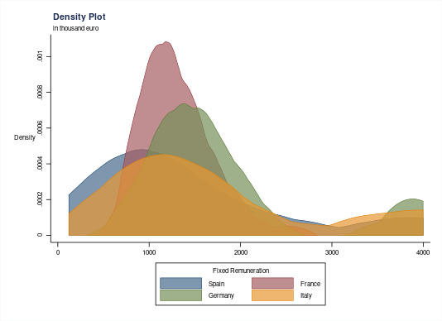 | 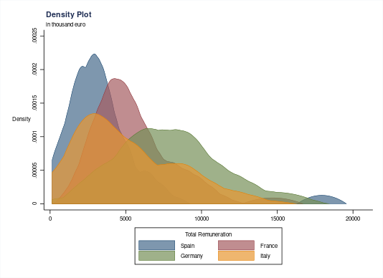

4.2. The scope of ESG variable pay

From the data analysis, a correlation emerges between regulatory amendments and the inclusion of ESG factors in CEO remuneration policies. In fact, ESG remuneration almost underwent a Copernican revolution between 2018 and 2022. Indeed, in 2018, only a minor fraction of companies, around 25%, included ESG performance as a factor in the variable pay for their CEOs. Fast forward to 2022, and the world has completely changed. The vast majority of the companies (approximately 90%) considered in the study provide for part of the remuneration linked to ESG metrics, despite some differences exist within countries: in France almost all companies provide for ESG metrics, while in Italy, Germany and Spain a bit more than 80% of the companies do (fig. xy, panel a).
Not only the number of companies which provide for ESG metrics has increased a lot between 2018 and 2022, but also the average number of metrics along which CEOs are assessed, which stood around 2,5 metrics per company. However, some heterogeneity between countries exist: France provides for more than 3 metrics per company, while Germany provided for less metrics than any other country (fig. xy panel b). The number of metrics is relevant, because it is an indicator of how comprehensive with regard to sustainability issues CEOs remuneration is.

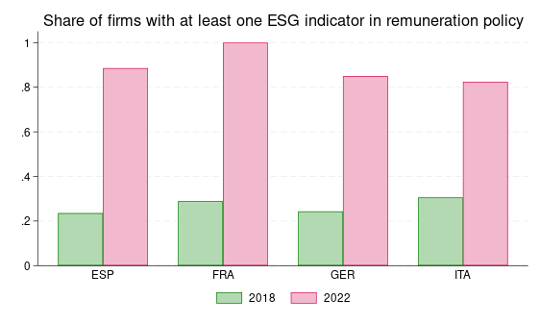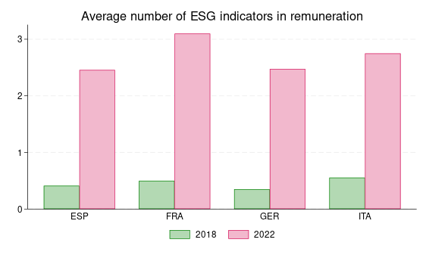

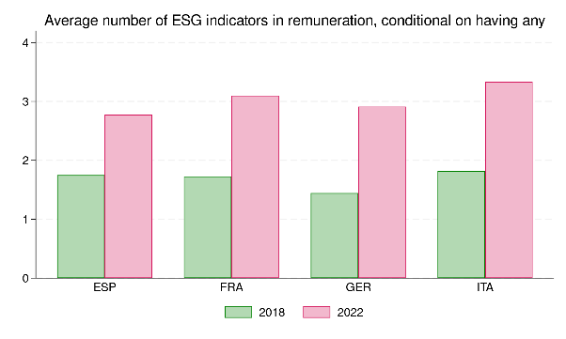

Also when turning to the provision of ESG metrics by sector of activity, rather than by country, in 2022 there is a substantial homogeneity: only companies in the basic material sector stands out, where around 70% of the companies has inserted ESG factors in CEOs remuneration (fig. xy, panel a). There is also a striking similarity between sectors when we consider the number of metrics provided for in 2022: also in this case, the only sector apart from the other is the basic materials one, which has less than 2 metrics (fig. xy, panel b).

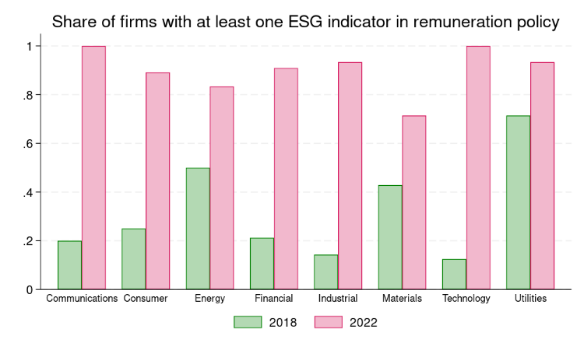

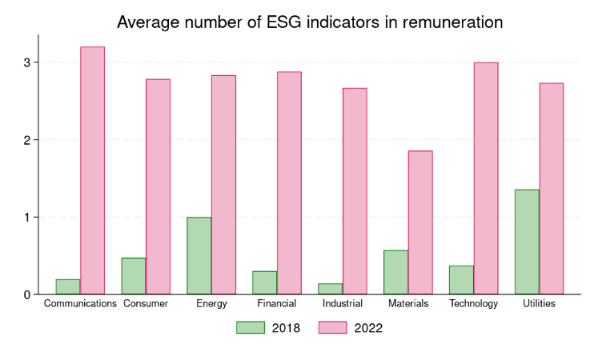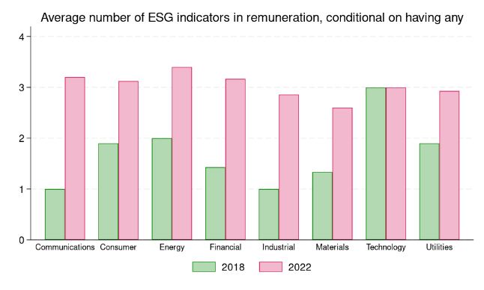

4.3. How ESG metrics are designed

In order to be effective in fostering sustainability related activities by CEOs, ESG metrics must be challenging and specific. Furthermore, they should be focused on the areas where corporations should improve more on their sustainability performance, which might depend both on sector and firm-specific factors. However, a primary issue with introducing ESG metrics into CEO compensation is that these metrics are often generic and difficult to review and compare. This problem arises because such metrics can lack specificity, making it challenging to objectively measure and evaluate their effectiveness, despite the directive explicitly request companies to disclose how these metrics contribute to sustainability.
In order to assess how binding and specific ESG metrics are we have to assess how the metrics are designed and whether a specific target is fixed for the CEO or not. In the charts below, we have reported three different kind of metrics: quantitative metrics, qualitative metrics, and a third type defined as generic when the information is so vague that it constitutes a simple statement of principle that is difficult to measure.
In 2018 almost all the ESG metrics where generic, while in 2022 the large majority where quantitative metrics. The only exception is Spain, where generic and quantitative parameters are almost even. Qualitative metrics are a small minority in all of the countries considered. Although there has been a significant increase in metrics referring to quantitative parameters compared to 2018, this progress is tempered by a concerning rise in the use of entirely generic and hard-to-evaluate statements. These generic metrics often fail to provide clear, actionable insights into a company’s performance on ESG factors, undermining their potential impact. For example, a company might state that it aims to “reduce pollution” without specifying how this will be measured or what targets need to be achieved. This vagueness can lead to a lack of accountability and make it difficult for stakeholders to assess the company’s true commitment to ESG principles. Also with regard to the way of setting metrics, therefore, there is a homogenization of market practices concerning the different types of ESG metrics, whether quantitative, qualitative, or entirely generic. While in 2018 it is possible to spot some differences between countries in the kind of metrics they use, by 2022 some differences subsisted, despite partially depending on the average number of metrics adopted by companies. Spain and Germany had more “generic” metrics than Italy and France, where quantitative metrics are more relevant.
Also if we consider the companies by sector of activity, rather than by their country of incorporation, we can find some differences. While the average number of the indicators adopted is very homogeneous, basic materials companies stand out as providing for, on average, less than two ESG metrics for CEOs variable pay. This might be evidence of the fact that companies in a sector of activity which might be considered particularly problematic for sustainability issues are not trying to improve their performance (fig. xy, panel a). With regard to the kind of metrics provided, some heterogeneity by sector exists too. At the lower end of the spectrum, we find companies in the basic material sector, which are the only ones to provide for a majority of generic metrics. At the other end, we find companies in the communication and technology sectors which mostly provide for quantitative indicators (fig. xy, panel b).

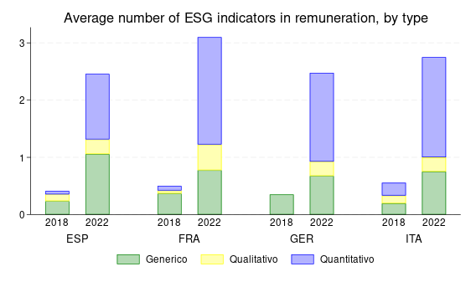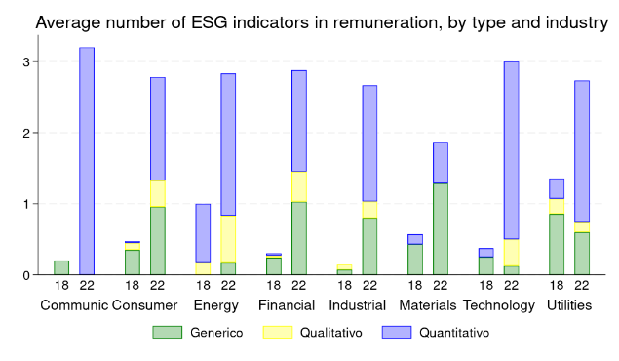

However, in order to make an ESG metrics binding, it is not sufficient to establish the metrics itself, but it is also crucial to establish a target which shall be achieved by the executive. A critical issue is that when companies adopt quantitative or qualitative ESG metrics, they do not always set targets in their CEO remuneration policies. Compared to the 2018 data, 2022 shows an increase in both ESG metrics that include targets and those that do not. Without clear targets, it is difficult to hold companies accountable for their ESG performance. In all the countries considered, the majority of qualitative and quantitative metrics also provide for targets. However, there is a significant heterogeneity between countries, where France and Germany provides for more targets, where Italy and Spain provide for less. This indicates that while companies may be more willing to provide for ESG factors in CEO’s remuneration, they are not necessarily committing to specific, measurable outcomes.

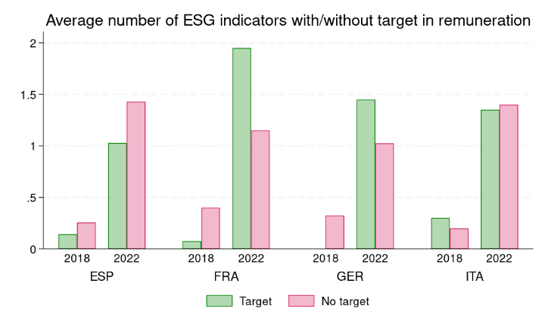

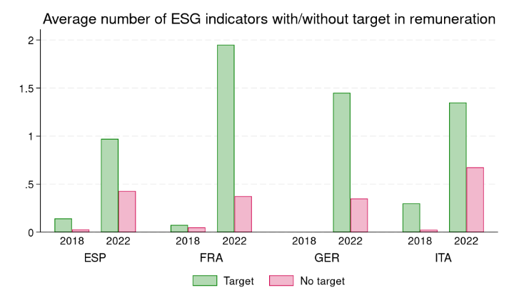

4.4. Which issues are tackled by ESG remuneration?

Two different views of the scope of ESG metrics have emerged. On the one side, some authors have argued that in order to be effective, ESG metrics in CEOs compensation should be comprehensive and encompass the whole range of ESG topics. On the other side, others have argued that ESG metrics should focus on the areas where the company creates more harm. Since both empirical studies found that companies in Europe and the US focus solely on a limited subset of ESG issues, their assessment of this finding differs widely. Bebchuk and Tallarita argue that it shows the inadequacy of CEOs compensation to enhance stakeholders welfare, while Dell’Erba and Ferrarini assess that companies appear to focus on the most relevant stakeholders rather than considering the full heterogeneity of stakeholder categories.
In order to assess which sustainability issues are tackled by companies in the main EU economies, in the charts below we have identified nine different categories of metrics that encompass environmental, social, and governance factors.
As evident from the charts, the most common target adopted in all of the countries concern the reduction of carbon emissions: that’s significant because it is directly related to an operational improvement which has a positive impact on stakeholders and can contribute to positive economic performance, particularly if the Paris agreement is fully implemented by signatories countries. Diversity and inclusion is another target widely adopted, particularly in Italy and France. Finally, the “other” (environmental, social, or governance) category, which encompasses a range of company specific measures, is widespread in every country.
With regard to the cross country analysis, the most striking factor is that Germany, which is the country where stakeholders have greater influence in governance, has almost no metrics addressing social factors, but almost all of the companies focus on carbon emissions (a higher rate than the other EU contries). While the reduction of carbon emissions may represent a positive commitment to improve environmental performance for companies with a large carbon footprint, the exclusion of ESG factors from compensation might mean that incentives are not considered an important instrument in advancing employees welfare and that better governance mechanisms exist at the disposal of employees or that state regulation already covers the main topics (the only ESG metrics adopted by German companies is indeed the category of other social).
The executive compensation policies of European companies do not consider all different categories of stakeholders, but focus on specific areas. These results are consistent with practices in the United States among companies in the S&P 100 and on a global level.
However, we discovered two issues which are remarkable also because shed light on the theory and policy of ESG remuneration. First, the most widespread target is the reduction of carbon emission, which is a target where a stakeholder interest meets a clear financial logic, for all the corporations. If governments push forward with the green transition, a clear business case for carbon emission exists. Moreover, the most employee friendly corporate governance system provides for almost no incentives regarding social issues in CEOs compensation. Likely, that is a plastic demonstration of the secondary role that incentives like CEO pay plays when other corporate governance mechanisms to enhance stakeholders interests exist.

France | Germany
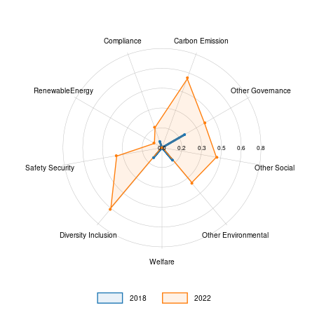 | 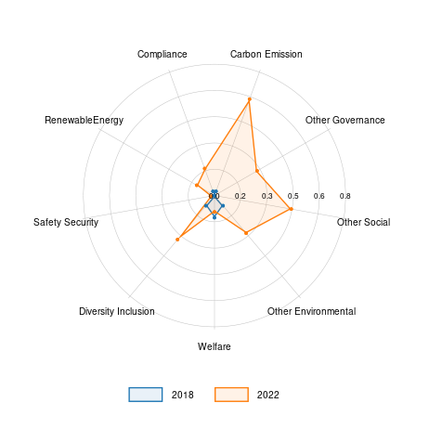
Italy | Spain
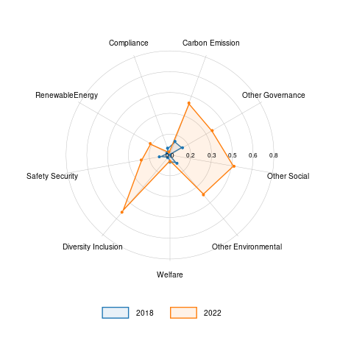 | 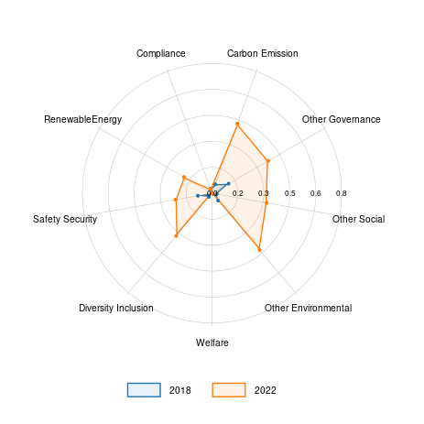

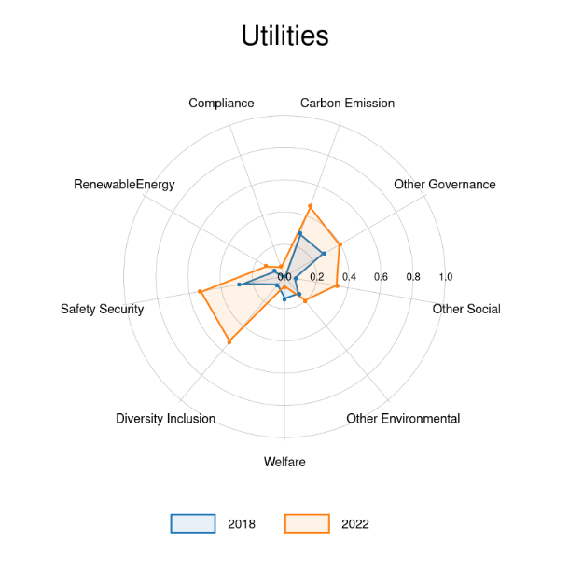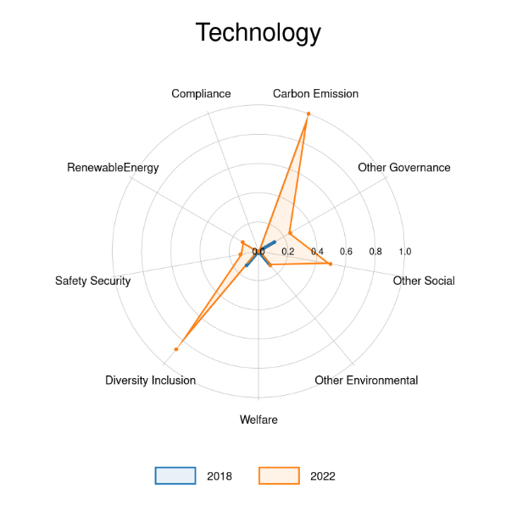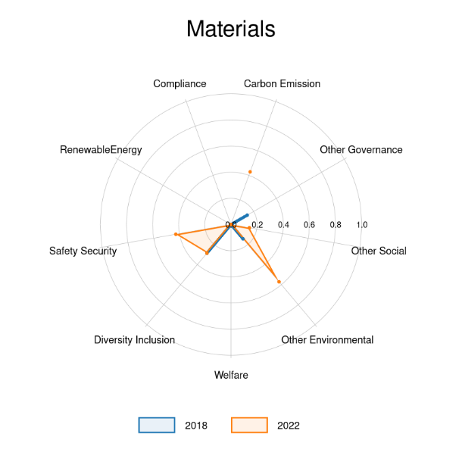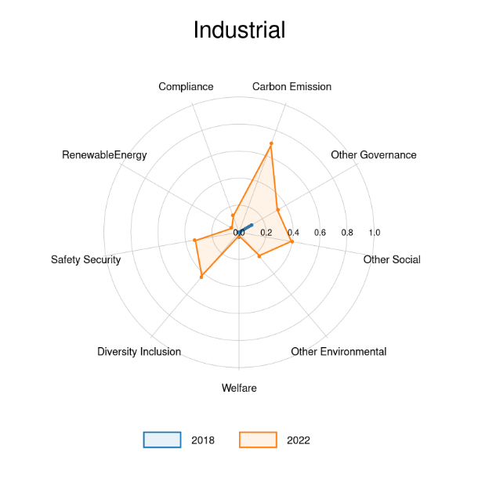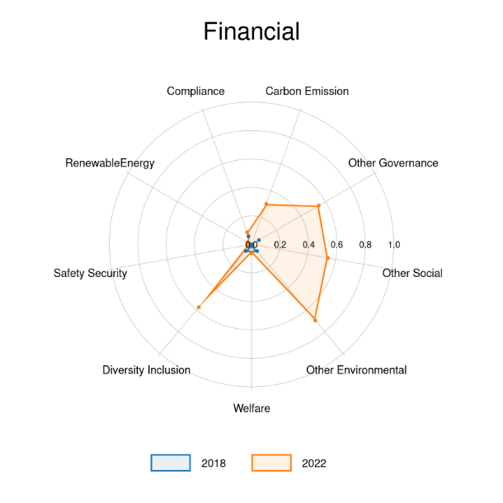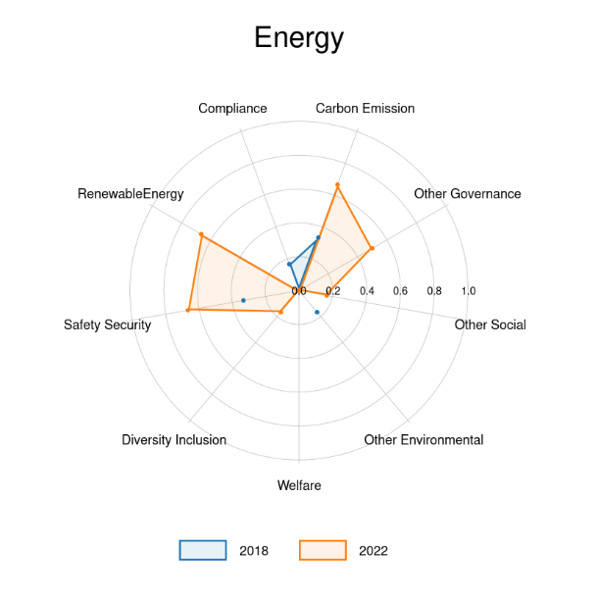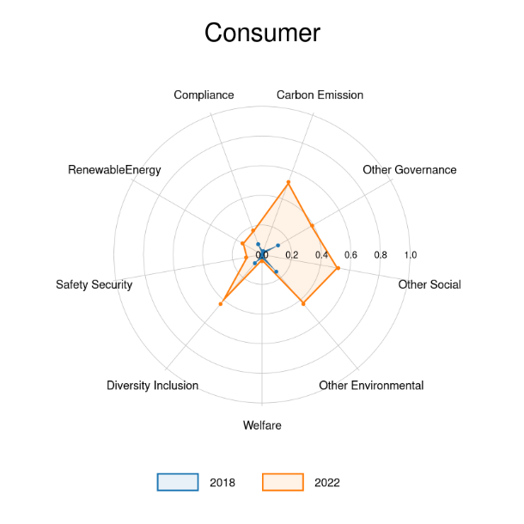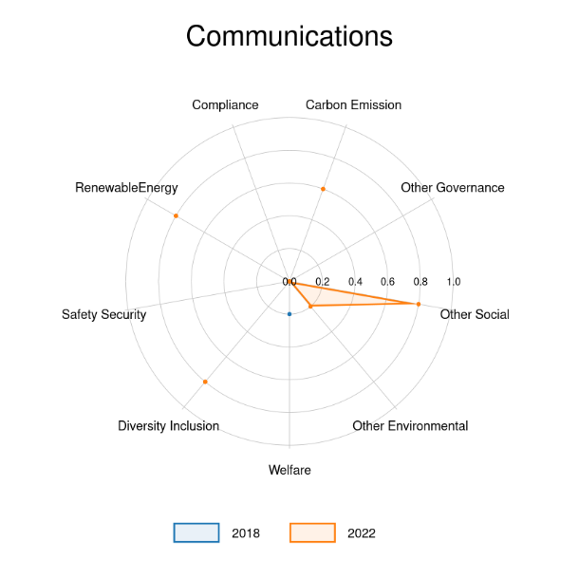

Carbon Emission
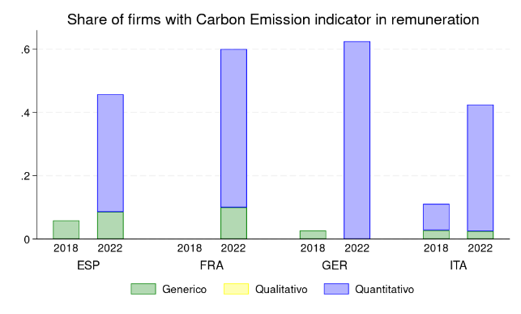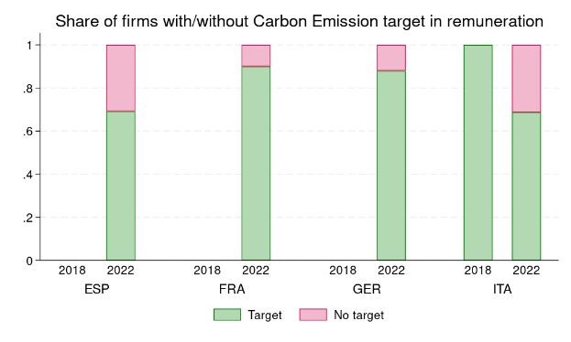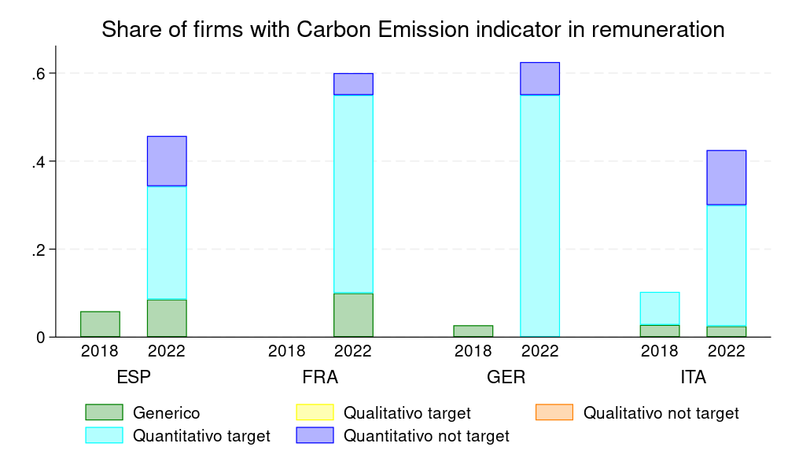

4.5. Short term and long term ESG incentives

The trend of linking CEO pay to ESG performance metrics has not only become more widespread but has also undergone a significant transformation in its approach. Initially, in 2018, ESG metrics were mainly incorporated into short-term variable compensation plans. This means that companies were rewarding their CEOs based on ESG achievements that could be realized within a short timeframe, typically a year or less. However, by 2022, there was a notable shift towards integrating ESG performance into long-term variable compensation plans. This change seems to indicate that companies are increasingly recognizing the importance of environmental and social issues, which are often better measured over longer periods. As a result, the percentage of companies including ESG metrics in their long-term compensation plans surged from a mere 5% in 2018 to over 50% in 2022. This shift reflects a growing commitment among companies to ensure that their leaders are incentivized not just for immediate ESG outcomes but for sustainable, long-term impacts. It potentially aligns CEO incentives with broader, more strategic ESG goals, thereby promoting a more enduring approach to corporate social responsibility and sustainability.
In the diachronic comparison, variations also emerge regarding the weight of ESG factors in relation to overall compensation. If in 2018, when they were considered, ESG metrics accounted for about 13% of short-term variable compensation and less than 20% of long-term variable compensation, in 2022 they accounted for 18% and 22%, respectively. While these variations may not seem particularly significant, they actually have substantial economic impact, partly due to the increase in variable compensation relative to fixed compensation. In 2018, short-term compensation linked to ESG parameters corresponded to about 40% of fixed compensation, while in 2022 this figure rose to nearly 60%. Moreover, ESG related variable pay was awarded by a very small subset of companies in 2018, while it was widespread by 2022.
Regarding the comparison between Member States, the 2022 data shows that the differences in the weight of ESG factors in CEO compensation have leveled out compared to 2018, where there was a notable disparity between countries: France and Germany on the one side, Italy and Spain on the other. A significant difference, however, is the use of multipliers linked to ESG factors by German companies. This means that the bonus tied to achieving sustainability goals requires the simultaneous achievement of financial objectives. Unlike other countries, German companies thus end up tightly linking environmental and social goals to the pursuit of the company’s financial interests.
If we look at the weight of ESG short term incentives compared to the total amount of short-term incentives the most notable fact is that the industrial and basic materials ties a lower share of the CEOs’ compensation to ESG metrics, despite it is presumable that their activities have deep repercussions on sustainability.

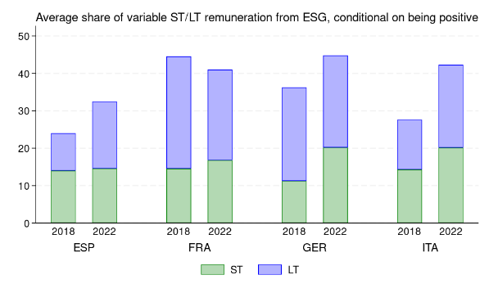
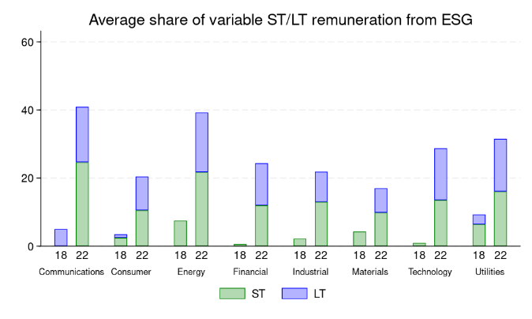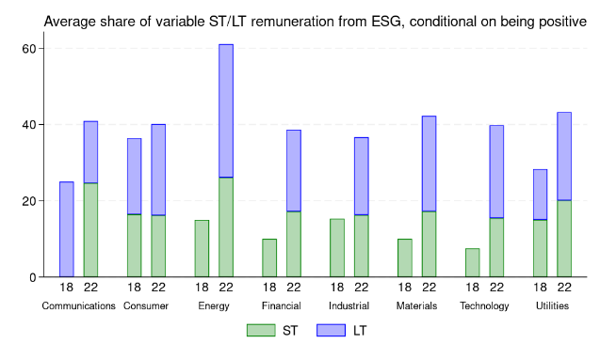

4.6. Rate of achievement

Generally, studies of CEOs performance do not take into account the rate of achievement of the performance targets by the executives. That is unfortunate because it is probably the best proxy, even if it acts with hindsight and is prone to bias, to infer how challenging a performance target is. The analysis of remuneration reports and not only remuneration policies allows us to assess the rate of achievement by CEOs of their short term targets, both financial and ESG. In 2018, the rate of achievement of short-term financial performance target was more than 100%, while ESG targets where met in almost 100% of the cases. In 2022, the picture is so rosy that might lead to a bleak conclusion. Both for financial and ESG targets, in all of the countries considered, the rate of attainment in more than 100%. This stellar performance might lead to think that the performance targets were not at all challenging when they were set and that look like a form of fixed remuneration rather than a variable one.
With regard to short-term financial performance targets, these results challenges the conventional assumption behind CEOs pay models and corporate governance theory which looks at CEOs’ pay as an incentivizing factor. This finding does not concern the core of this paper, but deserves deeper and more accurate research in the future.
With regard to ESG factors, such a high rate of achievement indicates that the metrics are not challenging at all for CEOs. The consequence is probably that they do not involve any significant change along the path of sustainability and the improvement of stakeholders welfare.
Nonetheless, it is interesting to read together the rates achievement of financial and ESG metrics. Contrary to common assumption, the increase of the weight of ESG factors within CEOs compensation has not worsened (if anything, it is the contrary) the rate of achievement of financial performance metrics. CEOs do not appear to be distracted by their ESG related tasks in pursuing economic and financial success of the company. Of course this result might depend on several causes which need not to be mutually exclusive. First, a success on the ESG front may contribute also to the financial success of the company; second, ESG targets are simply so vague and so unchallenging that they do not distract CEOs; finally, that CEOs might easily dedicate part of their attention to sustainability issues without hampering companies’ financial performance.
Whatever the favorite interpretation of the data, the analysis of the rate of achievement allows us to cast a sober light on how challenging short-term incentives plan are, but also to counter one of the main critiques directed at ESG pay, that is it might hamper financial performance. In order to investigate further that question, we turn to economic performance of the corporations of our sample.

4.7. ESG-based pay and corporate performance

A constant theme by the critics of the integration of ESG metrics into CEOs remuneration is that this worsens corporate performance through two different channels: on the one side, through the increase of agency costs, because of the award of additional remunerations to the detriment of shareholders; on the other side, by distracting executives from their main tasks. Generally, this idea is put forward as a theoretical discussion and no empirical studies exist on this specific point, also because of the difficulty in isolating a causal link between ESG remuneration and firm performance. However, our data (figure xy) contradict this hypothesis. The figure shows that there is no negative correlation between the increase in the weight of ESG related variable pay for firms and their economic performance (turnover). At least prima facie, therefore, ESG pay has not involved any worsening of the operating performance of the companies within our sample. As with the rate of achievement, the explanations might be multiple and not mutually exclusive, but also this data contradicts the theory of those who see the emergence of ESG metrics in CEOs pay as a fruit of agency costs which go to the detriment of shareholders.

Fig. xy
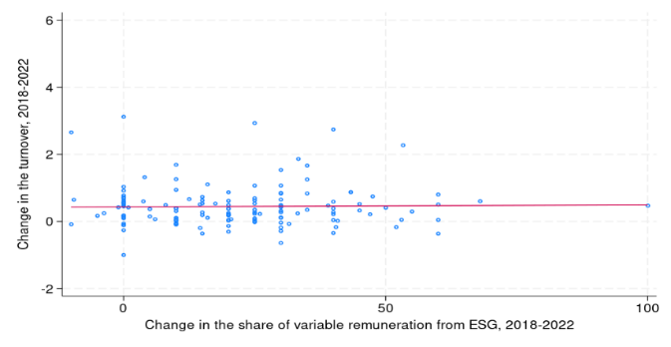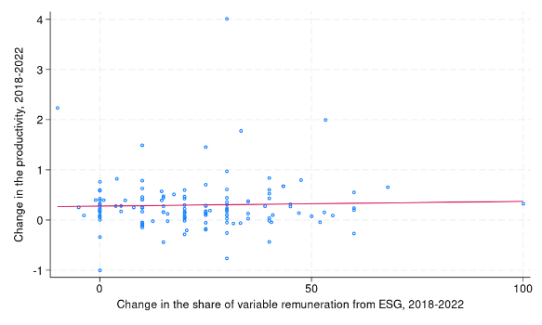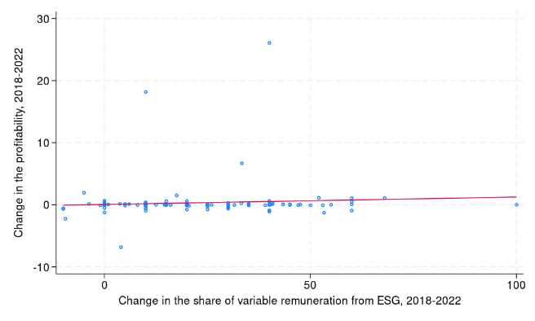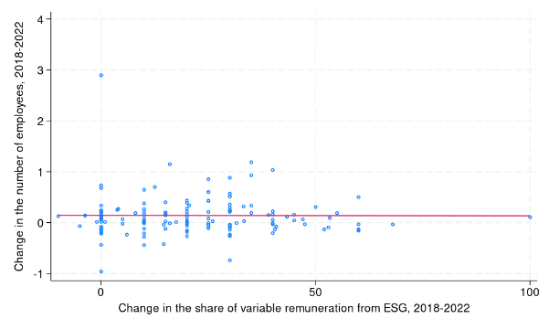

4.8. Main findings

This empirical analysis enriched the available studies on ESG metrics and CEOs remuneration, because of the diachronical approach, of the number of documents explored, the division of companies by sector of activity and the connection to corporate economic performance. Whilst we can confirm some of the facts discovered also by previous studies, the granularity of the data allows us to take a different view on several points, which become relevant for the explanatory and normative take of the next section. These are the elements which should we bear in mind.
First, there is great homogeneity in CEOs pay practice between the largest corporations in the countries we analyze; when we control for the dimension and the sector of activity, both the total fixed and variable pay in the four countries are roughly similar. That evidence is consistent with surveys which find that pay at peer companies is generally used as a benchmark. Considering that our sample is composed of the largest listed companies in the main EU economies, that similarity is not surprising.
Second, between 2018 and 2022 the world of ESG remuneration has changed: along with regulatory and soft law amendments, the practice of ESG remuneration has been turned upside down: almost 90% of the companies provide for ESG remuneration and generally set 2,5 metrics per CEO to attain. Most of the metrics are quantitative, even if totally generic metrics are present; moreover, not all of the quantitative metrics provide for a target. In this regard, our research aligns with global and US trends; despite the progress made, the factors and metrics adopted remain often generic and difficult to evaluate externally. Two elements stand out within this context: German companies, which are the most employee friendly from a corporate governance point of view, sets less targets than their peers and sets more generic targets – likely, the less demanding ones – than companies from other countries. With regard to the sector of activity, companies operating in the basic material sector – likely, an ESG problematic sector – set less targets and most of them are generic.
Third, the most common metrics concern carbon emission reduction, consistently with the fact that, at least in the EU, there is a clear business case for companies to start the green transition. At the same time, it is notable the low level of social targets adopted by German companies.
Fourth, the weight of incentives linked to ESG has increased.
Fifth, the analysis of the remuneration report, aside from remuneration policy, allows us to uncover the rate of attainment of short-term variable pay targets. We discover that in all of our countries, both in 2018 and 2022, companies had a 100% rate of achievement of both financial and ESG targets. That’s astonishing with regard to financial incentives and deserve deeper exploration. With regard to ESG targets, that’s telling in so far it is plausible that these targets are not particularly demanding and, consequently, it is doubtful how they incentivize CEOs to improve the sustainability performance beyond what would happen in the normal business course. At the same time, the attainment of these targets has not worsened financial performance in any meaningful way.
Finally, economic indicators generally associated with economic performance have not worsened as ESG remuneration increased. This dissipates the doubts of those scared that the provision of ESG metrics in CEOs incentive schemes might come to the detriment of shareholders.

5. Why have ESG metrics in CEOs pay become so widespread?

There are several narratives about the reasons for the diffusion of ESG metrics in CEOs compensation, generally based on two opposite explanations: some argue that CEOs want them in order to be able to implement structural changes to how companies operate or because they are able to extract agency costs. Others argue that shareholders, acting as stewards, want them either because they care about sustainability or because a better ESG performance is generally associated with better long-term financial performance. In any case, these explanations see a conflict between CEOs and shareholders.
Our study, thanks to analysis of data both for 2018 and 2022 within a changed normative framework, casts a different light: rather than contrast, cooperation. The most obvious drivers of ESG compensation in the main EU economies are, simply put, hard and soft law. As we have analyzed in the four countries, the implementation of the SHRD II coupled with corporate governance codes provides for the inclusion of ESG factors in compensation. These legislative amendments, also taking into account that corporate governance codes are generally draft by representatives of the whole business community are the results of a shared consensus both by managers and shareholders.
Furthermore, in the countries we consider, the idea of an antagonism between management and shareholders is setting CEOs pay does not hold even if we consider the pay setting process at the firm level, within the broader ecosystem of pay setting. Many of the companies in our jurisdictions (and in our sample) are companies with a controlling shareholder; secondly, laws and corporate governance codes in our four jurisdiction provide for protection for minority shareholders in the pay setting process – through board committees composed by a majority of independent directors – and of shareholders in general – through a binding vote on the remuneration policy and an advisory one on the remuneration report. Finally, proxy advisors generally support the inclusion of ESG metrics in CEOs’ pay. Rather than the fruit of discord and conflict, CEOs pay setting process is a participatory one in the EU context.
Moreover, the ecosystem of CEOs pay setting has surely contributed to the diffusion of CEOs ESG pay. Companies have a labour market constrain when setting CEOs pay: since many board members believe, as revealed by surveys, that the most important factor in establishing CEOs pay is to attract the right CEO, it is logical that this drives an homogenization of pay practices, at least at a superficial level. Moreover, remuneration at peer companies is taken as reference point for the pay setting process, another factor driving homogenization. Therefore, since company specific performance incentives are not the only important factors driving the practice of CEOs pay, the similarity and the fast diffusion of pay practices contributed, along with regulation, to the expansion of ESG CEOs pay.
This reconstruction of the process through which ESG pay has spread allow us to cast some doubts about a retrenchment of ESG metrics in CEOs pay in the EU. Despite further regulation at the EU level has been discarded for the moment, the ESG metrics are probably here to stay for the moment.
However, the crux of the policy discussion lies in the effects, both on economic performance and on sustainability, of ESG metrics in CEOs pay. If, as we have argued, the integration of ESG metrics in CEOs pay is the effect of consent from shareholders and CEOs, which are the effects of this policy? How effective it is in advancing stakeholders and shareholders interests?

6. The economic and sustainability effects of CEOs ESG pay

In order to assess the effectiveness and the implications of the introduction of ESK metrics within CEOs remuneration both the financial and the sustainability sides should be analyzed. Despite the deep embroilment of these two issues, we will separate them from the sake of clarity.
Starting with the financial side, our study has dissipates the fears that ESG factors might have negative effects on corporate performance: the introduction of ESG related metrics in CEOs pay has not determined any deterioration of economic performance of the companies involved. Our analysis, despite it investigates a correlation rather than a causation, is particularly significant because it isolates the years following the introduction of ESG factors in the ESG packages.
That analysis is particularly important also because it does not analyze financial markets variables, but firm-level accounting ones, which are not influenced by the (potential) increase in demand for shares deriving from an improvement of the ESG rating of the company or the perceptions by market participants about the potential beneficial effects of ESG improvements on long-term performance of the company. Our economic variables derived from firms’ balance sheets, indicates that the introduction of ESG factors does not worsen the company performance even in the short-term. At the same time, as it is predictable, these results indicates that ESG related compensation does not involve any form of redistribution from the company to stakeholders.
Our findings more robust and that is never analyzed in the literature is that the rate of achievement of financial performance targets has not been impaired by the introduction of ESG performance metrics. Therefore, in so far financial incentives are tied to finanacial markets results, not only the introduction of ESG metrics does not impair economic performance, but neither the financial one.
Further studies should investigate the reasons for these results, despite the difficulty of disentangling different effects which might likely coexist: ESG target might be undemanding and do not involve any real change in corporate business conduct, ESG improvement might benefit also financial and economic performance, or simply put CEOs might pursue both at the same time without the two influencing each other. Whatever the explanation, our empirical analysis has showed that the current system does not impair companies’ economic and financial performance, even in the short run. The outcome of the current corporate governance systems and regulation, therefore, has been to introduce sustainability in so far it is compatible with business performance and shareholder value: the flip of the coin, therefore, is that the current system does not lead to any specific rebalances of power between companies’ constituencies, nor it sacrifices operating end financial performance to enhance sustainability or stakeholders interests.
The effect on sustainability is harder to assess, largely because granular datasets on sustainability performance spanning years do not exist yet. While some empirical studies exist, most of the discussion has been around policy considerations based on how the metrics against which CEOs are assessed are designed. The published articles’ findings concur on this topic: ESG metrics are set in a vague way, the targets are difficult to assess and to compare the companies’ progress with industries’ standards is almost impossible. Rather than the findings, the disagreement concerns their interpretation. Whilst some authors find that this is a culprit of CEOs rent extraction to the detriment of shareholders and stakeholders alike, others have a more benign interpretation, because a change of culture and of business operations is difficult to reconcile with quantitative targets.
Our study confirms the results of these studies, showing a high degree of vagueness in how metrics are set. However, we add some elements that enriches the understanding of the interplay between ESG metrics and sustainability at the firm level. We show that the weight of ESG linked remuneration as well as the number and shape of the metrics has completely changed between 2018 and 2022. Every study that adopts a dataset spanning several years should carefully take that into account, as the simple presence of an ESG metric might hide extremely different situations. Also because of this reason, in order to assess the effectiveness of ESG remuneration to foster sustainability we should be careful in deriving results from metrics adopted years ago.
Secondly, the country by country analysis allows us to assess the interplay between different corporate governance regime and the use of incentives to foster sustainability: more on this in the next paragraph. However, it is important to record for now that the most adopted metrics concern carbon emission and that when we analyze companies by sector of activities we do not find striking differences in the kind of metrics they adopt, which might sound surprising since it is likely that they have a different sustainability footprint. Quite to the contrary, the basic material sector stands out as the sector with less and more generic metrics.
Finally, ESG targets are achieved in 100% of the cases, similarly to financial metrics.
All these findings portends that ESG metrics are not particularly stringent nor hard to achieve by CEOs, as well as the homogeneity of the use of ESG metrics by sector suggests that companies in more unsustainable industries are not hard pressed to improve their performance.
The assessment of these findings together with those concerning the financial performance of companies providing ESG allows to infer that companies adopt more ESG practice solely when it is not detrimental to shareholders and therefore the effect on sustainability is probably rather limited. The metrics appear undemanding and are almost always achieved. That casts a sober light on the transformational effect of these incentives on the business conduct. However, empirical studies should assess whether these incentives represent some form of greenwashing (etc.) or, simply put, they achieve the most considering that they are implicitly premised on a business case for ESG.

7. The unfulfilled promises of sustainability governance without stakeholders

This paper has comprehensively analysed how ESG linked pay has spread in the main EU economies and how it is structured, accounting for the differences between the different countries and corporate governance regime and for the sectors of activity in the EU. Unpacking data this way, we have cast a different light on the emerging phenomenon of ESG linked pay. However, this leaves the analysts with a set of questions on the political economy of setting ESG pay in both a shareholder and stakeholder centric environment.
As we have analysed at length in paragraph xy, the main components of CEOs remuneration regulation are its structure and transparency and the process for setting it. If the purpose of ESG metrics in CEOs pay is to raise the attention on a market failure, leading to an undervaluation of the effect of certain ESG factors on long term shareholder value, the actual regulation of CEOs pay in the EU is set to address it. EU and national laws, as well as codes of conduct, suggest ESG factors to be taken into account, provide transparency pf the pay to shareholders, require the intervention of minority disinterested directors in the pay setting process and give the ultimate decision power to shareholders.
Whereas if the main conflict to be addressed is the one between the company and stakeholders at large, the regulation is utterly inadequate. Indeed, it doesn’t provide any power to the constituencies which apparently hold interests contrary to those of shareholders; As we have documented, this has not come to the detriment of financial results and, from a combined reading of the different pieces of evidence, it is unlikely that the inclusion of ESG metrics in CEOs pay has favoured stakeholders interests beyond what is also at the same time beneficial for shareholders, at least in the long run – which, admittedly – corresponds to stakeholders welfare only in a limited set of cases.
Whereas this analysis provide quite an obvious result – despite the fears of shareholders value centred normative interpretation of the purpose of corporate law and unreasonable hopes of stakeholderists – it is important to go a step further, that our country by country analysis allows. This most basic question concerns the effectiveness of CEOs monetary incentives in pursuing sustainability. Indeed, these incentives are always lower than financial incentives, are subject to CEOs labour market constraints, and are an indirect way to steer the organization of the business activity on a more sustainable path. As the case of Germany demonstrates, where a stakeholder has voice in the corporate governance machine, CEOs incentives play a limited role in furthering the interests of that specific stakeholder class. Where stakeholders are powerful, different instruments – such as state regulation, different policy tools, or the conduct boundaries deriving from countervailing powers – are more effective in protecting stakeholders. Read through these lenses CEOs incentives are not the most useful tool to promote sustainability.
This evidence downplays the potential effects that a corporate governance reform aimed at providing more power to stakeholders in the setting of CEOs remuneration – even without considering the difficulties in enacting such a scheme in countries where corporate governance is shareholder centric – might not be particularly useful.

8. Conclusion

This paper has analysed the diffusion of ESG metrics in the pay packages of the CEOs of the four main EU economies. It has uncovered the main drivers behind the diffusion od CEOs ESG pay and has provided novel empirical evidence on the functioning of ESG CEOs remuneration that went unnoticed in previous studies, including with regard to the economic effect of the introduction of ESG factors in pay packages as well as the rate of achievement both of financial and ESG targets: the consideration of these factors is essential to move from a merely theoretical discussion to a more empirically grounded one. In so doing, the paper has debunked several myths about the perils of trying to foster sustainability through CEOs pay.
At the same time, the analysis country by country, as well as sector by sector has allowed for a more nuanced discussion of the promises of the ESG factors in CEOs pay. Here, the empirical evidence in support of those who court the idea that shareholders act as effective stewards for sustainability, or that companies are spontaneously converging to a more sustainable path, is scant. The most diffused target is related to carbon emission reduction, which corresponds to a reasonably held belief that the EU will hold to the 2015 Paris Agreement commitments: assessed through these lenses, carbon emission reduction largely correspond to long-term shareholder value. At the same time, through the case study of Germany we have demonstrated that where a specific group of stakeholders hold a position of power within the company CEOs incentives are not the governance tool that is used to promote their interests.
Whereas this whole discussion discards the fears of shareholder value supporters, flashes a sobering light on a corporate governance tool to advance sustainability, beyond what could be directly imposed by regulation and that requires a dynamic adaptation of the conduct of business operations. Rather than trying to adapt instruments introduced to advance shareholders interests which could barely promote sustainability in a shareholder centric corporate governance system, we should consider adopting novel techniques, which expand the traditional corporate governance domain. A major inspiration might be drawn from the corporate sustainability due diligence directive, where it provides that companies shall adopt a plan to be compliant with the Paris Agreement.
Looked to these lenses, companies might be left free to assess how much ESG related activity to pursue in order to foster their economic performance. However, they shall be assigned specific target with purposes which are essential to the EU public policy. This would reap the benefits of quasi-regulation (steering companies activity in a specific direction avoiding the greenwashing et similia risks of ESG) while at the same time avoiding its drawbacks, in so far companies are free to decide how to achieve the policy target.

Appendix
Table 1

Fiscal Year 2018 | France | Germany | Italy | Spain
ESG factors in remuneration | 30% | 23% | 29% | 23,5%
ESG ST (% of companies) | 30% | 17,5% | 22,5% | 20%
ESG ST/tot ST | 14,5% | 11,25% | 14,28% | 14%
ESG ST/fixed | 21,53% | 17,56% | 16,46% | 15,84%
ESG LT (% of companies) | 2% | 7,5% | 7,5% | 5,7%
ESG LT/tot LT | 30% | 25% | 13,33% | 10%
ESG LT/fixed | 73,57% | 50,96% | 26,53% | 12,05%
% ESG ST achieved | 102% | N/A | 109% | 84%
% financial ST achieved | 97,35% | N/A | 112% | 112,42%

Table 2
Fiscal Year 2022 | France | Germany | Italy | Spain
ESG factors in remuneration | 100% | 87,5% | 82,5% | 88,5%
ESG ST (% of companies) | 97,5% | 62,5% | 80% | 82,8%
ESG ST/tot ST | 16,83% | 20,18% (but most of the cases ESG STI are multipliers) | 20,14% | 14,61%
ESG ST/fixed | 29,62% | 31,88% | 24,04% | 19,47%
ESG LT (% of companies) | 52,5% | 60% | 67,5% | 42,8%
ESG LT/tot LT | 24,16% | 24,61% | 22,15% | 17,86%
ESG LT/fixed | 56,6% | 75,38% | 47,58% | 55,82%
% ESG ST achieved | 111,4% | 128,25% | Above 100% (most achievements are expressed in words) | 112%
% financial ST achieved | 104,76% | 105,76% | Above 100% (most achievements are expressed in words) | 108,8%

Bank of Italy, Economic Structure department; adjunct professor of financial market regulation, University of Bologna. The opinions expressed are the author’s solely and do not involve any responsibility of the Bank of Italy.
Post-doc candidate at Ca’ Foscari University, Venice.
https://corpgov.law.harvard.edu/2021/04/25/esg-investors-increasingly-seek-accountability-and-outcomes/
Flammer et al Corporate governance and the rise of integrating corporate social responsibility criteria in executivecompensation: Effectiveness and implications forfirm outcomes: p.1098; Hong, B., Li, Z., Minor, D., 2016. Corporate governance and executive compensation for corporate social responsibility. J. Bus. Ethics 136 (1), 199–213.
Eccles, R.G., Ioannou, I., & Serafeim, G. (2011). The impact of a corporate culture of sustainability on corporate behaviour and performance. Working paper 12-035. Harvard Business School, Boston; Kolk, A., & Perego, P. (2014). Sustainable bonuses: Sign of corporate responsibility or window dressing? Journal of Business Ethics, 119(1), 1–15.
H. Nguyen et al., Sustainability targets in executive remuneration contracts and corporate sustainability performance in the United Kingdom and European Union, in Environment systems and decisions, 43, 2023, 393 ss.; S. Cohen et al., Executive compensation tied to ESG performance: international evidence, ECGI working paper, 2023; Hong, B., Li, Z., Minor, D., 2016. Corporate governance and executive compensation for corporate social responsibility. J. Bus. Ethics 136 (1), 199–213. Flammer, C., Hong, B., Minor, D., 2019. Corporate governance and the rise of integrating corporate social responsibility criteria in executive compensation: effectiveness and implications for firm outcomes. Strateg. Manag. J. 40 (7), 1097–1122; Albert Tsang , Kun Tracy Wang,, Simeng Liu , Li Yu Integrating corporate social responsibility criteria into executive compensation and firm innovation: International evidence, in journal of corporate finance, vol 70, 2021.
Maas, K., 2018. Do corporate social performance targets in executive compensation contribute to corporate social performance? J. Bus. Ethics 148 (3), 573–585.
Albert Tsang , Kun Tracy Wang,, Simeng Liu , Li Yu Integrating corporate social responsibility criteria into executive compensation and firm innovation: International evidence, in journal of corporate finance, vol 70, 2021.
S. Cohen et al., Executive compensation tied to ESG performance: international evidence, ECGI working paper, 2023.
Edmans et al
Kraakman et al
Edmans gabaix
See nt.
Information asymmetries with regard to the business might generate different views on the optimal pay structure.
Edmans and Gabaix, rent extraction and shareholder value.
I. Capelli, “La sostenibilità ambientale e sociale nelle politiche di remunerazione degli amministratori delle società quotate: la rilevanza degli stakeholder dopo la SHRD II”, Orizzonti del diritto commerciale (2020), II, 585.
C.M. Bruner, “Corporate governance reform and the sustainability imperative”, Yale Law Journal (2022), vol. 131(4), 1220-1221.
J. O’Hare, “Don’t forget the “G” in ESG: the SEC and corporate governance disclosure”, Arizona Law Review (2022), vol. 64, 433; S. Gomtsian, “Executive compensation: investor preferences during say-on-pay votes and the role of proxy voting advisers”, Legal Studies (2024), vol. 44, 142.
Commission Recommendation of 14 December 2004 fostering an appropriate regime for the remuneration of directors of listed companies, 2004/913/EC.
Id, whereas (2): «The form, structure and level of directors’ remuneration are matters falling within the competence of companies and their shareholders. This should facilitate the recruitment and retention of directors having the qualities required to run a company. However, remuneration is one of the key areas where executive directors may have a conflict of interest and where due account should be taken of the interests of shareholders. Remuneration systems should therefore be subjected to appropriate governance controls, based on adequate information rights. […]».
In the Commission’s recommendation, transparency is manifested through a suggestion regarding the periodic publication of a statement concerning the board’s remunerations. This statement would not only describe the remuneration policy envisaged for the upcoming fiscal year, but also provide an overview of the manner in which the remuneration policy has been implemented in the previous fiscal year (see paragraph 3.2. of the Recommendation). This disclosure suggestion came with a shareholders’ vote on the company’s remuneration policy, which could be either binding or advisory. Moreover, obtaining prior approval for share-based schemes was also suggested (paragraph 4.2). On the topic see G. Ferrarini, N. Moloney, M. C. Ungureanu, “Executive Remuneration in Crisis: A Critical Assessment of Reforms in Europe”, Journal of Corporate Law Studies (2010), vol. 10, I, 88-89; S. Sonnati, “La trasparenza e la sostenibilità della retribuzione dei top manager tra diritto finanziario, corporate governance e profili giuslavoristici”, Diritto delle Relazioni Industriali (2023), III, 730 ff.; I. Capelli, “Le politiche di remunerazione degli amministratori nelle società quotate tra la massimizzazione del valore per gli azionisti e il perseguimento della sostenibilità ambientale e sociale: un percorso ancora agli inizi”, Orizzonti del Diritto Commerciale (2023), III, 757 ff.
Commission Recommendation of 15 February 2005 on the role of non-executive or supervisory directors of listed companies and on the committees of the (supervisory) board, 2005/162/EC, paragraph 3. According to the Recommendation, a remuneration committee should be established within the management board when the board plays a role in setting director remuneration. The remuneration committee should be composed exclusively of non-executive directors, with a majority being independent. It should propose remuneration policies addressing all forms of compensation, make proposals for individual remuneration, make recommendations on remuneration levels and structures, and assist in ensuring compliance with disclosure provisions. With regard to stock options and other share-based incentives, the committee should debate policy, review relevant information in annual reports and shareholder meetings, and make proposals to the board, specifying the choice between subscription or purchase options and the reasons behind it.
G. Ferrarini, N. Moloney, M. C. Ungureanu, “Understanding Directors’ Pay in Europe: A Comparative and Empirical Analysis”, ECGI Law Working Paper (2009), no. 126, 27.
Commission Report on the application by Member States of the EU of the Commission Recommendation on directors’ remuneration of 13 July 2007, SEC(2007) 1022, paragraph 4.2. On this topic see G. Ferrarini, N. Moloney & M. C. Ungureanu, (2010), 98.
Across the Channel, it has been realized that a paradigm shift in executive remuneration was necessary. In the United Kingdom, as in Europe, it became evident that previous documents aimed solely at regulating the methods and procedural aspects of pay determination were fundamentally flawed, as they neglected to address the structural aspect of remuneration. Cf. Financial Services Authority (FSA), “The Turner Review. A regulatory response to the global banking crisis” (2009), 79 ff.: «In the past neither the FSA nor bank regulators in other countries played significant attention to remuneration structures. And within firms, little attention was paid to the implications of incentive structures for risk taking, as against the implications for firm competitiveness in the labour market and for firm profitability. In retrospect this lack of focus, by both firms and regulators, was a mistake. There is a strong prima facie case that inappropriate incentive structures played a role in encouraging behaviour which contributed to the financial crisis».
G. Ferrarini, N. Moloney, M. C. Ungureanu, (2010), 74.
Y. Hausmann, E. Bechtold-Orth, “Changing Remuneration Systems in Europe and the United States – A Legal Analysis of Recent Developments in the Wake of the Financial Crisis”, European Business Organization Law Review (2010), vol. 11, 197. On the link between remuneration and the interest of shareholders see J.G. Hill, ‘Regulating Executive Remuneration: International Developments in the Post- Scandal Era’, European Company Law (2006), vol. 3, 64 ff. and L. Enriques, P. Volpin, ‘Corporate Governance Reforms in Continental Europe’, Journal of Economic Perspectives (2007), vol. 21, 117 ff.
Financial Stability Forum (FSF), “Principles for Sound Compensation Practices” (2010), available at: https://www.fsb.org/wp-content/uploads/r_0904b.pdf, 1: «Compensation practices at large financial institutions are one factor among many that contributed to the financial crisis that began in 2007. High short-term profits led to generous bonus payments to employees without adequate regard to the longer-term risks they imposed on their firms. These perverse incentives amplified the excessive risk-taking that severely threatened the global financial system and left firms with fewer resources to absorb losses as risks materialised. The lack of attention to risk also contributed to the large, in some cases extreme absolute level of compensation in the industry». See also the US Financial Crisis Inquiry Commission, “The Financial Crisis Inquiry Report: Final Report of the National Commission on the Causes of the Financial and Economic Crisis in the United States” (2011), available at: https://www.govinfo.gov/content/pkg/GPO-FCIC/pdf/GPO-FCIC.pdf, xix. In academic literature see among others: M. Dell’Erba, G. Ferrarini, “ESG & Executive remuneration in Europe”, ECGI Working Paper Series in Law (2024), no. 767, 7.
On the topic see G. Ferrarini, N. Moloney, M. C. Ungureanu, (2010), 74 ff.
G20, Leaders’ Statement, The Pittsburg Summit, 24–25 September 2009, available at: https://www.oecd.org/g20/summits/pittsburgh/G20-Pittsburgh-Leaders-Declaration.pdf.
FSB, “Principles for Sound Compensation Practices” (April 2009), available at: https://www.fsb.org/wp-content/uploads/r_0904b.pdf and FSB, “Principles for Sound Compensation Practices. Implementation Standards” (September 2009), available at: https://www.fsb.org/wp-content/uploads/r_090925c.pdf.
The High-level Group on Financial Supervision (chaired by de Larosière), Report (2009), available at: https://ec.europa.eu/economy_finance/publications/pages/publication14527_en.pdf, para. 117-121. The de Larosière Group highlighted that while public attention often focuses on high pay, it is the structure of compensation that influences risk management and contributed to the crisis. The Report stated that policy reforms should prioritize aligning incentives with long-term profitability and shareholder interests, ensuring transparency and accountability.
Cf. Commission Recommendation of 30 April 2009 on remuneration policies in the financial services sector, 2009/384/EC and Commission Recommendation of 30 April 2009 complementing Recommendations 2004/913/EC and 2005/162/EC as regards the regime for the remuneration of directors of listed companies, 2009/385/EC.
See whereas (3) of Commission Recommendation of 30 April 2009 on remuneration policies in the financial services sector, 2009/384/EC. On this topic see I. Capelli (2023), 762 ff.
See whereas (3) of Commission Recommendation of 30 April 2009 complementing Recommendations 2004/913/EC and 2005/162/EC as regards the regime for the remuneration of directors of listed companies, 2009/385/EC.
On the topic see Y Hausmann, E. Bechtold-Orth (2010), 196; G. Ferrarini, N. Moloney, ‘Executive Remuneration in the EU: The Context for Reform’, Oxford Review of Economic Policy (2005), vol. 21, 305 ff.
See whereas (6) of Commission Recommendation of 30 April 2009 complementing Recommendations 2004/913/EC and 2005/162/EC as regards the regime for the remuneration of directors of listed companies, 2009/385/EC.
See point 3.2. of Commission Recommendation of 30 April 2009 complementing Recommendations 2004/913/EC and 2005/162/EC as regards the regime for the remuneration of directors of listed companies, 2009/385/EC.
See on this topic Y Hausmann, E. Bechtold-Orth, (2010), 197. The role played by excessive executive pay in the financial crisis is recognized not only by the Commission but also by other financial institutions. The UK Financial Services Authority (FSA) adopted the same view on this topic in a document commissioned to Lord Turner, Chairman of the FSA, in the aftermath of the crisis. Cf. Financial Services Authority (FSA), (2009), 79 ff.
See point 3.1. of Commission Recommendation of 30 April 2009 on remuneration policies in the financial services sector, 2009/384/EC.
See point 4.1. of Commission Recommendation of 30 April 2009 on remuneration policies in the financial services sector, 2009/384/EC.
E.g. Financial Times, “Fed sets pay limits for banks” (23 october 2009), available at: https://www.ft.com/content/174bb5a9-818d-30d1-aa24-af1452441140; Financial Times, “Rudd calls for a crackdown on executive pay” (15 october 2008), available at: https://www.ft.com/content/07086648-9aaa-11dd-bfd8-000077b07658.
See points 4.2. and 4.3. of Commission Recommendation of 30 April 2009 on remuneration policies in the financial services sector, 2009/384/EC and points 3.3. and 3.4. of Commission Recommendation of 30 April 2009 complementing Recommendations 2004/913/EC and 2005/162/EC as regards the regime for the remuneration of directors of listed companies, 2009/385/EC.
See point 4.5. of Commission Recommendation of 30 April 2009 on remuneration policies in the financial services sector, 2009/384/EC and point 3.5. of Commission Recommendation of 30 April 2009 complementing Recommendations 2004/913/EC and 2005/162/EC as regards the regime for the remuneration of directors of listed companies, 2009/385/EC.
See points 5.1. and 5.2. of Commission Recommendation of 30 April 2009 complementing Recommendations 2004/913/EC and 2005/162/EC as regards the regime for the remuneration of directors of listed companies, 2009/385/EC.
Directive (EU) 2017/828 of the European Parliament and of the Council of 17 May 2017 amending Directive 2007/36/EC as regards the encouragement of long-term shareholder engagement. In all fairness the first intervention of the EU legislator on executive remuneration concerned the banking sector. The CRD III introduced for the first time rules to align the remuneration of managers in banks and financial intermediaries with personal performance and company objectives. It imposed specific limits on the timing and methods of variable remuneration payment and introduced mechanisms for ex post correction in cases of erroneous data or illegitimate conduct (malus and claw back clauses). After three years, CRD IV expanded upon these regulations by distinguishing between fixed and variable components of remuneration, requiring companies to determine a maximum proportional ratio between them, and mandating the inclusion of ex post corrective mechanisms.
See whereas (29) of Directive (EU) 2017/828. On this topic see M. Dell’Erba, G. Ferrarini, (2020) 8; I. Capelli, (2020) 556 ff.; J. M. Fried, “The uneasy case for favoring long-term shareholders”, Yale Law Journal (2015), vol. 124, 1554 ff.
Art. 9a(6) of Directive (EU) 2017/828.
A. De Martino, A. M. Pacces, “Shareholders Right Directive II: the Italian Implementation” (2020), Revue Trimestrielle de Droit Financier, vol. 2, 6. On the role of say on pay in the legal literature see R. S. Thomas, C. Van der Elst, “Say on pay around the world” (2014), Washinghton University Law Review, vol. 92, 653 ff.
See whereas (14) of Directive (EU) 2017/828.
Ibidem.
Art. 9a(2) of Directive (EU) 2017/828.
Art. 9b(4) of Directive (EU) 2017/828.
Art. 9a(3) of Directive (EU) 2017/828.
S. Gomtsian, (2024) 142; W.G. Ringe, “Investor Empowerment for Sustainability”, Review of Economics (2023), 21.
Principle 19 of the French corporate governance code; principle 22 of the Spanish corporate governance code; recommendation 25 of the Italian corporate governance code. According to principle 14 of the German corporate governance code, the creation of a remuneration committee within the supervisory board is not strictly requested by the corporate governance code (which expressly requires only the audit committee). If established, its chairman must be independent.
See whereas (29) and Art. 9a of Directive (EU) 2017/828.
Art. 9a(6) of Directive (EU) 2017/828; see also whereas 29 of the directive.
I. Capelli, (2020) 557.
Cf. para. 3.2. of Commission Recommendation 2009/385/EC: «Award of variable components of remuneration should be subject to predetermined and measurable performance criteria. Performance criteria should promote the long-term sustainability of the company and include non-financial criteria that are relevant to the company’s long-term value creation, such as compliance with applicable rules and procedures.».
I. Capelli, (2020) 561.
See for Italy, Art. 123-ter(3-bis) T.U.F and art. 84-quarter Regolamento Emittenti; for Germany §87I2 AktG; for Spain Art. 529 novodecies(3)(d) Ley de sociedades de capitales and for France L. 225-37-3 Code de commerce.
Art. V, Principle XV, Corporate Governance Code, January 2020. For a detailed analysis of the notion of sustainable success introduced by the Corporate Governance Code and the historical and regulatory context in which it developed, please refer to E. Ginevra, “Il Codice di Corporate Governance: Introduzione e Definizioni (con un approfondimento sul “Successo sostenibile”)”, Rivista delle Società (2023), II, 1038 ff.; G. Strampelli, “Soft law e fattori ESG: dai codici di corporate governance alle corporate e index guidelines”, Rivista delle Società (2021), II, 1100 ff.
Para. 24.1.1., Corporate Governance Code of Listed Corporations, June 2018. On this topic see V. Magnier, “L’apport de la soft law dans la construction des règles relatives à la rémunération des dirigeants de sociétés cotées: le code AFEP-MEDEF”, M. Storck, T. De Ravel D’esclapon, S. Rousseau (eds.) “La rémunération des dirigeants des sociétés cotées et le vote contraignant des actionnaires. La loi « Sapin 2 » du 9 décembre 2016” (2018), Strasbourg; B. François, “La RSE et les enjeux climatiques au cœur de la version révisée du Code AFEP-MEDEF”, Revue des Sociétés (2023), 258 ff.; C. Malecki, “Sustainable corporate governance: the French approach”, Environmental Liability - Law, Policy and Practice (2024), vol. 28, 1 ff.
For the Germany see G.I, Principle 23, German Corporate Governance Code, December 2019; for Spain see III.3.6., Good Governance Code of Listed Companies, June 2020.
E. Ginevra (2023), 1028-1029.
P. Marchetti, “Codici di condotta, corporate governance, diritto commerciale”, Rivista del Diritto Commerciale (2019), I, 27.
E. Ginevra (2023), 1030.
S. Gomtsian, (2024), 165.
Ibidem.
Total potential remuneration
S. Aresu, R. Hooghiemstra, A. Melis, “Integration of CSR Criteria Into Executive Compensation Contracts: A Cross-Country Analysis”, Journal of Management (2023), vol. 49, no. 8, 2770.
define
define
define
Generic metrics are not included because they never provide for targets as they are too vague.
M. Dell’Erba, G. Ferrarini (2020), 31-32.
M. Dell’Erba, G. Ferrarini (2020), 31-32.
L. Bebchuk, R. Tallarita (2022), 56.
S. Cohen, I. Kadach, G. Ormazabal, S. Reichelstein “Executive Compensation Tied to ESG Performance: International Evidence”, ECGI Finance Working Paper (2022), no. 825.
I grafici, in ordine, descrivono: - Per ogni paese-anno, lo share di aziende con indicatore di Carbon Emission generico, quantitativo e qualitativo - Per ogni paese-anno, lo share di aziende con/senza target di Carbon Emission, conditional on the indicator being qualitative/quantitative - Per ogni paese-anno, lo share di aziende con indicatore di Carbon Emission generico, qualitativo target, qualitativo not target, quantitativo target e quantitativo not target. Quindi il terzo grafico non aggiunge nulla rispetto ai primi due, ma raggruppa in un solo grafico le statistiche dei primi due: la combinazione dei primi due grafici è substitute del terzo.
On this topic see M. Dell’Erba, G. Ferrarini (2020), 33. Conversely, the authors highlight that not all targets need long-term horizons; even multi-year strategies can be broken into short-term stages. For instance, Aéroports de Paris set a target for reducing greenhouse gas emissions, part of a long-term plan, but it could be implemented within the short-term creating yearly incentives that support long-term strategies. Additionally, the authors emphasize that short-term targets are easier to monitor, assess and adjust, reducing the issues caused by the vagueness of long-term commitments.
Bebchuck tallarita
A notable exception is studio di Stanford
productivity = turnover/employees; profitability = (turnover-expenditure)/turnover
L. Bebchuk, R. Tallarita, “The Perils and Questionable Promise of ESG-Based Compensation”, The Journal of Corporation Law (2022), vol. 48, 68 ff.
M. Dell’Erba, G. Ferrarini (2020), 33.
Inserire ref ai comitati che hanno scritti i codici nei vari paesi
Sia long term directive è saltata sia csddd
The publication of CSRD compliant sustainability reports will allow this kind of studies in the near future.
Cheffins countervailing powers
The gist of this argument has something in common with what has been argued by brumer in xy.

