Article
Building a Natural Hazard Insurance System (NHIS):
the Long-lasting Italian Case
Fabrizio Terenzio Gizzi ^{1,}*, Donatella Porrini² and Francesco De Masi²
¹ Institute of Heritage Science, National Research Council (ISPC-CNR), Area della Ricerca, C.da S. Loja, 85050, Tito (Potenza), Italy;
² Department of Management, Economics, Mathematics and Statistics, University of Salento, Lecce, Italy; donatella.porrini@unisalento.it ; francesco.demasi@unisalento.it
* Correspondence to: fabrizioterenzio.gizzi@cnr.it
Abstract: (1) Background: The worrying growth of extreme natural events and their socio-economic impact over time is increasingly fuelling the debate on how to manage disasters in view of developing resilient and sustainable societies. One possible financial tools can be represented by the insurance against natural hazards such as earthquakes, floods, and landslides. (2) Methods: In this perspective, the article deals with the legislative attempts to build a Natural Hazard Insurance System (NHIS) in Italy. We analysed the (never promulgated) bills proposed over a time span of about 30 years by: a) artificial intelligence, considering the extraction of relevant data by using the text mining technique; b) careful reading of the texts and their cross correlated critical analysis. (3) Results show that the bills proposed were about 40 since the eighties of the twentieth century. Bills regard the proposals of both voluntary and semi-compulsory as well as compulsory NHIS. (4) Conclusions and perspective: based on the critical scrutiny of the bills and taking advantage of the international experiences, we supply some insights for the building of a NHIS in Italy.
Keywords: natural hazard insurance, built heritage, damage compensation, insurance system, data mining

1. Introduction
Recently, the rise in number and economic consequences of disasters triggered by natural hazards is feeding the debate about the development of insurance schemes as a risk financing and management instrument.
For many years, the issue of insurance against disasters has been the subject of attention at European level. In 2013, the European Commission dedicated a Green Paper to Insurance against Natural and Anthropogenic Disasters (European Commission, 2013). Moreover, in the important Paris Agreement of COP 21 of December 2015 (United Nations, 2015) an explicit reference has been included to the need to cooperate and improve understanding, interventions and support in various fields, such as early warning systems, emergency preparedness and risk insurance .
In many countries around the world, including Italy, interest in natural risk insurance system arises from the pursuit to find an efficient way of compensating those who suffer losses, to manage the financial risk of uncertain losses, and to ensure faster rebuilding and building repair times. In Italy, where the occurrence of earthquakes, floods, and landslides is responsible for mean annual losses equal to 0.2% of the national Gross Domestic Product (Neumayer & Barthel, 2011), the problem arises as particularly relevant due to both the low penetration rate of the hazard insurance and complex aspects and intrinsic limits of the insurance market (Gizzi et al., 2016). Therefore, the debate about building a NHIS is an old issue. Particularly, the discussion was born and is still alive, based on the question on how to pay for the economic consequences, whereas the discussion concerns fairness, economic efficiency, political feasibility, and public acceptance.
With this in mind, the article analyses in depth the Italian history (thirty years long!) of attempts to pass a law for building a NHIS, considering that the lessons learnt could be a prospect of a future reform.
The article includes five main sections: a) the theoretical framework about NHIS; b) the different national NHISs; c) the analysis of the Italian bills by both the Artificial Intelligence (AI) and critical reading of them; d) the critical points emerged by the analysis; e) some insights about possible future implementation of a NHIS in Italy.

2. Theoretical framework
A NHIS finds its theoretical foundations in the economic literature, which underlines the effectiveness of the insurance contract as a risk management tool. In its most basic form, insurance is a mechanism where risks are transferred from one party (the insured) to another party (the insurer) in return for a payment (the premium) (Kunreuther, 1996). Moreover, insurance provides incentives to act in a risk-reducing way, triggering adaptation activities and addressing the underlying physical risks that influence the impact of “natural” disasters. This is why the literature on climate change adaptation and disaster risk reduction includes many references to insurance as an instrument to address rising risk levels (Botzen et al., 2010).
When we move to define an NHIS, the design features becomes relevant given the purpose to have an effective risk management tool at a national level. How the insurance scheme is designed and implemented depends on a range of factors.
The main features indicated in the literature are the following:
1. insurance can cover different types of natural hazards and exposures and have different coverage designs (including deductibles, exclusions, and conditions);
2. insured might seek cover on a voluntary basis or it can be compulsory (or semi-compulsory);
3. insurance can be provided by public or private entities.
Particularly, for what concerns this last point, such a feature is noticeable in the context of different roles and responsibilities of the public and private sector. Policymakers appear to believe that insurance companies may be involved in delivering public policy goals and they advocate their involvement as a solution, especially in times of limited public budgets (Collier & Cox, 2021) such as after COVID-19 pandemic.
In the different models, the role of the state can take different form: a) state can act as regulator of insurance systems or can play a more direct role, as primary insurer, guarantor/reinsurer or “residual insurer”; b) state can offer post-event financial assistance, through specific funds or ad hoc measures, financed by tax revenues; c) finally state can coordinate insurance systems, sometimes through an Authority.
If we have a look to the results of many contributions in the literature, in the natural hazard insurance market some form of state intervention is considered necessary to face the problems on both the demand side and the supply side. Schwarze and Wagner (2007) introduced the idea of “distorted demand and insufficient supply, factors that are fatally interconnected and mutually escalate each other’s effects”.
This kind of “disaster syndrome” (Kunreuther, 2000, p. 301) is inherent in the market, but there is also a fundamental policy failure connected with the need of emergency policies. Helping people ex post with public funds, state reconstruction programs, guaranteeing them support by state emergency aid not only depress the demand for insurance, but also reduce the incentive to preventive behaviours, and the pressure to take public protection measures.
More recently, Paleari (2018) presented a comparative analysis of the insurance system in the EU-28 countries showing that “very high insurance penetration rates are mostly associated with the direct involvement of the Government in the scheme”. However, the same author underlined that “very high insurance penetration rates are not only and always associated with compulsory insurance and “the way ex post Government compensation is shaped does not seem to be strongly correlated either to insurance penetration rates or to the voluntary/compulsory nature of the scheme” thus concluding that “as the link between insurance schemes and risk reduction is not automatic, it should be strengthened by adequate supporting measures”.
In the following section, we will analyse specifically the experience of several countries all over the world.

3. Different national experiences
Several NHISs have been developed internationally with the common objective to provide households with financial protection against losses from natural hazards. However, they are based on different intervention schemes and modalities. In order to identify possible best practices that can be extended in the Italian scenario, we analysed the main characteristics of the different national experiences.
In Turkey, a compulsory earthquake insurance scheme, called TCIP (Turkish Catastrophe Insurance Pool), was established in 2000. It requires that all households purchase a specific earthquake insurance policy, with government reinsurance as a support for the entire program (Freeman and Scott, 2005).
Due to the high threat represented by earthquakes, the New Zealand Government established an “Earthquake Authority” (EQC), a State Owned Entity that provides capped insurance to residential buildings, land and personal contents (Nguyen & Noy, 2017). It is managed by a board of commissioners who offer insurance contracts as an extension of fire policies, even on a voluntary basis. As a result, more than 90% of residential properties are financially protected.
In a similar manner, the Japanese government established the “Japan Earthquake Reinsurance” (JER), which offers coverage on residential buildings and undertakes the provision of reinsurance for earthquake risk. However, “Private insurers must enrol in the JER which offer optional earthquake insurance as part of a comprehensive insurance policy” (Nguyen & Noy, 2017).
One of the most interesting systems is CEA, the “California Earthquake Authority”. It was found after the Northridge earthquake of 1994, when the major insurance companies announced their intention to stop selling such contracts due to the high losses (Jaffee & Russell, 2000). It is a publicly managed, privately funded organization, which is constituted by an aggregate of insurance private companies. It provides basic residential earthquake insurance coverage throughout the state, purchased in a voluntary market. In particular, CEA sells insurance contracts as a regulated entity in a voluntary market, using its contracted participating insurers as sales agents, policy administrators, and claim adjusters (Marshall 2018). The relationship between CEA and participating insurers can be summarized: the CEA policy is designed, priced, and backed by the Authority, while participating insurance companies only and service the CEA policy in conjunction with their homeowner’s policies (Lin, 2020).The CEA’s latest Strategic Plan recognizes three main goals: Educate, Mitigate, and Insure, with a significant expansion from its earlier plan, which focused on insuring only. One strategy of CEA concerns the educational aspect, which is managed through its Website, main media, and thematic conferences (Marshall, 2018). For these purposes, CEA has expended comparatively large sums on marketing and advertising, committed to visible outreach efforts (including loss mitigation programs). CEA also implements incentive actions to mitigate the seismic risk by providing, for example, a reduction in the insurance premium of not less than 5% of the annual premium or also by carrying out lobbying actions with stakeholders for the approval of laws aimed at favouring the mitigation of seismic risk. As regards the policy take-up, recently higher levels of policy sales have been recorded (Marshall, 2016) even if the state-wide take-up rates for residential earthquake policies is has never exceeded 16%, probably due to the high premium (Pothon et al., 2019).
In order to reach the three main goals, CEA has a user-friendly Website, where potential insurance buyers and policyholders can find most of the information he/she needs, such as: a) earthquake hazard and risk in California, b) seismic risk mitigation actions, c) insurance premium by the estimated-premium calculator tool, d) personal earthquake preparedness.
Looking at the European landscape, Germany has adopted a market-based natural hazard insurance system in which private insurers provide coverage for extreme events as an extension to building or content insurance forms (Schwarze and Wagner 2007). In this scenario, the federal government has only limited legal competence regarding protection against natural hazards such as flooding and ex-post compensation. Going into detail, political responsibilities are distributed between the federal government, federal states and local authorities. Therefore, because of the lack of overarching federal legislation, regulations on disasters differ between federal states (Keskitalo et al., 2014).
In Spain, in 2008 it has been established the so-called “Consorcio de Compensacion de Seguros” (CCS). It operates as a private-public partnership, providing a state-guaranteed cover for the no-ordinary risks that is associated with a voluntary insurance scheme for all hazards. In particular, the CCS provides insurance against natural hazards on a subsidiary basis if the coverage is not explicitly assumed by a private company or the company cannot meet its indemnification obligations (Mysiak and Pérez-Blanco, 2016).
The Netherlands has both a governmental compensation scheme, called “Calamities Compensation Act” (CCA), and a voluntary private flood insurance, the “Neerlandse”. The CCA operates with specific “water authorities” and is based on a principle of solidarity that can be applicable in cases in which flooding has been formally declared to be a disaster (Hartlief, 2014). On the other side, the insurance scheme is based on risks differentiation so that the costs of premiums is directly related to flood risk maps. In details, “the value of the insured property is determined by the home contents and rebuilding value indicator” of the Netherlands or a taxation, report if a sworn broker or assessor” (Suykens et al., 2016).
Due to the high exposure to flood events, a joint initiative between the English Government and insurers has been settled, the so-called “Flood Re”. This decision calls for the institution of an insurance pool for properties at high risk of flooding, thanks to an efficient reinsurance scheme. Specifically, it is based on “provision for households under low to normal risk with standard insurance provision, and high risk properties under the Flood Re pool” (Surminski & Eldridge, 2017). The subsidy for the latter is claimed from a levy taken from all policyholders and imposed on insurers according to their market share. The premiums offered for high risk households are fixed dependent on council tax banding and cover is offered at a set price based on what is felt to be initially affordable” (Surminski & Eldridge, 2017). The aim is to improve the availability and affordability of flood cover for those people who live in high-risk areas.
In examining each national NHIS supported by national governments, besides the effective political and economic culture spread in every specific country, one of the main reasons for the differences in approach is the level of exposure and the event typology. The link between hazard risk and government policy-scheme is relevant. In other words, for countries with very high levels of risk, they tend to develop programs that focus on that specific risk. In this direction, the cost of these extreme events is to be considered as a key component of the overall NHIS to create assistance programs and relative projections. In order to effectively reducing the number and the effects of hazards, countries should also tackle all those activities that prefigure disasters. It is for all these reasons that policy-makers have to play a primary role in this matter, encouraging and establishing the development of efficient political schemes.
Considering these principles, in the following section the bills for a NHIS proposed in Italy in the last 30 years will be analysed with the intention of outlining a possible future proposal.

4. The long-lasting Italian Case

4.1. Materials and Methods
We mainly analysed the bills aimed in some way at building a NHIS in Italy. Furthermore, we also considered the laws approved by the Italian Parliament aiming to introduce some novelties in the landscape of natural hazard insurance.
The Italian Constitution establishes that the legislative function is exercised collectively by the two Chambers, the Chamber of Deputies and the Senate of the Republic). This means that to become law a project must be approved in the same text by both the Chambers. The procedure for the formation of the law (the so-called iter) is divided into successive four main phases (Figure 1): a) the presentation of the bill, b) the approval of the Chamber to which it was first presented, c) the transmission of the text to the other Chamber and its approval in the same wording or with modifications (if it is modified, the project passes from one Chamber to another, until it is approved by both in the same wording), d) the promulgation by the President of the Republic, the publication in the Official Gazette and its entry into force. At the Chamber of Deputies, the bill can be presented by the Government, by each deputy, by at least 50,000 voters as well as from other bodies.
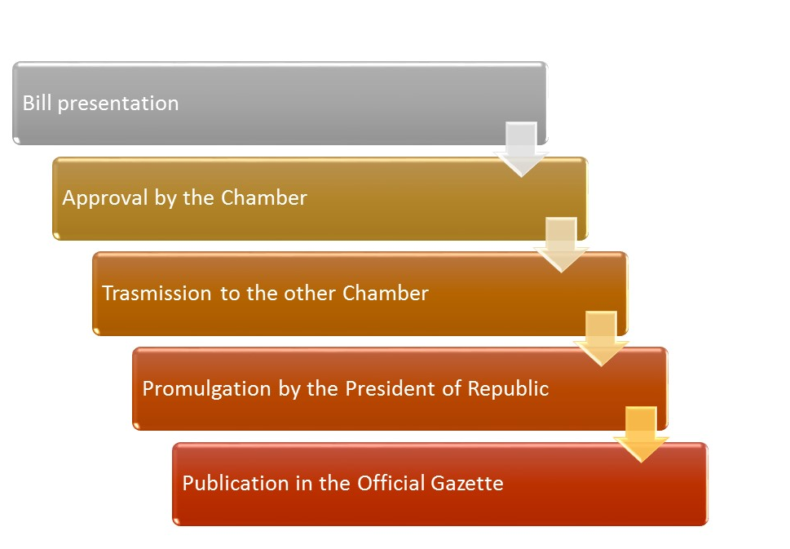

Figure 1. The (simplified) legislative iter in the Italian system

In order to identify and analyse the bills proposed for the NHIS in Italy we followed the seven methodological points illustrated in Figure 2.
In order to search for bills, the authors took advantage of the specialized database available on the Senate website (www.senato.it ). The search was carried out starting from the VIII legislature, which began on June 20, 1979, up to the one still in progress (XVIII). In consideration of the structure of the database, the search was carried out in the complete texts of the bills only for the branch of the Senate, while for the search relating to the bills for the Chamber it was carried out in the summary sheets (Cards of treatment).
On the other hand, with regard to the laws approved and in force, the portal of the Italian laws ( www.normattiva.it ) was consulted, which is a textual database with the entire normative corpus of the Italian republic, published since 1946, and with the normative corpus of the Italian monarchy, published from 1861 to 1945.

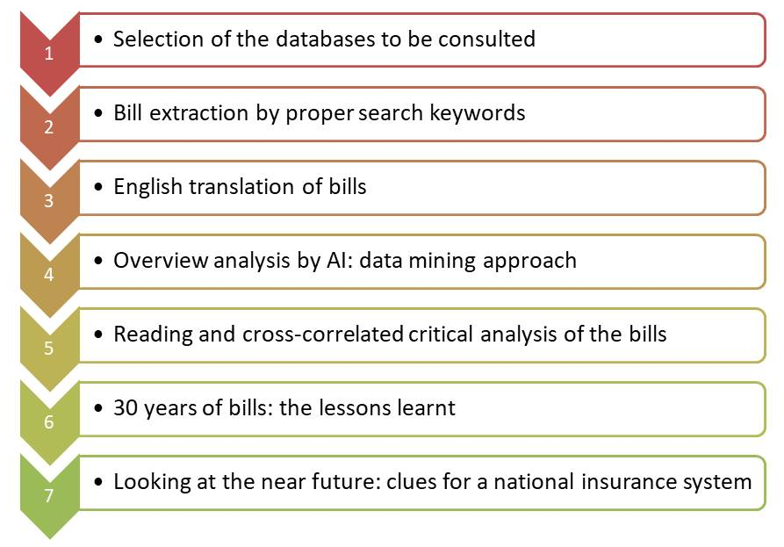
Figure 2. Main methodology paths followed to analyze the bills (or laws) on NHIS

In both official databases, searches were carried out using the key words calamità naturali (natural calamities), that is the main term used in the Italian legal language to indicate extreme natural events, and assicurazioni (insurances). Data by both databases were downloaded in May 2021. The results of the searches were then filtered manually through a detailed examination of the contents with respect to the research objective.
In order to get a general overview of the bills and laws, they were preliminary investigated by artificial intelligence (AI)-data-mining approach, using the VOSviewer software (version 1.6.16) (Van Eck & Waltman, 2011, 2014). The software builds co-occurrence networks, appropriate to give an idea of relationships between words and it is widely used to analyse, in bibliometric perspectives, articles indexed in scientific databases such as Scopus and/or Web of Science thus investigating research trends in different academic fields (e.g., Gizzi & Leucci, 2018; Gizzi & Potenza, 2020, Knapczyk et al., 2018). As far as the authors are aware, this is the first time the software has been used for the scrutiny of legislative documentation.
The software uses the text mining technique to identify the noun phrases. The noun phrases are classified based on a relevance score: high relevance score is assigned when terms co-occur mainly with a limited set of other noun phrases so showing a more precise connotation in the field considered. This means that noun phrases with low relevance score are those that tend to be too general and meaningless for the domain of interest: they are omitted from the data processing. The software grouped the high relevance noun phrases (referred as terms) together into clusters to identify possible subfield or research topics. The default option of the software is to select the 60% most relevant terms among the noun phrases that occurred 10 times at least. In our analysis, we did not use all the bills or laws text to extract noun phrases, but we analysed only the sections dealing with the NHIS. With the purpose to perform the data mining analysis, the preliminary English translation of the bills and laws was carried out from Italian. Considering the low number of bills or laws, we opted to lower the threshold values of noun phrases as much as possible, fixing the occurrence at 1 times at least. Conversely, the percentage of most relevant terms to be considered was raised to the maximum (100%). Furthermore, the option to insert a thesaurus text file was considered. This option is helpful in order to merge different spellings of the same term (e.g., “earthquake” and “seismic event”) or merging different terms referring to the same concept (e.g., “insurance premium” and “premium”; “private housing” and “private home”). After that, the resulting terms were cleaned by deleting the irrelevant words (e.g., “Italy”, “December”, “useful”).
The software builds three typologies of maps: network visualization, overlay visualization, and density visualization. The first map shows the items by their label and by a circle. For each term, the size of the term’s label and the size of the term’s circle depends on the weight of the term. Furthermore, the colour of an item is determined by the cluster to which the item belongs. The overlay visualization is the same as the network visualization except that items are coloured in a different way depending on the user choice. Lastly, density visualization shows the density of an item at a certain point. In our analysis, we built and analysed comparatively the network and the density visualizations.

4.2. Results

4.2.1. Statistics of the bills and insight by AI-data mining approach
We identified 42 bills and laws regarding the subject of NHIS. The first act dates back to 1989 and the last to 2019, thus covering a time span of 31 years, with the average of about 1.3 bills or laws per year. The shortest period in which no bills (or laws) were drafted is one year, the longest one is three years, the latter traceable at the beginning and at the end of the 31-years period (Figure 3, Table 1).
With regard to the proposals, it emerges that the prevailing insurance systems proposed, not only for residential assets but also for public buildings such as schools, are the compulsory for 36.8% of cases, followed by semi-compulsory (compulsory extension of fire policies coverage undersigned to cover properties) and voluntary ones, amounting at 31.6% respectively. The window of thirty-one years can be divided into three main periods: 1) from 1989 to the first half of the nineties of the twentieth century, where the compulsory system clearly prevails, 2) from the second half of the nineties and up to the first decade of the 2000s, where semi-compulsory or voluntary systems prevail, 3) in the second decade of the 2000s, in which the compulsory system prevails again, but also flanked by the other two schemes, with a relative prevalence of the voluntary one (Fig. 2).
The difficulty for Italian politics to tackle the issue is evident from the comparison between the number of bills (37, 88%) -never promulgated- and the laws enacted (5, 12%). The highest annual number of acts (7) was recorded in 1998, one year after the earthquake of the Umbria-Marche Apennines of September 26, 1997 (Mw=5.97, Rovida et al., 2020).
The bills, having not been successful in one legislature, were often repeated in one or more subsequent legislatures.
Overall, legislative proposals are mainly made by deputies or senators (mainly in associated form) and subordinately by the Government. In few cases, the same bill is presented in both houses of the parliament (Chamber of Deputies and Senate of the Republic). The proposals were presented by single or group of parliamentarians belonging to many parties, highlighting the presence of a certain transversal interest of the political class regarding the issue of NHIS.
The bill for a NHIS was usually motivated by the proposer(s) by the need to guarantee adequate, timely and uniform levels of satisfaction of the repair and reconstruction needs of private real estate as well as to relieve the Italian state from the huge economic disbursement after significant disasters.

Table - 1. Italian bills or laws related to NHIS in Italy over the last thirty one years (LEG=Legislature; AT=Act Typology; AN=Act Number; EC=Equivalence Code (the same code identifies bills re-proposed in different legislatures); NSP=National Scheme Proposed; NP=Number of bill promoters; BR=Branch of the Italian Parliament from which the bills or laws were proposed (CH=Chamber of Deputies, SE=Senate of the Republic).
LEG | Date (dd/mm/yyyy) | AT | AN | EC | General aim of the act | NSP | NP | BR
X | 2-nov-89 | BILL | 4315 | A | New rules on civil protection | Compulsory | 10 | CH
XI | 22-apr-93 | BILL | 1164 | B | Delegation to the Government to issue general provisions on interventions resulting from damage caused by natural calamities | Compulsory | 17 | SE
XII | 30-giu-94 | BILL | 800 | B | Delegation to the Government to issue general provisions on interventions resulting from damage caused by natural calamities | Compulsory | 2 | CH
XII | 20-lug-94 | BILL | 638 | B | Delegation to the Government to issue general provisions on interventions resulting from damage caused by natural calamities | Compulsory | 7 | SE
XII | 4-mag-95 | BILL | 2481 | B | Delegation to the Government to issue general provisions on interventions resulting from damage caused by natural calamities | Compulsory | 1 | CH
XIII | 9-mag-96 | BILL | 235 | B | Delegation to the Government to issue general provisions on interventions resulting from damage caused by natural calamities | Compulsory | 2 | CH
XIII | 19-dic-96 | LAW  DECREE | 705 | C | Establishment of capital reserves for the risks of natural calamities | / | - | SE
XIII | 9-dic-97 | BILL | 2926 | D | Delegation to the Government for the rationalization of the reimbursement of damages caused by natural calamities to private property | Voluntary | 22 | SE
XIII | 30-mar-98 | LAW | 61 | E | Conversion into law of the decree-law of 30 January 1998, n. 6, containing further urgent interventions in favour of the earthquake-stricken areas of the Marche and Umbria regions and other areas affected by calamities | / | - | -
XIII | 14-mag-98 | BILL | 3270 | F | National solidarity fund for the insurance of major environmental risks | / | 1 | SE
XIII | 35955 | BILL | 4966 | G | Delegation to the Government for the enactment of rules on the protection of natural calamities. Provisions concerning the obligation of insurance against risks deriving from natural calamities | Semi-compulsory | 1 | CH
XIII | 9-giu-98 | BILL | 3326 | G | Delegation rules for an active defence strategy against natural calamities and insurance against catastrophe risks | Semi-compulsory | 34 | SE
XIII | 24-giu-98 | BILL | 5018 | G | Delegation to the Government for the issuing of rules on defence against natural calamities. Provisions concerning the obligation of insurance against risks deriving from natural calamities | Semi-compulsory | 10 | CH
XIII | 20-nov-98 | BILL | 3662 | H | Public finance measure for stabilization and development | Semi-compulsory | 12 | SE
XIII | 20-nov-98 | BILL | 3662-TER | I | Public finance measures for stabilization and development | Semi-compulsory | 12 | SE
XIII | 11-feb-99 | BILL | 3798-I RIST | J | National Civil Protection Service | Voluntary | 21 | SE
XIII | 5-mag-99 | BILL | 5809-TER | K | Provisions on insurance and state intervention for natural calamities | Semi-compulsory | 4 | CH
XIII | 25-ott-00 | BILL | 7385 | L | Framework law on natural calamities | Voluntary | 1 | CH
XIV | 26-gen-01 | BILL | 533 | M | Framework law on interventions for the restoration of damage and the reconstruction following a calamity or catastrophe | Voluntary | 7 | SE
XIV | 25-lug-01 | BILL | 531 | J | National Civil Protection Service | Voluntary | 14 | SE
XIV | 5-dic-01 | BILL | 930 | L | Framework law on natural calamities | Voluntary | 4 | SE
XIV | 30-set-03 | BILL | 2512 | N | Provisions for the preparation of the annual and multiannual State budget (2004 finance law) | Semi-compulsory | 1 | SE
XIV | 1-dic-03 | BILL | 2512-B | N | Provisions for the preparation of the annual and multiannual State budget (2004 finance law) | Semi-compulsory | 1 | SE
XIV | 30-dic-04 | LAW | 311 | O | Provisions for the preparation of the annual and multiannual State budget (2005 finance law) | Voluntary | - | SE
XIV | 15-giu-05 | BILL | 5921 | P | Delegation to the Government for the regulation of insurance to cover risks deriving from natural calamities | Semi-compulsory | 3 | CH
XV | 29-giu-06 | BILL | 1238 | P | Delegation to the Government for the regulation of insurance to cover risks deriving from natural calamities | Semi-compulsory | 1 | CH
XV | 18-ott-06 | BILL | 1099 | L | Framework law on natural calamities, as well as delegation to the Government for compensation for damages and for the suspension of terms in civil and tax matters | Voluntary | 22 | SE
XVI | 29-apr-08 | BILL | 243 | L | Framework law on natural calamities, as well as delegation to the Government for compensation for damages and for the suspension of terms in civil and tax matters | Voluntary | 2 | SE
XVI | 15-mag-08 | BILL | 552 | Q | Safety regulations in schools | Compulsory | 1 | SE
XVI | 13-set-08 | BILL | 1682 | P | Delegation to the Government for the regulation of insurance to cover risks deriving from natural calamities | Semi-compulsory | 1 | CH
XVI | 27-mag-11 | BILL | 2721 | R | Provisions on urban regeneration to promote housing capacity and the increase of green areas | Compulsory | 3
XVI | 15-mag-12 | LAW  DECREE | 59 | S | Urgent provisions for the reorganization of civil protection | Voluntary | - | SE
XVI | 19-dic-12 | BILL | 3631 | T | Establishment of compulsory insurance against risks arising from natural calamities, as well as a Fund for the safety and energy efficiency of buildings | Compulsory | 29 | SE
XVII | 15-mar-13 | BILL | 124 | U | Provisions concerning a national plan for the environmental and building heritage requalification | Voluntary | 1 | SE
XVII | 15-mar-13 | BILL | 279 | P | Delegation to the Government for the regulation of insurance to cover risks deriving from natural calamities | Semi-compulsory | 1 | CH
XVII | 26-giu-13 | BILL | 881 | T | Establishment of compulsory insurance against risks arising from natural calamities, as well as a Fund for the safety and energy efficiency of buildings | Compulsory | 3 | SE
XVII | 19-set-17 | BILL | 2904 | V | Provisions for the prevention of seismic risk, for post-earthquake reconstruction and the safety of real estate assets, as well as for the adoption of a national anti-seismic plan | Compulsory | 5 | SE
XVII | 27-dic-17 | BUDGET LAW | 205 | W | Budget law | / | - | SE
XVIII | 23-mar-18 | BILL | 61 | V | Provisions for the prevention of seismic risk, for post-earthquake reconstruction and the safety of real estate assets, as well as for the adoption of a national anti-seismic plan | Compulsory | 1 | SE
XVIII | 23-mar-18 | BILL | 107 | Q | Safety regulations in schools | Compulsory | 2 | SE
XVIII | 17-dic-18 | BILL | 1454 | X | Deductibility of expenses incurred for the voluntary insurance of buildings against damage caused by natural calamities | Voluntary | 1 | CH
XVIII | 28-giu-19 | BILL | 1943 | Y | Establishment of a national program for the compulsory insurance of private buildings against damage resulting from natural calamities | Compulsory | 1 | CH

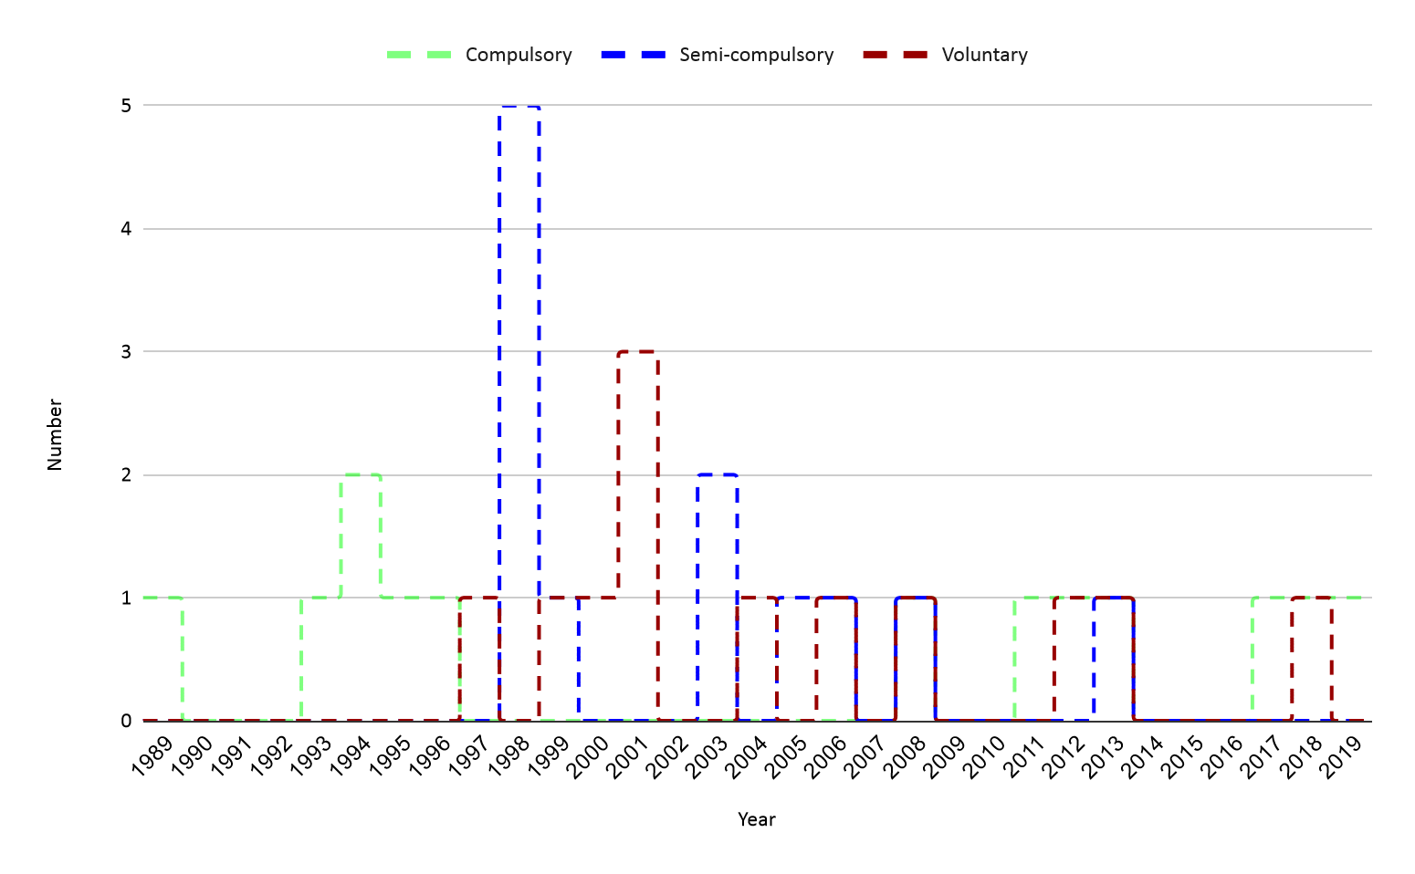
Figure 3- Temporal trend of bills (or laws) dealing with NHIS for Italy

TERMS | FREQUENCY | TERMS | FREQUENCY
- natural calamity | 40 | - delegation rule | 15
- damage | 32 | - earthquake | 14
- risk | 30 | - illegal building | 14
- insurance company | 24 | - semicompulsory insurance | 14
- force | 23 | - compulsory insurance | 13
- insurance | 23 | - decree | 13
- regulation | 23 | - insurance coverage | 13
- building | 22 | - real estate | 13
- private property | 21 | - coreinsurance consortium | 12
- agreement | 20 | - state intervention | 12
- government | 17 | - voluntary insurance | 12
- insurance premium | 17 | - collective interest insurance | 11
- provision | 17 | - contract | 11
- civil protection | 15 | - legislative decree | 11
- compensation | 15 | - reinsurance | 11

Table 2. Terms of the bills (or laws) on NHIS having higher frequency (> 10)

The analysis of the bills by AI shows a map made up of 179 terms divided in two main clusters (Figure 4a): 1) the red, the larger group, which includes 120 terms, 2) the green, made up of 59 items. In the map, the terms related to the same cluster are more interrelated with respect to the terms of the close cluster. In addition, the closer the terms are on the map, the greater their interdependence, i.e. their co-occurrence in the bills (or laws).
Thirty are the most frequent words (Table 2). The network is dominated by the "natural calamity" term (40 occurrences) which, as expected, is a central term in the map (Figure 4a) as it is a keyword common to nearly all bills or laws. The other terms refer mainly to: a) the assets to be protected (building, private property, real estate), b) the typology of NHIS and the contractual aspects of insurance policies (e.g., compulsory, semicompulsory, voluntary, insurance premium, compensation)
Considering the red cluster (Figure 4a), the terms refer mainly to the insurance schemes to be adopted (“compulsory insurance”, “semi compulsory insurance”, and “voluntary insurance”) with the main general and contractual rules governing them. In the lower portion of the map, the terms such as "hydrogeological instability" and "earthquake” make evident against which natural hazards the “buildings” and “real estate” should be insured. On the other hand, the term "safety” identifies the general framework of the disaster risk reduction policy within which the insurance scheme was often proposed. In the upper part of the red cluster the terms recall the “policy” of fiscal incentives for insurance coverage (e.g., “deductibility”, “incentive”, “income”, and “irpef”, the latter being the Personal Income Tax) taking into account the “invariance” principle of “public finance”, that is, the granting of incentives without adding to the state budget.
Considering the green cluster, the terms refer to the damage compensation and the related risk of insurance insolvency to be guaranteed by a “co-reinsurance consortium” and a “capital reserve” by insurers (Figure 4b).
Taking a closer look at the terms such as their number of connection and degree of link strength, the rules that propose the three insurance schemes seem differ in complexity. In fact, while the obligatory scheme seems to be the least complex, with a lower of both number of connections and link strength (60 terms, total link strength, TLS=204) (Figure 5a), the voluntary one shows an intermediate complexity (92 connections, TLS=265) (Figure 5b). The greater complexity of the rule seems to be that which proposes the semi-mandatory regime (141 related terms, TLS=665) (Figure 5c). Furthermore, analysing the term “semicompulsory insurance”, the highest connection with the green cluster emerges as respect the other systems, to testify the high concern of the promoters of semi-compulsory scheme with respect to the issue of economic sustainability and potential insolvency of insurance companies (Figure 5c). What’s more, “voluntary insurance” as well as “semi compulsory” insurance show a greater connection with the upper portion of the red cluster once compared with “compulsory insurance” term, indicating a higher attention by proponents of non-obligatory insurance systems to facilitate the underwriting of policies. In addition, while the two forms of non-compulsory insurance have an interrelation with the theme of “illegal building”, the term "compulsory insurance" is not related to it, highlighting a different approach by the proposer to the issue (Figure 5a,b,c,).

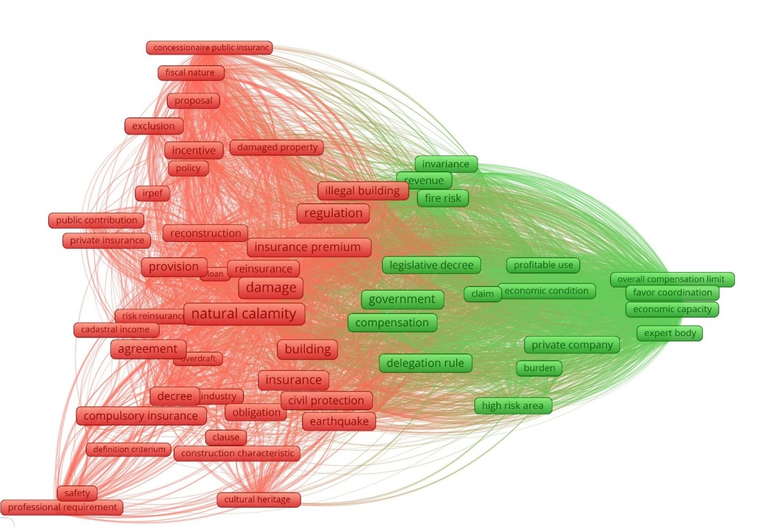

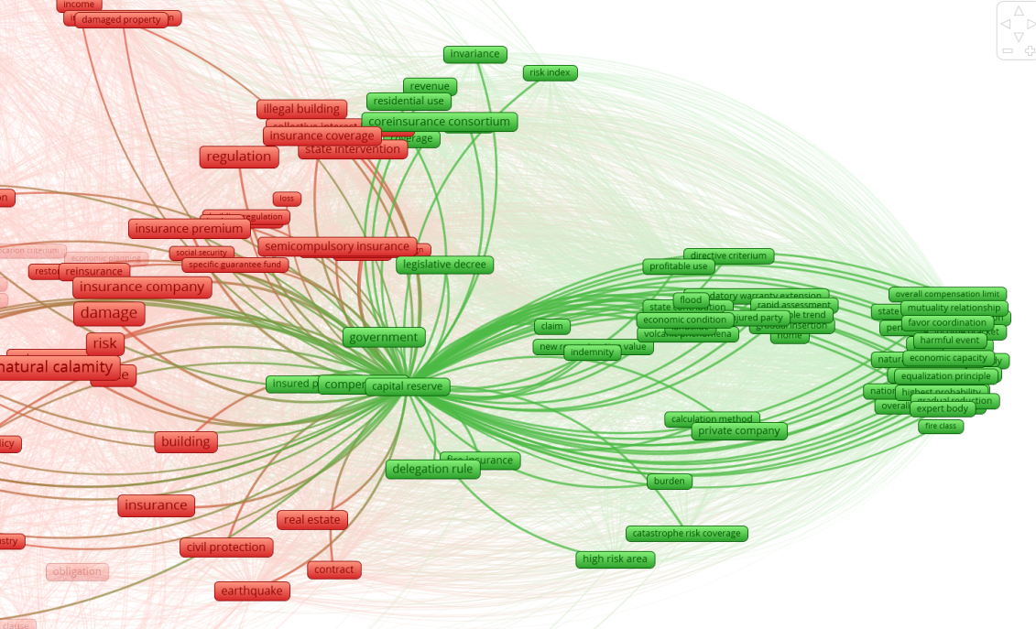
Figura 4. a, upper) Co-occurrence term map related to the bills on natural hazard insurance since 1989; b, lower) zoom view on the green cluster, with the network links related to the “capital reserve” terms, well representing the main topic of the green cluster
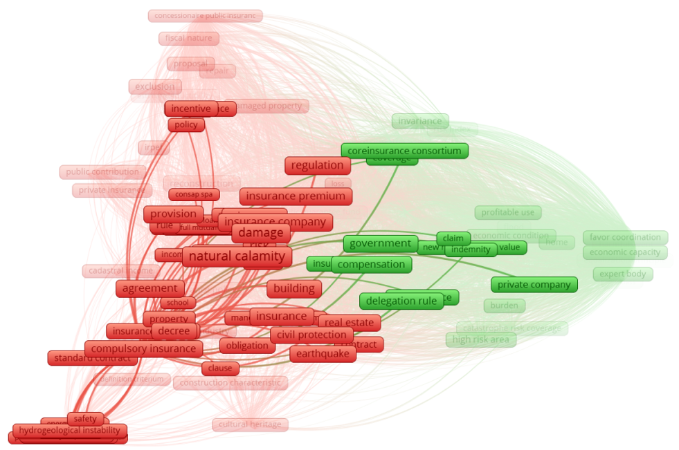
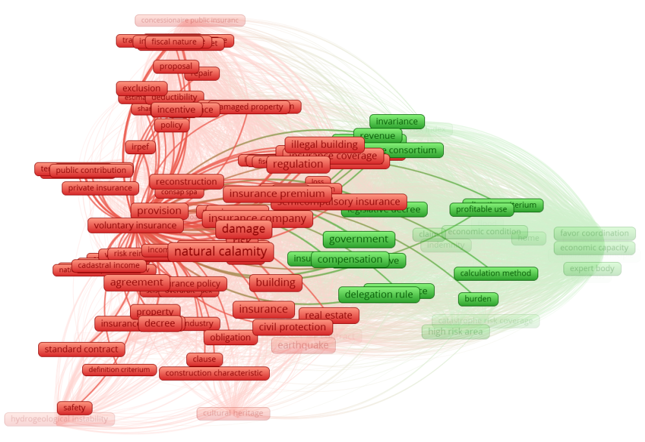
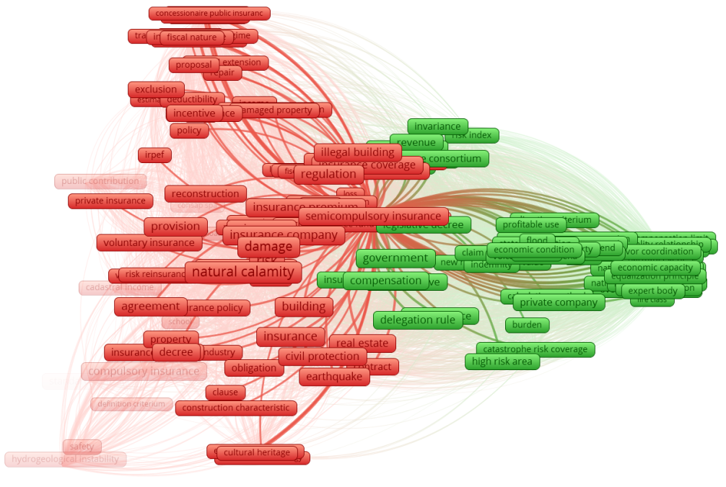
Figura 5. Map of the co-occurrence terms for Italian bills and laws dealing with NHI; a, upper) network for “compulsory insurance”, b, middle) network for “voluntary insurance”; c, lower) network for “semi-compulsory insurance”. The last two terms have a relationship with “illegal buildings”, connection absent for “compulsory insurance”

Once performed the preliminary analysis by AI, the main Italian bills were examined in detail by a critical and cross-correlated reading to outline the critical points that might be considered at the base of the difficulties in building a NHIS system. Next sections will discuss such aspects.

4.2.2 Analysing bills’ contents and critical points
The first bill (2 November 1989) was proposed about ten years later the 23 November 1980 Irpinia-Basilicata earthquake (Mw=6.8), one of the strongest earthquakes occurred in Italy since the beginning of the XX century (Gizzi et al., 2012; Rovida et al., 2020). The bill provides for the establishment of a National Insurance Fund managed by a specific Service of the National Department of Civil Protection entrusted also for the promotion of insurance coverage. The resources of the Fund consist of the endowment provided for by law and the compulsory insurance premiums paid by citizens, businesses and local authorities. For the management of the National Insurance Fund, the Minister of Civil Protection can stipulate conventions between consortia of insurance companies.
In 1993, after about four years from the first legislative attempt, a new bill was drafted. The same bill will then be re-proposed for the next three years. The attempts provide for the delegation to the government on compensation of damages caused by natural hazards. A compulsory insurance system is proposed for both immovable and movable properties. The insurance scheme is based on three main pillars: 1) a mandatory insurance consortium between the insurance companies, 2) a fund for the insurance of private assets where insurance premiums can also be brought together, and 3) local bodies, established in each municipality with the task to facilitate the insurance underwriting. The management of the Fund is based on quite complex concerted actions between ministries and between ministries and a technical committee.
The legislative act of December 1996 does not provide for the establishment of a NHIS, but attempts to establish the conditions for doing so. Indeed, the decree law establishes the need for insurance companies dealing with natural hazard coverages to set aside a portion of the premium relating to insurance contracts for the risks of disasters thus establishing a balance reserve to cover the insolvency risk. The decree, which could be seen as a premise for the development of an economically sustainable NHIS, in some way paves the way for the legislative proposals of the following years.
The next bill that focuses attention on the adoption of a NHIS system dates back to December 1997. Taken as a whole, the bill addresses the broader issue of rationalizing the restoration of damage caused by natural hazards to assets owned by individuals. As regards the insurance, the bill delegates the government for the issuing of specific decrees to regulate the coverage, proposed on a voluntary basis. In doing so, the bill provides the general guidelines to be followed by the government to enact the decrees, such as: 1) to limit the state intervention only to cases of disasters declared of national importance by the government, 2) to schedule insurance fiscal incentives but with invariance of revenue for the State, 3) to define the maximum limits of insurance reimbursement, 4) to fix the criteria to assess the value of the assets to be insured, 5) to integrate properly the insurance and state compensations, 6) to coordinate insurance companies for catastrophe reinsurance, 7) to list the types of assets, in addition to those built in contrast with environmental, urban planning and building regulations and regulations, for which the intervention of the State for damage compensation must be excluded.
Aside from the less relevant law of March 1998 and the bill of May 1998, which respectively address the partnership between the public and insurance companies in the compensation of damages and the establishment of a fund for the insurance of major environmental and production risks, the main proposals of 1998 are those presented to the two branches of parliament in June. The three bills are the same and are based on the adoption of a semi-compulsory system. The bills delegate the government to issue general rules on defence against disasters triggered by natural hazards, which for the first time are defined for legal purposes. The insurance system is included by the proponents in a broader framework aimed at mitigating risks, through a specific fund, and educating the population to be aware of natural risks, all actions that had not been taken by the state until then, in the opinion of the proposer of the bill(s).
From this last bill, two important points arise: the payment of the premium for the insurance of properties owned by individuals in disadvantaged economic conditions and the coverage of illegal buildings. According to the bills, in the fire insurance contracts relating to real estate owned by private individuals or legal entities, insurance against risks deriving from earthquakes and other natural hazards must be provided by the insurers which cannot refuse to take out the natural hazard coverage. Furthermore, the clause of the obligation to extend the coverage is also made compulsory in contracts in progress from the first renewal. Illegal buildings as well as cultural heritage and properties in high hazard areas are excluded from the obligation to disaster insurance. Furthermore, the bill also provided for tax breaks for both premium and compensation. The policy and coordination structure is flanked by a national system of assessment and control of the implementation of the provisions of the law, but there is no specific authority with competences on the insurance issue.
The last two bills of November 1998, which still propose a semi-mandatory scheme, are part of wider legislative interventions aimed at stabilizing public finance and development. The first proposal takes up the issue of the integration between insurance companies and state compensation, postponing the subject to a subsequent regulation by the Ministers. The definition of a specific regulation is also postponed by the second bill of November 1998 to implement the mandatory extension of fire policies to disasters, partly following the provisions of the December 1997 bill. An aspect that characterizes this bill (3662-TER) from the previous ones, and which will be included in some more recent bills, is the reference to what happens in the event of the absence of insurance coverage. Again, also this bill considers the economic conditions of the injured, providing that a share of the damages, between 20 and 50 percent, should be borne by the owner of the damaged property. For what concerns the issue of the illegal buildings, they are considered as excluded from any compensation by the State. The bill provides for the regulation on the insurance system to be defined in agreement between the technically competent ministries.
The draft law of February 1999, which will then be re-proposed in 2001, attempts to introduce an insurance system on a voluntary basis, within a broader legislative perspective, which is that of the establishment of the national civil protection service. The proposal fixes the percentage of damage potentially remunerable by the state for an amount not exceeding 50 percent effectively raising the percentage of refundable damage as fixed in 1998.
Three months later (May 1999), the bill addresses one of the critical point outlined above extending the social and solidarity role of the State for the complete reconstruction of the main houses whose owner has a low income. Therefore, the proposal introduces for the first time, the concept of voluntary insurance where the State safeguard the people with low income by ex post aid. The proposal also foresees the need for a definition a) of standard contracts, which guarantee an easy settlement of damages, b) the procedures for risk reinsurance, including through the establishment of a voluntary consortium between insurance companies.
The bill again delegates the Government to issue legislative decrees to regulate the subject of State intervention for the reconstruction of private immovable property destroyed or damaged by natural hazards, including the mandatory extension of fire policies (semi-compulsory insurance) to cover the risk. The proposal takes up and aggregates indications already reported in previous proposals such as tax incentives for policies, the limitation of state intervention, the assets to be excluded from compensation, the coordination between the companies for catastrophe reinsurance, and the definition of criteria for quick compensation from the companies. The need for a specific information campaign on the subject of insurance was introduced for the first time, to be carried out by the Department of Civil Protection.
The bill of October 2000 proposes a voluntary insurance system. The parliamentary act proposes a voluntary insurance system within a hypothesis of a framework law on “natural” disasters. The proposal foresees that the government adopts legislative decrees on a limited number of aspects such as the exclusion of any compensation action by both the State and the insurance companies in the case of buildings constructed illegally, the participation in compensation between the State and insurers, the generic incentive for underwriting the policies. The same law was re-proposed just over a year later (December 2001).
The draft law of January 2001 proposes a voluntary insurance system delegating to the competent ministries the burden of establishing: 1) agreements with insurance companies to define standard schemes of contracts with certain indemnity guarantees, 2) a reinsurance system. Probably to facilitate the process of approving the law, the speakers did not include cases in which the state would not have compensated the owners (illegal buildings). A few months later (July 2001), a new bill based on the direct (fiscal) and indirect incentives (introducing limits on compensation for damages by the State) of voluntary insurance was proposed again. Another attempt to introduce a voluntary system was made in December 2001 and was then re-proposed in 2006 and 2008. The rather general proposal traces the general lines to be detailed through the delegation then conferred to the Government on the subject of compensation for damages.
The bill of September 2003 proposes a semi-mandatory system and the delegation to the Government for the issue of a regulation following general principles already included in the proposals examined previously (assets to be excluded, definition of the values of assets for insurance purposes, co-insurance). However, the proposal introduces for the first time the need to correlate insurance premiums with territorial risk indices for the different types of natural hazards and providing for deductibles and compensation limits. The proposal also provides for the total exclusion of State intervention for damages suffered from uninsured buildings whose owners have an income above a certain threshold. The bill was proposed again in December of the same year after the approval of the bill in September, with the removal of the paragraph of the bill relating to insurance coverage.
The State finance law for the year 2005 provides for the introduction of a reinsurance company to start a voluntary insurance system. Although the law does not directly address the insurance issue and the methods of implementation of the system, it emphasizes the need to exclude state intervention to cover damage to illegal buildings.
The bill of June 2005, reiterated in other three legislatures (June 2006, September 2008, March 2013), delegates to the Government the regulation of insurance trying to introduce again, also by fiscal incentives, the mandatory extension against the risks of natural disasters for properties covered by fire insurance policies and correlating the premium to the risk indexes.
In May 2011, an attempt to introduce a limited compulsory insurance was proposed only for buildings or structures built within urban regeneration interventions, but the bill was once again not approved. A comparable approach, but based on the encouragement of voluntary insurance, was proposed in 2013 as part of the provisions concerning a national plan for the environmental and building heritage redevelopment, with the aim of determining a significant reduction in costs by the state.
After the 2009 L’Aquila and 2012 Emilia earthquakes, the building of a NHIS system becomes topical again and another attempt to introduce such a system was performed through the article No. 2: “Coperture assicurative su base volontaria contro i rischi di danni derivanti da calamità naturali” (Voluntary insurance coverage against damage caused by natural disasters) of the executive order No. 59/2012 dealing with “Disposizioni urgenti per il riordino della protezione civile” (Urgent provisions for the rearrangement of the National Civil Protection). The fundamental assumption of the article was to guarantee suitable, timely and uniform reparation and rebuilding actions considering that the State has limited economic resources to cope with the medium-long term consequences caused by natural hazards.
The lack of an agreement between the policymakers in respect of the insurance system to be adopted undermined the efforts (Gizzi et al., 2016) and probably stimulated the bill of December 2012, based on the compulsory insurance system. According to the proposal, all public and private properties had to be in possession of insurance against the risks arising from any natural hazard, including seismic events and hydrogeological instability, within a few months of the entry into force of the law.
The legislative proposals of the last three years are mainly based on a mandatory insurance system, also providing for the stipulation of the insurance contract as a binding requirement for the validity of the purchase and sale or rental contracts of the properties (bill of September 2017). The latest bill proposed in June 2019 provides for a very complex mandatory system with "The establishment of a national program for the compulsory insurance of private buildings against damage resulting from natural disasters", where the State is called upon to play the role of insurer of last resort.

5. Discussion
In the above sections, we have examined the possible reasons of the failure to introduce a NHIS in Italy. Indeed, the analysis of the bills (never promulgated) could be a source to understand the reasons of this log-lasting history and a possible proposal for the future. The critical points of discussion are essential the following: first, the choice between a compulsory versus a voluntary scheme, secondly the issue of the coverage of Illegal buildings.

5.1 Compulsory versus voluntary NHIS
From the analysis of legislative attempts made in the last 30 years or so, a gradual approach over time to the insurance issue seems to emerge. After the first bills based on a compulsory scheme, the next looked at voluntary or semi-compulsory systems. However, after the earthquakes of 2009 in L'Aquila, 2012 in Emilia and 2016 in Central Italy, the huge damages and the economic burden on state finances pushed the speakers to propose laws based mainly on a mandatory scheme.
To introduce a semi-compulsory scheme, some bills provide the obligation for companies to sell coverage against natural hazard damages. This rule can discourage insurance companies, fearing the risk of insolvency also due to the circumstance that the bills usually do not refer to the Italian state as the insurer of last resort. Indeed, usually the bills provide for overcoming insolvency through risk reinsurance or the establishment of a voluntary consortium between the insurance companies and the provision of reserve capital.
However, the bills scheduling the State as insurer of last resort, may have encountered obstacles in bill approval as they did in other countries, such as Germany (Schwarze & Wagner, 2007). Moreover, the same semi-mandatory schemes provide for the mandatory extension of the fire policy to the risk of “natural” disasters also for existing contracts. This rule may have discouraged the insurers, fearing the risk of client’s withdrawal from the basic (fire) property coverage.
The Italian bills proposals are in line with other countries experiences. In fact, an analysis of the NHIS adopted in some countries shows that the compulsory scheme usually corresponds to a relevant role of the state, even if semi-compulsory or voluntary scheme are more common. In these last cases, very often the purchase of a natural hazard insurance coverage is linked with another one related to the buildings (like the fire insurance contracts). The decision to introduce a compulsory NHIS does not necessary correspond to the effect of reduction in the competition level in the insurance market (Porrini & Schwarze, 2014), but generally compulsory insurance scheme is hard to be implemented and also has an unpredictable impact (Chen and Chen, 2013).
The failure in building an NHIS scheme in Italy could be in some way related to the idea that a compulsory or semi-compulsory insurance can be perceived as a “tax” in a context of already high fiscal pressure. Indeed, Italy is ranked first for fiscal pressure among the 27 Countries of the European Union (Di Nardo, 2010). Therefore, citizens are very sensitive to taxation of their home ownership. In this sense, the introduction of a compulsory insurance policy would be very unpopular with a negative effect for the political party proposing it.

5.2 The issue of the illegal buildings
As regards to this point, the insurance bills usually address the issue of unauthorized building. Indeed, dealing with the rules to be applied for both insurance and State damage compensation in the event of disaster occurrence, bills frequently fix the exclusion from any compensation for the properties built illegally. If this is certainly acceptable in legal principle, it probably collides with the extremely complex Italian social-political issue.
Illegal building is defined as an activity of land transformation and construction/use of buildings that infringes territorial planning rules in force. Unauthorized building practiced in a widespread form is not a matter present in a generalized manner in all countries. What markedly distinguishes the Italian case from the other countries is the way in which the issue has been dealt with in recent decades. In fact, in the last fifty years there has been a lack of a serious project to return to legality. If we thus consider illegal activity according to the notion of double violation, i.e. as a frequent and at the same time unpunished irregularity, the examples are essentially reduced to two situations: Italy and some capitals of developing countries (Predieri, 1985). In Italy, the phenomenon is mainly due to the transfer of population from the countryside to the cities after the end of the Second World War (Romano et al., 2021).
In compliance with the 2000 BES report (Benessere equo e sostenibile - Fair and Sustainable Wellbeing, https://www.istat.it/it/archivio/254761 ), the Italian illegal building index, referred to residential constructions, stood at 17.7 illegal constructions per 100 authorized. The rate reaches 45.2 illegal buildings per 100 authorized in Southern Italy, but it is also of concern in Centre of Italy, where the value is close to the Italian average. What’s more, the amount of illegal buildings to be demolished by local authorities is so high that some authors (Forte et al., 2016) proposed a computer-based approach to define pulling down priorities based on prearranged criteria.
The so-called abusivismo edilizio takes on particular importance in Southern Italy where the abusivismo di necessità (need for family home) is joined with abusivismo di speculazione (speculation) (Zanfi, 2013).
Over the years, the Italian Parliament approved three building amnesties (the so-called condono edilizio) in 1985, 1994, and 2003 which did not solve the problem and instilling further waves of spontaneous building, encouraging the belief that further amnesties would follow to allow illegal situations to be remedied by law (Zanfi, 2013). Moreover, the same approvals by the Italian Parliament of the building amnesties could be interpreted as an attempt by the institutions to pursue a situation of widespread illegality that, in this way, is officially accepted (Destro, 2013).
Although there were no further amnesties, from January 2010 to December 2012, at least 17 bills were sponsored, that however were not enacted (Romano et al., 2021). This “legislative turmoil” testifies that politicians ride the issue of unauthorized buildings trying also to get electoral benefits (Zanfi, 2013). Therefore, insurance bills that included restrictions of benefits for owners of neither legal nor safe buildings could have encountered relevant opposition in the parliament, slowing down or blocking the approval iter.

6. Conclusions and perspectives
As it has been outlined in the Section 2, the penetration of natural hazard insurance depends on the solution of issues related on both the demand and supply side of the market. Different countries experiences (Section 3) correspond to several attempts to overcome market failures, characterized by a particular role played by the state.
In Italy, from the point of view of the formulation of the bills, during the last thirty years all attempts have been addressing the issue of defining the insurance scheme to be adopted by a technical regulation, which the bill assigns to the Government or concertation between ministries and other technical bodies. However, still a NHIS scheme has to be built, to be approved by the national Parliament and to be implemented in a country, like Italy, particularly subject to natural hazards.
To try overcoming this impasse, a solution could be the establishment of a permanent public authority with specific competences on NHIS with the aim to facilitate the resolution of the technical aspects related to the introduction of the insurance system.
Similarly to the experience of CEA described above, a public authority could be established with the target to increase the penetration of the insurance policies. And this authority could be organized in a way to represent every competent part operating in the market such as: the Italian Civil protection Department (Protezione Civile https://www.protezionecivile.gov.it/), the Association of the Italian Insurance Companies (ANIA https://www.ania.it), the Institute for Insurance Supervision (IVASS https://www.ivass.it), Universities, and Research centres. This authority by providing in its composition the representatives of all market players would help to solve the issues that in the past have effectively blocked the introduction of an NHIS system.
For example, an aspect that the bills do not adequately address and that the authority could addressing better is the increasing of risk perception among citizens about the natural risks of the territory where they live. Risk perception is the subjective judgment that people make of a definite peril and how concerned they are with the effects. It influences people to take proper actions when dealing with natural hazards, including their decision in respect of buying insurance coverage. For instance, people who perceive a risk as “high” where they live are more likely to take suitable countermeasures adapt strategies and sustain proper institutional actions even if this requires new efforts (Armaş, 2006; Plapp & Werner, 2006). That being stated, studies regarding Italy show a low risk perception. Marincioni et al. (2012) who examined a sample of the population involved in the 2009 L’Aquila earthquake (Mw = 6.3) concluded that the residents of the town had a low risk perception and no awareness of the structural performance of their own buildings. Crescimbene et al. (2014), by the analysis of about 5000 on-line tests, concluded that most of the Italians living in areas with high seismic hazard have either a low or incorrect risk perception, thus suggesting the need for new communication strategies. Salvati et al. (2014) highlighted that Italians have a perception of technological risks greater than that of natural risks and consider earthquakes more dangerous than geo-hydrogeological perils. The authors deduced that more actions are needed to increase the population's knowledge of hydrogeological hazards and associated risks. In this perspective, the authority could coordinate the actions of risk education of people and monitor the introduction of the scheme over time.
As concerns fiscal incentives to stimulate the demand of hazard insurance, some bills suggest tax incentives to underwrite natural hazards coverage assuming no revenue variance for the state, but not supporting claims with economic impact estimates. Therefore, the vagueness of the proposal could have made the technical control bodies responsible for sceptically analysing the proposals.
On the other side of the market, the supply side, Italian insurance companies does not seem sensitive to increase the penetration of this kind of insurance in the market, given the problems connected with their potential high financial exposure and the consequent high level of premiums. As stated in Gizzi et al. (2016): “[…] the Italian private insurance market has some limits on the supply side, and in fact, the insurability is not guaranteed for all hazards and properties. The premium formation presents some drawbacks, and the compensation for the insured may not be sufficient to achieve the rebuilding/repairing aims”. On the supply side, the authority could act in Italy as the CEA does in USA being a private-market participant in a voluntary market for residential insurance but within a mandatory-offer system. In relation to the above-mentioned issue of the choice between a compulsory and a voluntary system (sec. 5.1), a public authority, acting as a player in the market, could guarantee the correct use of a voluntary scheme. Particularly, a system that guarantees a fair premium (calculated according to actuarial techniques), but also a possible subsidy system that supports people with lower income.
Moreover, the organization of a public authority in Italy is usually done in pursuit of the principle of neutrality with respect to political parties (Martucci, 2012) and this would help to detect the problem of any unpopularity connected to the introduction of an NHIS system. The public authority could also coordinate directly: a) the risk mitigation plans and the relative legislative initiative aimed at supplying fiscal incentives (e.g., Superbonus 110%, the fiscal incentives for energy saving and seismic vulnerability reduction interventions) linking tax incentives to the stipulation of insurance policies; b) action plans aimed at rising natural hazard risk awareness through a dedicate web site, meetings and community engagement, taking also benefit by the use of Big Data (Gizzi et al., 2020; Tan & Maharjan, 2018).
In this matter, the authority can act as insurer of last resort, providing protection against those risks that the private sector is unable or unwilling to bear. As an example, it could be set a coverage cap over which the state intervenes, offering financial resources to those people affected by a disaster. This strategy might guarantee market stability, increasing, therefore, the efficiency and effectiveness in country policy process for improved outcomes. However, acting as insurer of last resort could create moral hazard. It is therefore necessary to set up strong incentives on beneficiaries to monitor and reduce their risk, using a bonus-malus system and risk-based premiums. Hence, the Government should aim to support rather than undermine the private sector market, focusing on addressing market failures.
The authority could also overcome the difficulties related to illegal construction by separating the rules of natural hazards insurance from the more general rules, defined in the several bills, on the regulation of the state action and intervention in the event of a disaster, thus mitigating possible political conflicts.
The incentive for voluntary insurance by the authority should focus on the possible advantages of an insurance system. One of these could be the possible shorter times required for compensation of damages compared to the times that the State could guarantee, especially in conditions of accentuation of the economic crisis and the sharp worsening of the State Budget due to the COVID-19 pandemic.
As a conclusive remark, for all the reasons above analysed, a public organization that operates with suitable and transparent independence and that is unambiguously directed to operate in the public interest under recognized financial, management, and scientific/engineering principles, could finally guarantee in the next future in Italy an efficient and affective NHIS scheme helpful to safeguard private homes from the consequences of disasters.

Author Contributions: FTG conceived the research, coordinated the drafting of the article and wrote sections 4 and 5. DP co-directed the research and wrote Sections 1, 2, and 3 with FDM. All the authors wrote section 6 and revised the final version of the article.
Funding. This research received no external funding
Conflicts of Interest: The authors declare no conflict of interest.

References

Armaş, I. Earthquake Risk Perception in Bucharest, Romania. Risk Analysis 2006, 26, 1223-1234; DOI: 10.1111/j.1539-6924.2006.00810.x.

Botzen, W.J.W.; van den Burgh, J.C.J.M.; Bower, A.E.L.M. Climate change and increased risk for the insurance sector: a global perspective and an assessment for the Netherlands. Nat Hazards 2010, 52, 577–598; DOI: 10.1007/s11069-009-9404-1.

Chen, Y.; Chen, D. The review and analysis of compulsory insurance. Insurance Markets and Companies: Analyses and Actuarial Computations 2013, 4, Iss. 1, 6-17.

Collier, S.J.; Savannah, C. Governing urban resilience: Insurance and the problematization of climate change. Economy and Society 2021, 50:2, 275-296; DOI: 10.1080/03085147.2021.1904621.

Crescimbene, M.; La Longa, F.; Camassi, R. What’s the Seismic Risk Perception in Italy? In Engineering Geology for Society and Territory; Lollino, G.; Arattano, M.; Giardino, M.; Oliveira, R.; Peppeloni, S., Eds; Springer International Publishing, Switzerland, 2014, Vol. 7, 69-75; DOI: 10.1007/978-3-319-09303-1_13.

Destro, N. Geografia delle case deboli. Oltre l’abusivismo edilizio. Phd Thesis, Università degli Studi di Padova, Dipartimento delle Scienze Storiche, Geografiche e dell’Antichità, 2013.

Di Nardo, T. Analisi della pressione fiscale in Italia, Europa e nel Mondo. Struttura ed evoluzione dei principali indicatori di politica fiscale. Documento di Ricerca del Consiglio Nazionale dei Dottori Commercialisti e degli Esperti Contabili e della Fondazione Nazionale dei Commercialisti 2010, https://www.fondazionenazionalecommercialisti.it/node/1498 (accessed, 29 September 2021)

European Commission. Green Paper on the insurance of natural and man-made disasters, 2013. Available online: https://eur-lex.europa.eu/legal-content/EN/ALL/?uri=CELEX%3A52013DC0213 (accessed, 27 September 2021).

Forte, F.; Granata, M.F.; Nesticò, A. A Prioritisation Model Aiding for the Solution of Illegal Buildings Problem. In Computational Science and Its Applications; Springer, Cham, 2016; vol 9786; DOI: 10.1007/978-3-319-42085-1_15.

Freeman, P.K.; Scott, K. Comparative analysis of large-scale catastrophe compensation schemes, Catastrophic Risks and Insurance. Policy Issues in Insurance 2005, 8 ed, OECD, Paris, 187–234.

Gizzi, F.T.; Potenza, M.R.; Zotta, C. 23 November 1980 Irpinia-Basilicata Earthquake (Southern Italy): Towards a Full Knowledge of the Seismic Effects. Bulletin of Earthquake Engineering 2012, 10, 1109-1131; DOI: 10.1007/s10518-012-9353-z.

Gizzi, F.T.; Potenza, M.R.; Zotta, C. The Insurance Market of Natural Hazards for Residential Properties in Italy. Open Journal of Earthquake Research 2016, 5, 35-61; DOI: 10.4236/ojer.2016.51004.

Gizzi, F.T.; Leucci, G. Global Research Patterns on Ground Penetrating Radar (GPR). Surv. Geophys 2018, 39, 1039–1068; DOI: 10.1007/s10712-018-9475-1.

Gizzi, F.T.; Potenza, M.R. The Scientific Landscape of November 23rd, 1980 Irpinia-Basilicata Earthquake: Taking Stock of (Almost) 40 Years of Studies. Geosciences 2020, 10, 482; DOI: 10.3390/geosciences10120482.

Gizzi, F.T.; Kam, J.; Porrini, D. Time windows of opportunities to fight earthquake under-insurance: evidence from Google Trends. Humanit Soc Sci Commun 2020, 7, 61; DOI: 10.1057/s41599-020-0532-2.

Hartlief, T. Privaatrecht in nood. In Crises, rampen en recht; Muller, E.R.; Hartlief, T.; Keulen, B.F.; H. R. B. M. Kummeling, H.R.B.M., Eds; Kluwer, Deventer, Netherlands, 2014; pp. 65-194.

Jaffee, D.M.; Russell, T. Behavioral models of insurance: The case of the California Earthquake Authority. University of California-Berkeley Working Paper 2000.

Knapczyk, A.; Francik, S.; Pedryc, N.; Hebda, T. Bibliometric analysis of research trends in engineering for rural development. In Proceedings of the 17th International Scientific Conference Engineering for Rural Development, Jelgava, Latvia, 23–25 May 2018; pp. 700–707.

Kunreuther, H. Mitigating disaster losses through insurance. Journal of Risk and Uncertainty 1996, 12, 171–187; DOI: 10.1007/BF00055792.

Kunreuther, H. Strategies for Dealing with Large-Scale and Environmental Risks. In Frontiers in Environmental Economics; Folmer, H.; Gabel, L.; Gerking, S.; Rose, A., Eds.; Cheltenham, Edward Elgar, 2000; pp. 293-318.

Lin, X. Risk awareness and adverse selection in catastrophe insurance: Evidence from California’s residential earthquake insurance market. Journal of Risk and Uncertainty 2020, 61(1), 43-65; DOI: 10.1007/s11166-020-09335-4.

Marincioni, F.; Appiotti, F.; Ferretti, M.; Antinori, C.; Melonaro, P.; Pusceddu, A.; Oreficini-Rosi, R. Perception and Communication of Seismic Risk: The 6 April 2009 L’Aquila Earthquake Case Study. Earthquake Spectra 2012, 28, 159-183; DOI: 10.1193/1.3672928.

Marshall, D. An Overview of the California Earthquake Authority. Risk Management and Insurance Review 2018, 21(1), 73-116.

Martucci, F. The Independence of Regulatory Authorities in Italy. Revue française d’administration publique 2012, 143, 723-734; DOI: 10.3917/rfap.143.0723.

Mysiak, J.; Pérez-Blanco, C.D. Partnerships for disaster risk insurance in the EU. Natural Hazard Earth System Sciences 2016, 16, 2403–2419; DOI: 10.5194/nhess-16-2403-2016.

Neumayer, E.; Barthel, F. Normalising Economic Loss from Natural Disasters: A Global Analysis. Global Environmental Change 2011 ,21, 13-24; DOI: 10.1016/j.gloenvcha.2010.10.004.

Nguyen, C.; Noy, I. Insuring earthquakes: How would the Californian and Japanese insurance programs have fared down under (after the 2011 New Zealand earthquake)? Working Paper Series from Victoria University of Wellington, School of Economics and Finance, 2017; Vol. 6416.

Paleari, S. Disaster risk insurance: A comparison of national schemes in the EU-28. International Journal of Disaster Risk Reduction 2018, Volume 35; DOI: 10.1016/j.ijdrr.2018.12.021.

Plapp, T.; Werner, U. Understanding Risk Perception from Natural Hazards: Examples from Germany. In Risk 21—Coping with Risks due to Natural Hazards in the 21st Century; Vullet, A.D., Ed; Taylor and Francis Group, London, 2006; pp. 101-107.

Porrini D.; Schwarze, R. Insurance models and European climate change policies: an assessment. European Journal of Law and Economics 2014, vol. 38, issue 1, 7-28; DOI: 10.1007/s10657-012-9376-6

Predieri, A. Abusivismo edilizio e nuove sanzioni; Nuova Italia Scientifica, Roma, 1985.

Pothon, A; Gueguen, P.; Buisine, S.; Bard, P.Y. California earthquake insurance unpopularity: the issue is the price, not the risk perception. Nat Hazard Earth Syst 2019, 19(8):1909–1924; DOI: 10.5194/nhess-19-1909-2019.

Romano, B.; Zullo, F.; Fiorini, L.; Marucci, A. Illegal building in Italy: Too complex a problem for national land policy?. Cities 2021, 112, 103159; DOI: 10.1016/j.cities.2021.103159.

Rovida, A.; Locati, M.; Camassi, R.; Lolli, B.; Gasperini, P. The Italian earthquake catalogue CPTI15. Bulletin of Earthquake Engineering 2020, 18(7), 2953-2984; DOI: 10.1007/s10518-020-00818-y.

Salvati, P.; Bianchi, C.; Fiorucci, F.; Giostrella, P.; Marchesini, I.; Guzzetti, F. Perception of Flood and Landslide Risk in Italy: A Preliminary Analysis. Natural Hazards Earth System Science Discussions 2014, 2, 3465-3497; DOI: 10.5194/nhess-14-2589-2014.

Schwarze, R.; Wagner, G.G. The political economy of natural disaster insurance: lessons from the failure of a proposed compulsory insurance scheme in Germany. European Environment 2007, 17, 403-415; DOI: 10.1002/eet.456.

Surminski, S.; Eldridge, J. Flood insurance in England – an assessment of the current and newly proposed insurance scheme in the context of rising flood risk. J. Flood Risk Manage 2017, 10, 415-435; DOI: 10.1111/jfr3.12127.

Suykens, C.; Priest, S.J.; van Doorn-Hoekveld, W.J.; Thuillier, T.; van Rijswick, M. Dealing with flood damages: will prevention, mitigation, and ex post compensation provide for a resilient triangle?. Ecology and Society 2016, 21(4); DOI: 10.5751/ES-08592-210401.

Tan, Y.J.; Maharjan, R. What googling trends tell us about public interest in earthquakes. Seismol Res Lett 2018, 89(2A), 653–657; DOI: 10.1785/0220170116.

United Nations. Paris Agreement, 2015. Available online: https://unfccc.int/process-and-meetings/the-paris-agreement/the-paris-agreement (accessed, 21 September 2021).

Van Eck, N.J.; Waltman, L. Text mining and visualization using VOSviewer. ISSI Newsl 2011, 7, 50–54.

Van Eck, N.J.; Waltman, L. Visualizing bibliometric networks. In Measuring Scholarly Impact: Methods and Practice; Ding, Y.; Rousseau, R.; Wolfram, D., Eds.; Springer: Berlin/Heidelberg, Germany, 2014; pp. 285–320.

Zanfi, F. The città abusiva in contemporary southern Italy: Illegal building and prospects for change. Urban Studies 2013, 50(16), 3428–3445; DOI: 10.1177/0042098013484542.

